August to October 2018: www.briansacks.com/Israel_Diary_Aug_to_Oct_2018.docx
01-11-18
Today's bus journey to Tel Aviv was a characteristically Israeli slice of life. The bus was massively overcrowded for the first few stops. After that it thinned out somewhat but then hit a police roadblock. We were stuck at a junction for some time, with passengers and bus driver alike getting noisily agitated. The bus driver then shouted his decision about the rerouting. A major hullaballoo broke out, with most of the passengers yelling out their frustrations in Hebrew, and the majority eventually walking out. All there was for me to do was to sit down, swallow a mental valium and hope for the best. The rest of the journey was punctuated by the driver yelling his announcement at regular intervals, that he was only going to the Central Bus Station.
Once I reached the bus station, and overcame the challenge of finding my way out of it, I walked through a rather seedy part of Tel Aviv to a significant event, the “NAS Daily” meet-up. Nas, full name Nuseir Yassin, is a Muslim Arab from a village in the north of Israel. Very self-motivated, he taught himself English, largely by sitting in his room and playing video games with English speakers across the internet. He learned that Harvard offered scholarships for those in financial need, and duly earned himself a Harvard place. From there he went into hi-tech, then chucked that in to make videos; one video per day, generally one minute long, each ending "That's one minute, see you tomorrow". The videos tell stories from his travels around the world, and are almost exclusively positive. Nas is now 935 days into his commitment of 1000 days, and he has just short of 10 million followers on Facebook.
By the time I got there, the hall, with capacity 450, was full and I needed to wait for one or two people to leave before I was allowed in. I found myself standing at the back, with Nas at the front responding to questions from the attendees. In the course of it he explained how difficult it was to make videos in Israel: “I have been to some of the most corrupt countries in the world: Egypt, North Korea, African countries where corruption is rife. But I can still find positive stories and make videos about them. But when I make a positive video set in Israel I am told that I am normalising relations with the oppressor, that I am spouting Hasbara, even that I am a Mossad agent!” He lamented the separation between the Jewish and Arab communities in Israel, whereby he did not have a single Jewish friend until he went to Harvard. He is a very impressive young man, walking a tightrope across the chasm between the Jewish and Palestinian communities.
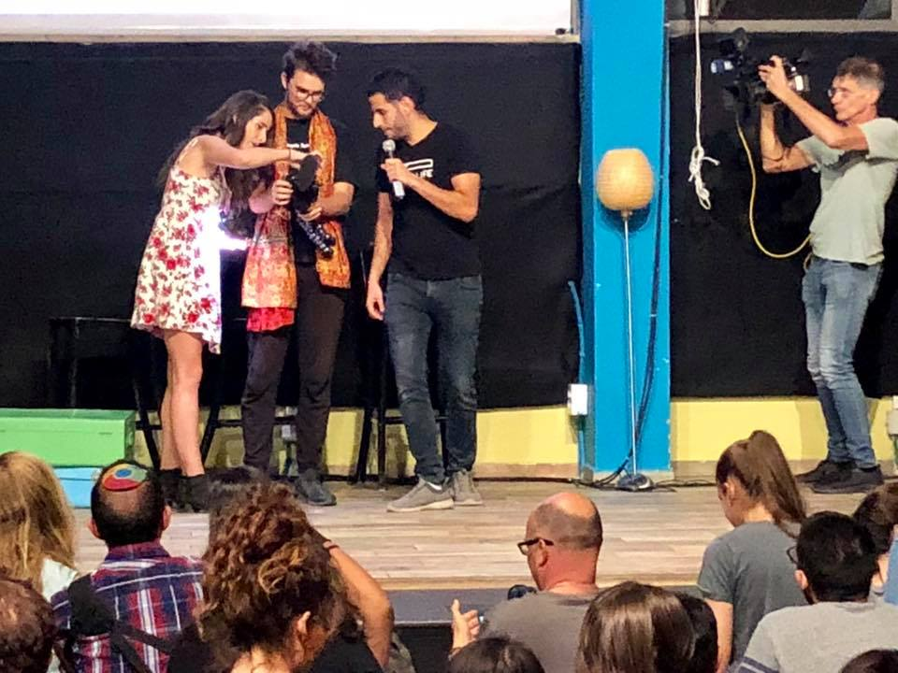 | With thanks to Norma Franklin, who found a place near the front!

02-11-18
New light was shed on two of the incidents I wrote about yesterday.  Those events exemplify what are probably the two most bitter divisions affecting Israeli society internally and externally: that between the ultra-Orthodox Haredim and the rest of Israeli society, and that between Israel and the Arab world.  Firstly, my son-in-law David told me that the roadblock I encountered on the bus was caused by the Haredim bringing Bnei Brak to a standstill with a protest because one of their number had been arrested for draft dodging. | 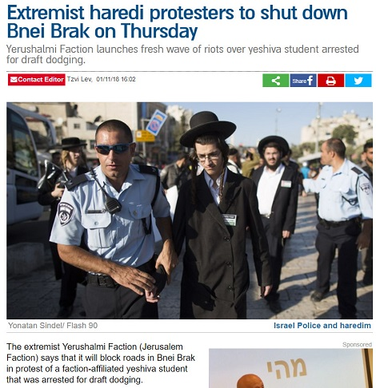
Secondly, Nas Daily's description of the reaction he receives to any video he makes in Israel was borne out with today's video, on a subject as apolitical as veganism. I post here a screengrab from Facebook, with the full meet-up complement from yesterday joining Nas in his customary sign-off “That's one minute, see you tomorrow!". On the right-hand side, Facebook is showing the most significant comments on the video. Of the 6.6K comments, a large proportion expressed a sentiment similar to the first one listed, which, as you will notice, has attracted 2.5 K ‘likes’ and seemingly no dislikes.
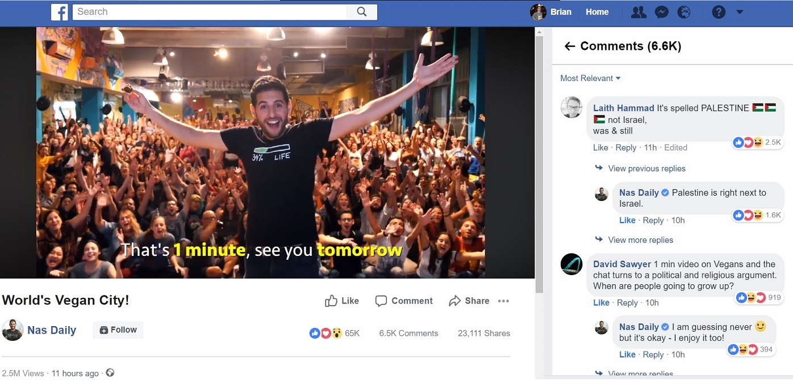
David and Jessica hosted a "Partnership" Shabbat evening prayer service in their flat. This is a service in which a group of like-minded Modern Orthodox Jews try to extract every possible drop of gender equality from the rather rigid and dry body of Orthodox Jewish Law. Women have pride of place in the seating arrangements, and lead the less legally-contentious parts of the service. Attempting to take the viewpoint of an objective observer, it is gratifying for me to see that green shoots of religious innovation can sprout to counter ideas that have been fixed for two thousand years.
(Yes, I know I could extend the metaphor to more closely parallel the Parable of the Sower, but I wouldn't want to venture over stony ground)
I was bemused to note that every single male participant wore a knitted kipa (that is, yarmulke); this is clearly the uniform of the Modern Orthodox. But in contrast to the black-hatted sameness of the Ultra Orthodox male headgear, these kippot were each colourful and individual. Three of the youngsters wore "football supporter" kippot; the two that I could identify were for Paris St Germain - quite a telling hint towards the size of the relatively recent French “Aliya”. When walking along the Tel Aviv beach and overhearing snippets of conversation one could sometimes think that one was in the South of France.

03-11-18
Trigger Alert:  Might offend religious sensibilities! But only intended as a bit of fun – though it might make you think...  On my walk back from the outdoor gym - still being well utilised late at night by Ultra Orthodox youngsters - I stopped to take this photograph. It is the reverse side of the road sign adjacent to my bus stop to Tel Aviv. I also post here Google's translation, which is self-explanatory, and represents a belief held by many thousands of people regarding Menachem Mendel Schneerson, who died in 1994. | 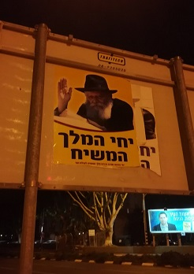 | 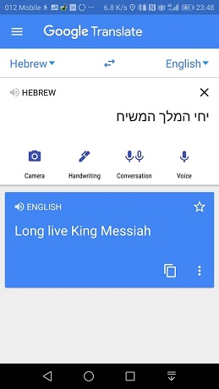

While on the subject of the Messiah, it may be of interest to note his identity as named by the prophet Isaiah:
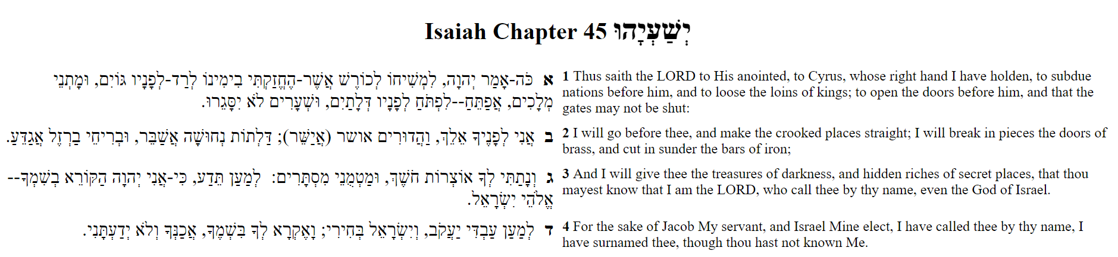
Oh! I almost forgot:
and by Andrew Marr www.briansacks.com/Temp/Andrew_Marr_and_the_Messiah.mp4
05-11-18
There was impressive thunder and lightning last night, and now autumn is definitely here. Daytime has been grey and drizzly, though with the temperature still in the low twenties. Then it rained constantly throughout the evening and night.
People are sneezing and catching colds, not least playschool children and their parents. So I will need to be careful when I babysit tomorrow. I will definitely be in the hunt for winter clothes when, earlier in the day, I travel to Petach Tikva for my meeting with the Ministry of the Interior. (I had previously written that it was scheduled for Wednesday; I should have written Tuesday. The Hebrew for Tuesday is "Yom Shlishi", which translates to "Third Day". The Hebrew days of the week are named in this fashion, with the "First Day" being Sunday. The one departure from this pattern is Saturday, which is simply "Shabbat").
05-11-18
Is it that they believe that the House of Lords is a den of money launderers? Or is it more personal than that?
Those are questions that spring to mind as a result of something that happened today. I will reveal more in due course, when things are sorted out.
06-11-18
I took the bus to Petach Tikva, for my appointment to apply for my first Israeli passport. The bus stopped at Shuk Ironi; as Jeremy Corbyn has pointed out, this cannot be the Irony market, so I assume it must be the Iranian market. I did succeed in finding a sweatshirt to prepare for the colder weather to come.
Petach Tikva is the fifth largest city in Israel, and one of its founders was my great-grandfather, Aryeh Leib Frumkin. Quoting Wikipedia, "He emigrated to Eretz Yisrael during the First Aliyah in 1883. While there he founded the settlement of Petah Tikva in which he built the first house and helped to drain the malaria-ridden swamps. His planting of the first tree there is emblazoned on the seal of the municipality and there is a street named after him."
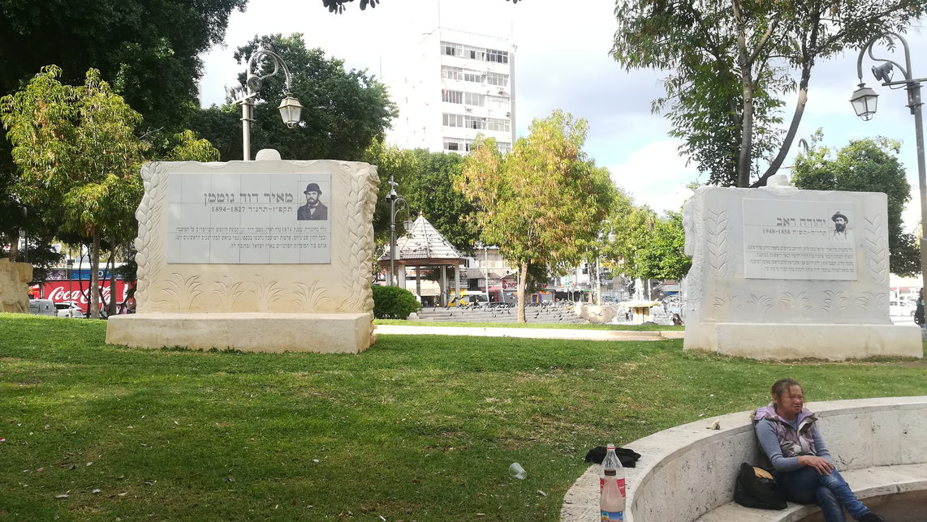
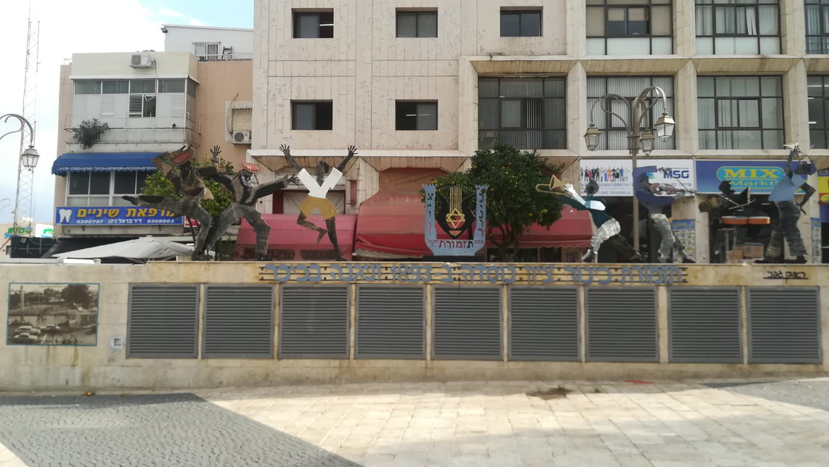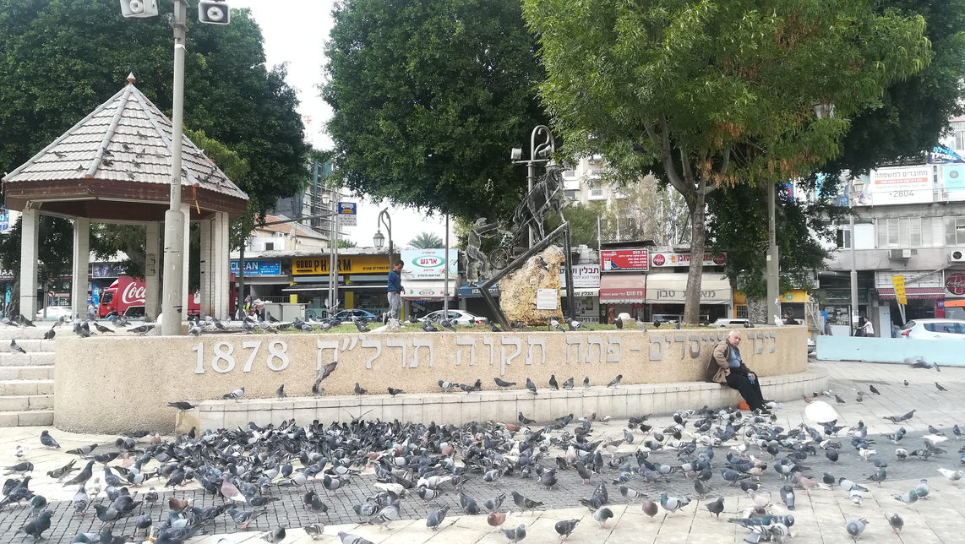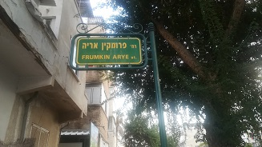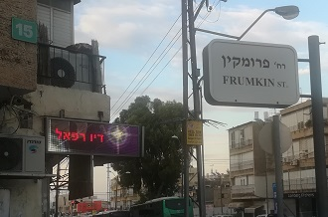

Only in Israel  As you walk out of the facilities at the office of the Ministry of the Interior, a poster displays for you the appropriate blessing for coming out of the toilet: "Blessed are You, Adonai, our God, King of the universe, Who formed man with wisdom and created within him many openings and many hollow spaces. It is obvious and known before Your Seat of Honour that if even one of them would be opened, or if even one of them would be sealed, it would be impossible to survive and to stand before You even for one hour. Blessed are You, Adonai, Who heals all flesh and acts wondrously." | 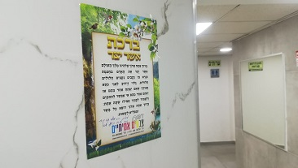

07-11-18
Thanks to my brother Alan, I attended the Balfour Annual Dinner, commemorating 101 years since the signing of the Balfour Declaration and 70 years since the founding of the State of Israel. The main speakers were Natan Sharansky, who spent nine years in the Gulag before being freed to emigrate to Israel, where he has made a major impact in political life; and Roderick Balfour, great-great-nephew of Arthur James Balfour, who wrote the Declaration. Roderick Balfour spoke very movingly, and could not prevent his own tears from falling as he told of the final meeting between Chaim Weitzman and his great-great-uncle.

Alan also took the opportunity to pass onto me a suitcase he had brought containing some of my possessions from London. My living room is now enhanced with the Daniel Sacks Award Shields, my discus painted by four times Olympic gold medallist Al Oerter, and my Rolls Royce Silver Cloud.

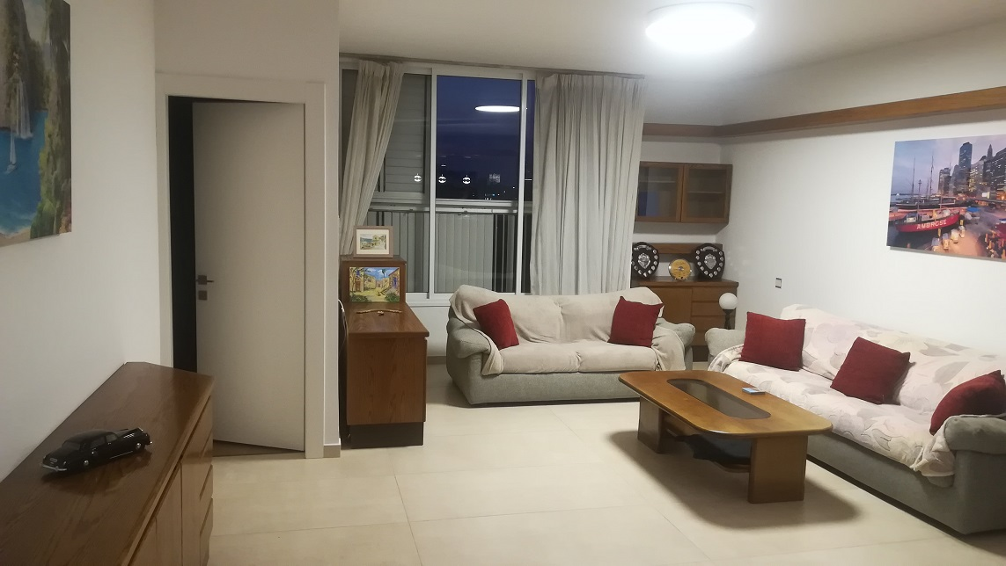
09-11-18
To pick up on the questions that occurred to me on November 5 ("Is it that they believe that the House of Lords is a den of money launderers? Or is it more personal than that?"):
On October 31 I initiated a transfer of funds from my UK bank to my Israeli bank, to meet an apartment rental payment due in November. The following day, Transferwise, the company I was using for currency conversion and transfer, notified me that my documents had been accepted, my cash had been received, and the funds would be in my Israeli bank account on November 5. But when I checked on November 5, the funds had not been converted or transferred. I chased up the reason, and received this email:
Dear Brain,
Hope you are well!
In order to comply with the financial industry regulations we need to ask additional information from you. Due to your relation to Jonathan Henry Sacks, Member of the House of Lords, we’re required to collect your source of wealth and the reason for your transfers.
Please reply back to my email with the following:
1) What is your source of wealth – i.e salary; sale of investments, property, company; inheritance etc
2) General transfer purpose – short description explaining how you will use TransferWise i.e.
- Who will your recipients or the senders of transfers to you be and what will be the reason for payments?
- What are the amounts you are looking to send and receive and what will be the main currency routes?
Thank you for your help with this. If no response in 2 working days, we will cancel and refund any amount we have received from you.
Best wishes,
Wairimu
TransferWise
The happy ending to this story is that finally, on November 9, I am told that the money has been transferred, to be in my Israeli account on November 12. Having made a trip to my bank branch a fortnight ago with evidence that the money has been legitimately earned, reported and taxed, I can only hope that I won't face further problems on the Israeli side next week.

While on the subject of legitimate earnings, reporting and taxing, I will make mention of a BBC Radio 4 programme that I listened to last week, which exposed benefit fraud in parts of the Stamford Hill Haredi (that is, Ultra Orthodox Jewish) Community.
The programme absolutely cut me. I really admire my niece-by-marriage Eve Sacks’ fortitude in fighting the good fight against all that is wrong in the Haredi community, and in fighting to help people escape. Heaven forbid that anyone would associate me or any of my family with the practices of the Haredi community (or parts thereof) as alleged in the programme. Those practices cause anti-semitism and also let anti-semites off the hook, because any left-wing politician can shout "Israel is an apartheid state that has no right to exist" and then say "Of course I'm not an anti-Semite, I fight for the rights of the Stamford Hill Community".
I posted this on Facebook:
Now the Haredi community has made me so uncomfortable that I feel I have to lose all dignity and shout this out: For the record, both my parents earned the Defence Medal for their National Service during World War II, and they taught us above all to be honest citizens.
I am totally opposed to the beliefs and practices of the Haredi community.
10-11-18
As life settles down into more of a routine, what can I say about this Israeli weekend, Friday and Shabbat? Just that it is a joy to spend Friday evening with Jessica, David, Tzviya and Amit; and invigorating to spend an hour at the outdoor gym on Saturday evening, working out under floodlight with the ultra orthodox, keeping in time with the beat of the music pounding into my ears.
11-11-18
I have ordered an oil-filled heater, to keep me warm and virus-free at night. It has cost more than twice the equivalent price in the UK. Food and manufactured goods are expensive in Israel, not helped by the relative weakness of the pound. But there are financial swings and roundabouts in play. My phone contract costs 30 shekels a month, just over six pounds, and includes 50 GB of data. Using my phone as a Wi-Fi hotspot means that I have no need for any additional internet service. Also, up to this point, the solar boiler has provided all my hot water. But approaching winter means that this cannot continue, and a workman is coming on Tuesday to repair the electric boiler timer clock.
13-11-18
460 rockets and mortar shells have fallen in southern Israel in 25 hours – by far the heaviest ever bombardment by Hamas. I saw a video of a continuous minute of this onslaught and it resembled a New Year firework display, one rocket straight after another, with the regular boom of the interception by the Iron Dome missile defence system. Yet, if I hadn't been in touch with the news, I would not have known anything about it. Life continues undisturbed here in central Israel, for now. But it does jolt me into a keener awareness that I should ask about the safe shelter in this building.
Facebook is of course full of argument about it all. But it is upsetting that there is such acrimony in threads even where all the contributors are on the same side.

In learning Hebrew, one difficulty I have been encountering is a consequence of written Modern Hebrew not including vowels. It means that many words and verb forms which are uniquely specified when written with vowels in Classical Hebrew, become ambiguous and by no means unique when the vowels are removed. Modern Hebrew compensates for this by tossing in extra "filler" letters. The equivalent in English would be to toss in ‘tt’ instead of ‘t’ and ‘ll’ instead of ‘l’. This rubs up against my sense of Classical Hebrew purity, but I need to swallow this sentiment and recognise that if I don't go with the Modern Hebrew flow, then people will simply think that I can't spell. Of course, a rather more major problem is that – and Mrs Google told me this – it takes a knowledge of 10,000 words to be proficient in any language; and I find trying to fix words in my brain at this age is like trying to play darts on a dartboard made of solid steel.
A third difficulty occurred to me just today, as I finished a three-hour stint of babysitting (Tzviya and Amit were delightful, they made it very easy). I was relieved in my duties by Efrat, who speaks only in Hebrew. Tzviya started jabbering away to her in Hebrew even though Jessica and David only speak English at home. So Tzviya has picked up Hebrew really quickly just from playgroup. As she was speaking I recognised that children learn to speak in simple, short, direct sentences. By contrast, I think in long, convoluted sentences, which I try to translate, and fail. So, for example, I could write the preceding 270 words. Tzviya would simply say, "You are not good at speaking Hebrew". And she would have hit the nail on the head.
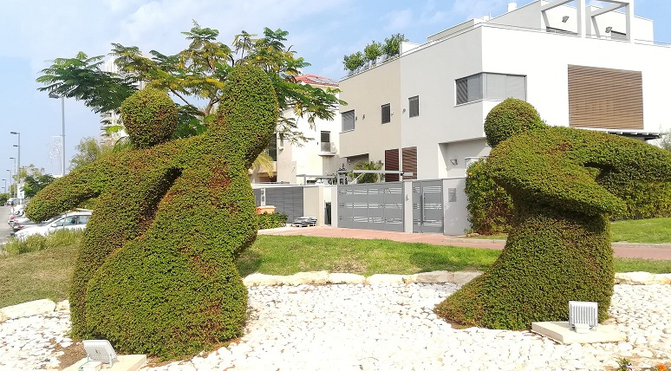
On the walk back from Amit’s playgroup: the topiary still looking good in mid-November....
.. while directly across the road, most of land between David and Jessica's flat and my flat is being built upon; the nearside to become apartments, while all the land across the road is part of the Bar Ilan campus.

14-11-18
I woke up with a day's plan of a dual-purpose trip to Petach Tikva: combining a visit to the Ministry of Absorption with a trip to collect my suitcase which had been damaged in flight and had now been repaired courtesy of El Al. Those two aims quickly became three because I was rung up by the Ministry of the Interior and was asked to come to their office as there was a problem with my passport application. Conveniently, the two government offices were close to each other, in the Shuk Ironi area, a sort of grubby and downmarket Petticoat Lane combined with massive food market.
I have remarked previously that my Health Clinic offered its "Know your Rights" leaflet in three languages: Hebrew, French and Russian. The Ministry of Absorption went one better, offering its annual calendar in Hebrew, French, Russian and Amharic. But again, as confirmed by my enquiry with the reception, there was no English version.  It might be better to gloss over the fine details of my visit to the Ministry of the Interior and simply say that next time, I would be better advised to have more sleep the night before. Once I finally secured a numbered place in the queue, I was helpfully handed a slip of paper which, when translated, said that the average wait time was two hours. So I made my trip to reclaim my suitcase and returned to await my number coming up. | 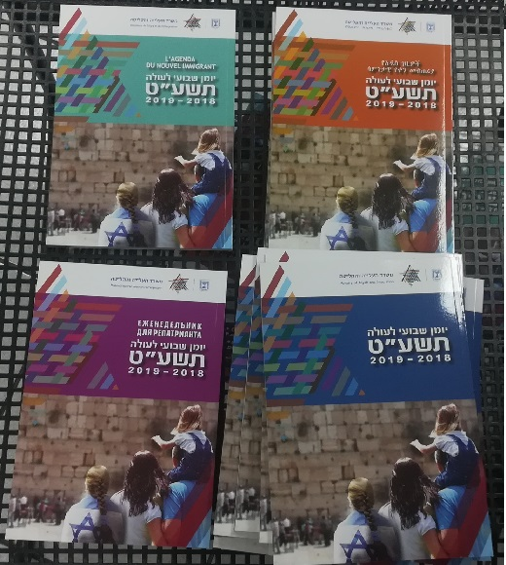
 | No English here
The problem with my passport application was, it seems, my fingerprints. The images that they had taken when I applied for the passport last week were unsatisfactory. This time, all six fingerprints (the two main fingers plus thumb on each hand) were taken several times, and then two people pored over the images for considerable time before I was told "that's it".

One of the items on my Shuk Ironi shopping list was an apron. I found it in the “One shekel” shop - a campaign goodie from a municipal presidential election in Central Mexico!

18-11-18
I spent the weekend in Jerusalem, taking up a long-standing invitation by my younger brothers Alan and Eliot. On this occasion, I enjoyed the excellent hospitality of Judith and Alan.
As I travelled into Jerusalem on Thursday evening, the results of the city mayoral election were just in. It was an extremely close contest. From the point of view of an intelligent and moderate voter, the wrong candidate won. Alan told me that he had been in a two-hour meeting with the new mayor, and came out with the assessment that he had no coherent vision for Jerusalem as a city for all its inhabitants. I reflected that if even a very small proportion of the residents of East Jerusalem had voted, rather than boycotting the election, they could have secured a victory for a candidate who would be rather more concerned about improving conditions in their part of the city.
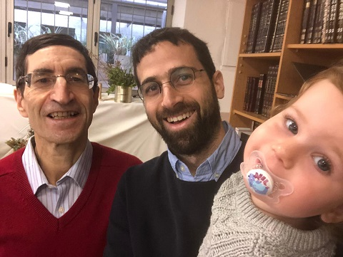 | On Friday morning I joined family and friends in celebrating the birth and naming of Tehilla’s and Dan’s daughter Matar. Matar is now the eighth grandchild of Dan's parents Judith and Alan. Matar means rain, which is considered a blessing in Israel, especially in the Negev Desert that constitutes 50% of the land mass. Rain does not often conjure up the same feelings of hope in England!
Brian, Dan and Matar’s older sister Ori
Friday was another troubling day politically. After Avigdor Lieberman's resignation as Defence Minister on Wednesday, the Jewish Home party left the government, leaving it with a precarious majority of 1. The mass desertions from the government were in protest against Benjamin Netanyahu's acceptance of a ceasefire agreement with Hamas. Netanyahu stated that his decision was on the basis of knowledge that he could not share with the public; it is presumed that this was that Iran would transform the conflict into one in which Israel confronted both Hamas, with its 20,000 rockets, in the South, and Hezbollah, with its 120,000 missiles, in the North. Both of these terrorist organisations are controlled by Iran: Hamas in Gaza and Hezbollah in Lebanon and Syria. Meanwhile, the day’s headline is shown in the screenprint alongside. And in other news on Friday: the United Nations passed nine resolutions targetting Israel, and none targetting any other country. | 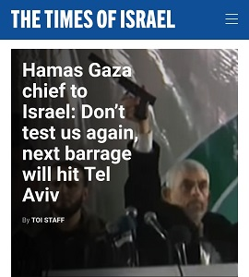

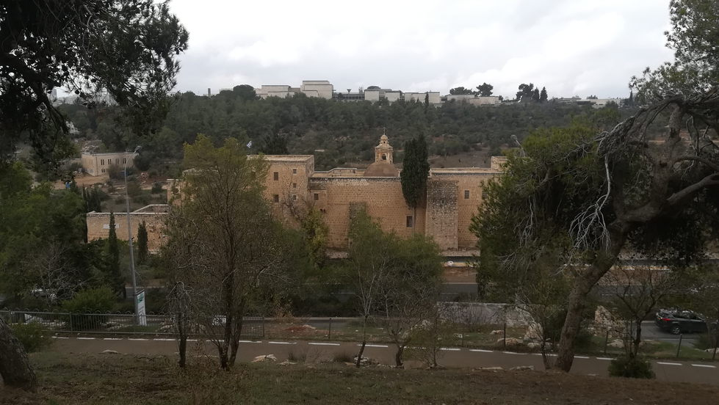
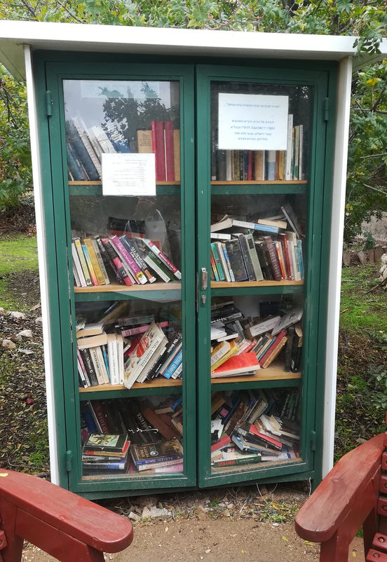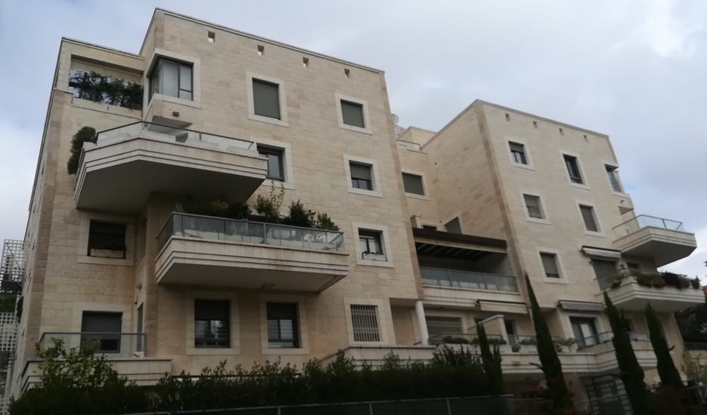
A walk around Jerusalem on a cool and damp Friday morning: All buildings in Jerusalem are, by law, covered in Jerusalem Stone. "Bring and Take" communal book cupboards are common throughout Israel.

21-11-18
Having virtually not slept at all, I decided to utilise my state of wakefulness at 8 AM by taking myself to the Health Clinic for another blood test to see whether I am still anaemic. Walking through the Bar Ilan campus under hazy blue skies and with no one else around, I was struck again by its beauty.
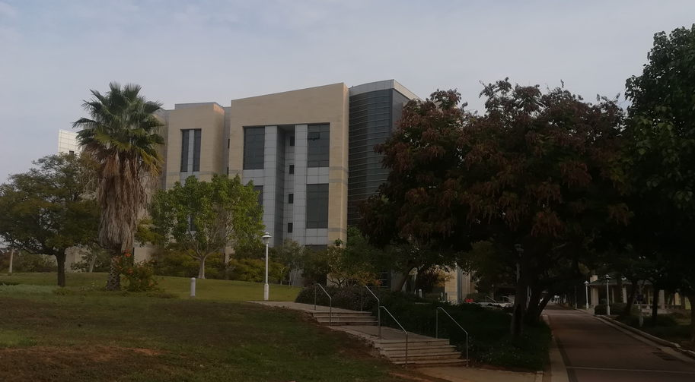

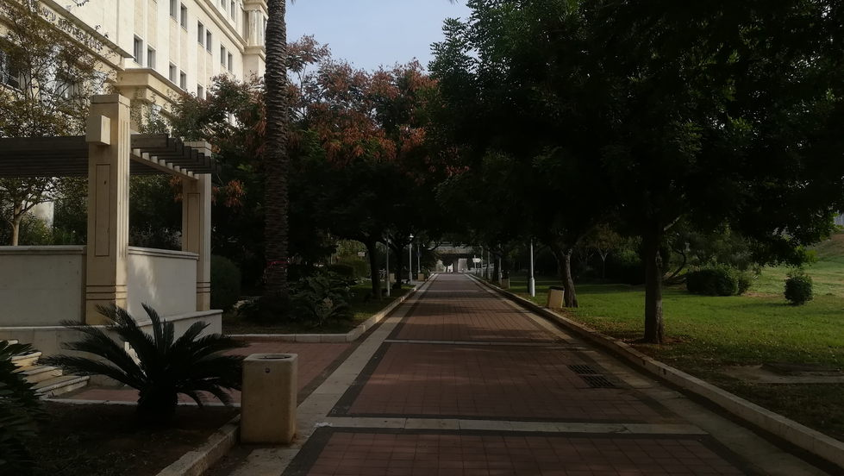

At the Health Clinic, again, two identical stands each urged their customers to know their rights – so long as they are Hebrew, French or Russian speakers. | 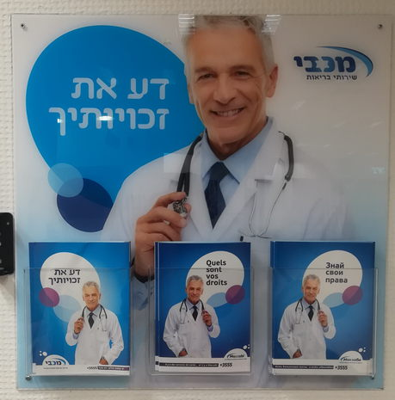
 | No English here – again

I returned to the flat to find that there was no working electricity at all. Luckily, the landlady sorted for an electrician to come fairly promptly. He has diagnosed a faulty box that controls the electricity supply to the flat, and he's going to get hold of a replacement. The problem seemingly also involves faulty connections and problems in the supply by the electricity company. But as the electrician just speaks Hebrew, I can only nod, partly pretend that I understand, and partly admit that I don't. It's a bit like being back in a maths supervision at Cambridge (a.k.a tutorial anywhere else).
Now reporting minute by minute in real-time: partly assisted by Google translate on my phone, he has told me that he has replaced the faulty box, and is returning to working just a few doors away in the same road; the electricity company should restore the electricity in a couple of hours, and he will look in after that, also checking on a light fitting which independently had been giving me an awful lot of trouble. Or as Lyn has been telling her friends, "Brian is living in the house that Jack built!"

As the electrician had stated, the electricity did come back on in a couple of hours, and he returned to fix the dodgy light fitting. On a less upbeat note, a couple of hours after that, I negotiated the Health Provider website for my blood test results, and my anaemia is no better.

Now that a diagnosis of anaemia has been confirmed, I can no longer escape confronting a test pack that I was given three months ago. On opening the envelope, I see that, this time, the instruction leaflet is printed in Hebrew, Arabic and Russian. Being of a somewhat squeamish disposition, I did not really enjoy making sense of the instructions. | 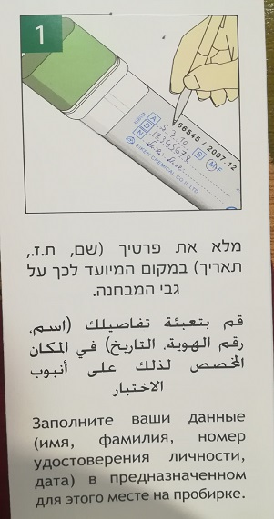

This diary keeps me cheerful. I am no Phil Collins or Woody Allen; I can't turn a disappointment into a song or a movie. But at least it will give me something to write about!
22-11-18
Tel Aviv is a very young, vibrant and crowded city. Its streets are full of young people zooming around on bicycles (both pedal-powered and electric) and motorised stand-up scooters. But very few of those vehicles are on the road; almost all of them are on the pavements. I have always felt that it is only a matter of time until someone rides into me. Several times a day somebody will speed by on the pavement within inches of me. But today I had possibly my nearest miss, or at least the one that startled me the most. As I stepped off the bus in Tel Aviv to attend my Ulpan language course, a cyclist stormed by, overtaking the bus on the inside.
As I say, Tel Aviv is a young city. But also a city that has its dangers for the not-so-young.

23-11-18
Lightning_over_Tel_Aviv_early_morning_23-11-18
23-11-18
If one spent any time listening to Israeli radio this week one would be struck by two things:
- there is no "a"-as-in-"cat" sound in Hebrew
- how bizarre it is that advertisers think that there is something persuasive in a voice that sounds as if it belongs to a crazed lunatic dosed up on amphetamines.
And you would certainly know that today is Blek Friday!

25-11-18
Another walk to the Health Centre in Old Givat Shmuel, again enjoying the early morning beauty of the Bar Ilan campus under blue skies. The roundabout separating the Clinic from the Town Hall a few yards away has this rather pleasing statue in its centre. | 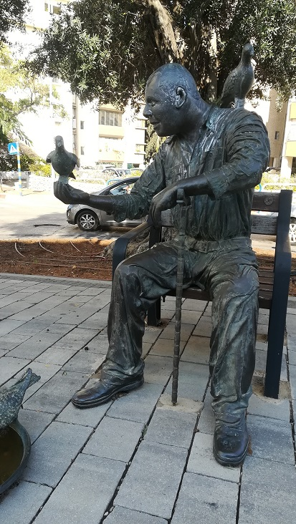

The buses of Tel Aviv are self-evidently several decades old, with corresponding deficiencies in suspension and smoothness of ride. And their drivers seem habitually to be acting out a fantasy of racing in Formula 1. Also, my route home from language class seems to diverge particularly sharply from uniform motion in a straight line. Having suffered from a queasy stomach all day, I was more than usually sensitive to the excesses of three-dimensional relative motion I experience on that ride: being tossed up and down as the bus charges over ramps occasioned by the constantly-changing building work going on; lunging forward and back as the driver stamps his foot on the accelerator or brake; and being thrown centrifugally as he races around a corner.
27-11-18
I enjoyed a splendid afternoon with Tzviya and Amit: picnic lunch and much playing in the park, and a bag of Bamba. A friend saw us and enthused, "Bamba, that's the best Israeli invention. It's the reason why no Israeli children have peanut allergies." And yes, a Google search of "Bamba peanut allergy" shows the fair degree of truth lying behind that claim. The snack is 50% peanuts, and almost all Israeli children eat it from as soon as they can take solid food. In other words, Israel has gone completely against Western thinking on peanuts, and the result is that peanut allergy is almost unheard of in Israel. Bamba might even find a useful place in my diet: plenty of protein, vitamins and iron.
In the evening I went to a showing of the award-winning cult film "Zero Motivation", which was followed by a Q&A with one of its stars, Nelly Tagar. It was a very enjoyable event, taking place in a new-to-me Tel Aviv language school. But as I looked around the audience of a hundred or so, I realised that again I was more than twice the age of almost every person there.

28-11-18
Taking advantage of both insomnia and a favourable weather forecast, I decided to enjoy a day of sunshine at Bograshov beach in Tel Aviv prior to doing a bit of walking and shopping at sunset.
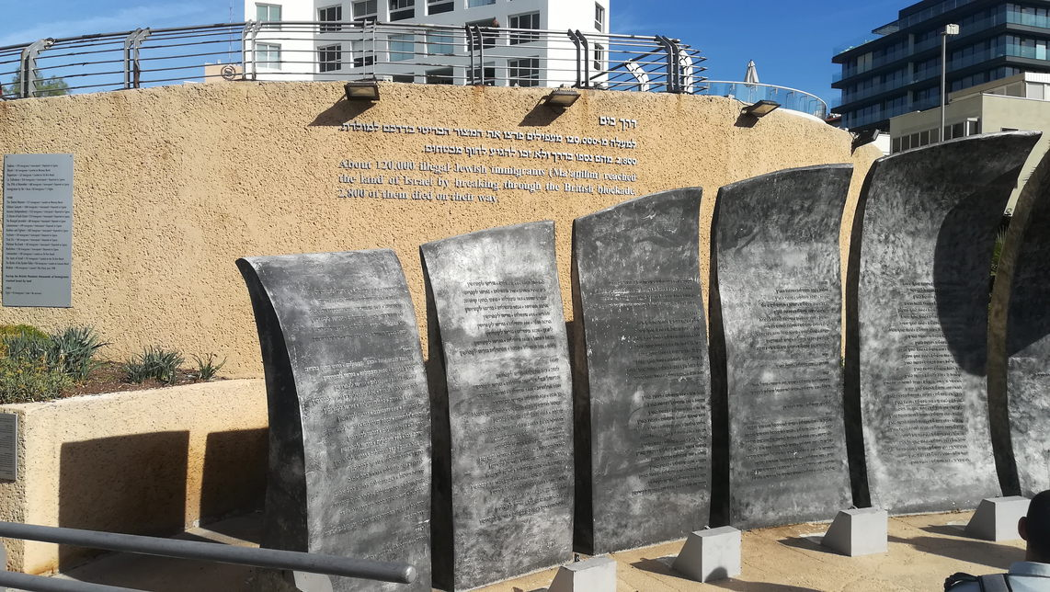
At the top of the beach is this poignant memorial. The inscription reads: About 120,000 illegal Jewish immigrants reached the land of Israel by breaking through the British blockade. 2800 of them died on their way.
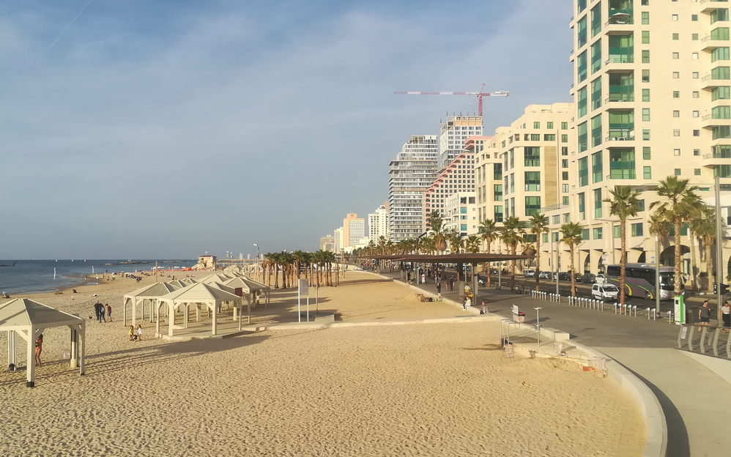
Looking northwards along Tel Aviv beach and promenade
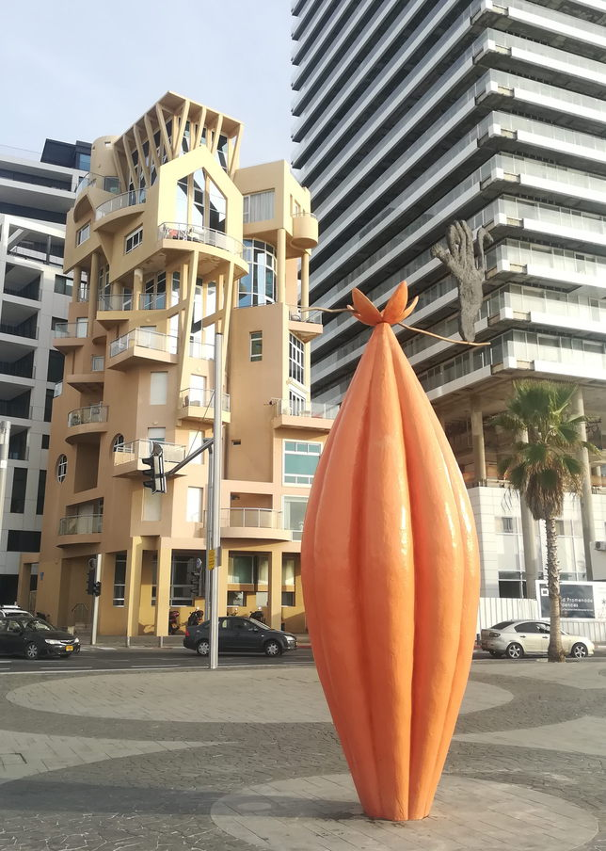
A zany mix of styles on the promenade and seafront road
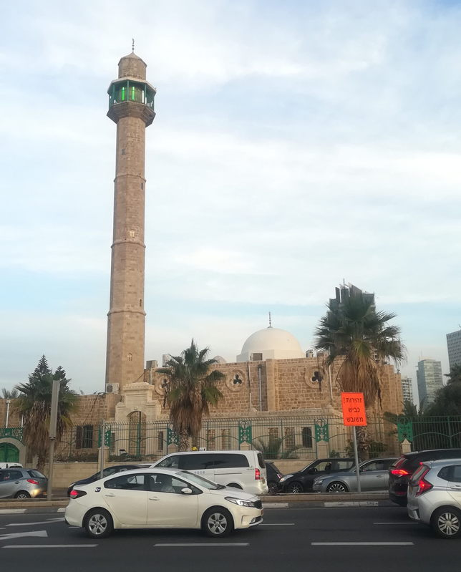
The Hassan Bek Mosque, surrounded by traffic, close to the boundary between Tel Aviv and Jaffa. The Mosque was built in 1916, and in the 1980s it was substantially enlarged and the minaret was rebuilt at twice its original height. Its architecture presents a sharp contrast from the high-rise hotels nearby.

02-12-18
The start of December represents two milestones in this new stage of my life: four months in Israel and three months in my rented flat. Also, after 20 sessions at Level 4 on our Hebrew course, we have moved onto Level 5.  Tonight was the first night of Chanukah, the Festival of Light, and for the first time I lit the candles with Jessica, David, Tzviya and Amit. Facebook has also reminded me of a topical post from eight years ago, in which I wrote of a debt that Judaism owes to yet another ruler of an empire (see my earlier post of November 3) | 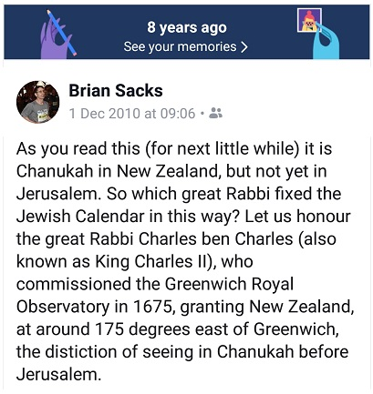
On a different note: If I were an athletics coach in Israel, I would make use of everyday experiences here to illustrate points in racing tactics:
To not ease up until you have crossed the finishing line: Just as if you were running for a bus where, no matter that the driver is aware that you are sprinting wildly, no matter that you are just one metre short of the door, he will not wait a split-second before driving off
To always visualise the race as continuing for twenty metres past the finish: Just as if you were on one of the buses that doesn't have a "stop" button; in which the bus will certainly sail past your stop until you and your fellow passengers have yelled loudly and continuously enough to rouse him from his reverie.

03-12-18
Back to Kiryat Ono, where I started in August, for a doctor’s appointment in the Maccabi clinic in the Mall. As in Givat Shmuel, this clinic also runs a Rights Lottery. Today's winners, now entitled to know their Rights at Maccabi Healthcare are: speakers of Russian and Amharic!  To me it is reminiscent of the Eurovision Song Contest, and Grand Bretagne's habitual 'nul points'.  Meanwhile, across the road, Maccabi have their own pharmacy, equally hospitable to non-Hebrew speakers. On entry one has to make a selection for a place in one's appropriate queue – see alongside. The top button translates as "Regular queue". The bottom button could mean "To the queue without orthopaedic prescription" or it could mean "Do not queue without orthopaedic prescription"; the Hebrew word "אל" can mean "to" or "do not", depending on its vowel. And the vowel is not shown.  Leaving that minor detail aside, the newcomer is left to wonder whether there is perhaps an orthopaedic practice attached to the pharmacy, or whether "orthopaedic prescription" is synonymous with "doctor's prescription" in Israel. | 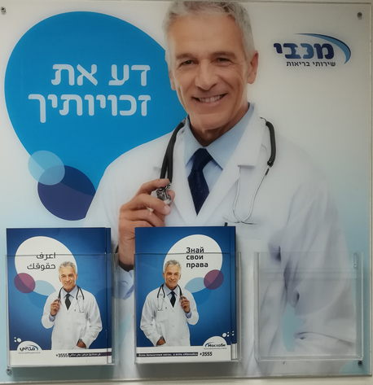
 | 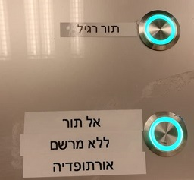

Anyway, one thing I learned during the course of the day was that one of the most useful sentences you can learn in Hebrew is something along the lines of the following:
רק כי כשהתחלתי לדבר בעברית לא הצלחתי להבין את הטלטלה של הפיצוץ בעברית בתגובה אלי לא אומר שאתה יכול לפעול כאילו אני פגום נפשית
It means: "Just because when I started to speak in Hebrew I couldn't understand the torrent of Hebrew blasted back at me in response doesn't mean that you can act as if I'm mentally defective".
And counterbalancing all of the above, my family doctor is probably the best that I have ever had, with excellent people skills, even for people such as myself. Well worth the trip to Kiryat Ono Mall.
And in the Mall, Chabad were lighting Chanukah candles and handing out doughnuts! It was almost enough to make me become a believer in their Messiah (see entry of November 3).
At the Ulpan - the Hebrew Language class - we finished the session with a "pick a card and answer the question in Hebrew" game on the theme of Chanukah. The traditional children's game for the festival is the dreidel, the spinning top of the Don McLean song:
https://www.youtube.com/watch?v=N8wWsncWFSg
One of my fellow students picked a card on the theme of the dreidel, and her question was "Talk about something you have done, or will do, that has spun your life around". Her answer was simply moving from Slovakia to Israel last year.
Two generations back, most of her family had been killed in the Holocaust. She grew up being told to always keep it a secret that she was Jewish. To not let anyone know of her involvement in Jewish communal life. That when she was asked why she was wearing her best clothes, she should answer "I am going to church" or "I am going to the theatre". As she grew she decided that when she was an adult she would not live this way.
That is why last year she left behind all her family and friends to move to a country where she knew no one. And her reason for moving was not economic, not religious, not Zionistic. It was simply that she was not prepared to live a double life any more.
06-12-18
Yesterday was a frustrating day. I waited in for the delivery of a radiator: "It will come between 2 PM and 6 PM. You will be rung by the driver half an hour before he arrives." Well, no phone call, no delivery. Having worked my way through an automated customer support line that Kafka would have been proud to have designed, the automated message at the end of it was: "Our support agents are available between 8 AM and 6 PM. Goodbye!" - all of the preceding in Hebrew of course. So I turned to the online system and left two detailed messages. Each resulted in an immediate text message providing a link to my online status. Sure enough, my online status was "delivered".
So this morning I chased it up again via the Kafka-esque Customer Service line. I was eventually told that it will be delivered today. A further phone call linked me to the relevant branch manager, who told me, "We had a problem with the truck yesterday."
Anyway, after every Shabbat or festival meal, observant Jews sing Psalm 126, which has the line, "Turn things around for us, Lord, like flash floods in the desert!" Well, sure enough, there are flash floods in the streets outside my window today, with accompanying thunder, lightning and a monsoon downpour – and I have a new radiator!
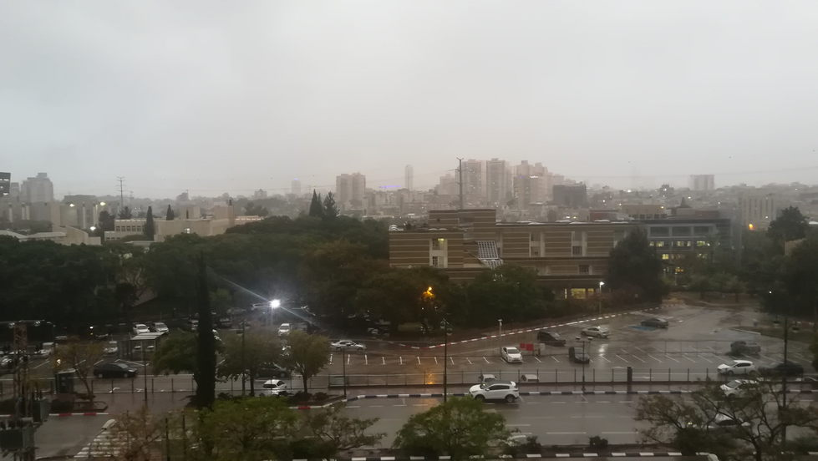
The view out of my window today towards Tel Aviv
08-12-18
35mm of rain yesterday made it a perfect day for staying in and working on the ninth annual Daniel Sacks Awards. With the downpour reduced to a mere 10mm today, I was able to go for my usual Saturday evening workout, having a newly and naturally washed outdoor gym completely to myself.
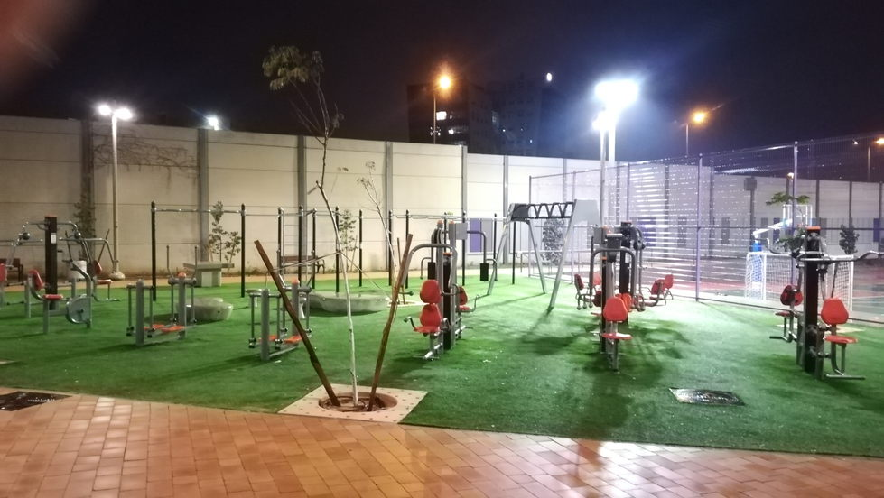
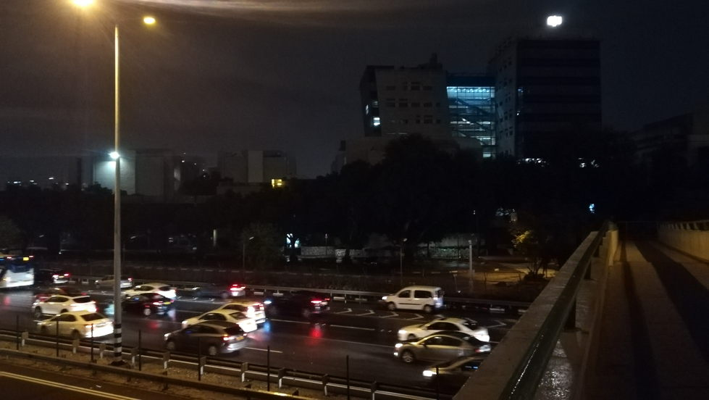
A giant Chanukah candelabra atop a faculty building casts its light over Tel Aviv-bound traffic passing under Bar Ilan Bridge

09-12-18
Living in the suburbs in Givat Shmuel rather than in the big city of Tel Aviv, I am lucky that, to walk anywhere involving crossing a road, I generally do not have to suffer extended waits at junctions for the green light for pedestrians. However, it does mean that on my walks I am crossing the Israeli equivalent of zebra crossings at frequent intervals. It has often seemed to me that my presence on a crossing has an effect on oncoming motorists akin to that of a red rag to a bull, or a dangling hand to a shoal of piranha. But it occurred to me today that the difference between England and Israel in this matter is not just one of driver attitude (or, perhaps, how he gets his kicks). In England there are flashing beacons at a zebra crossing to alert the motorist ahead of time, and, perhaps, to make the subliminal suggestion that the authorities would prefer him not to mow down a pedestrian at that point. In Israel, there is no similar warning to the motorist, and I infer that the message to the pedestrian is "Are you feeling lucky today?"
Update after further observation: In many, but by no means all, instances, there are road signs warning motorists of a pedestrian crossing ahead. There are no flashing, or otherwise lit, beacons, nor traffic lights to control a crossing that isn't part of a junction already controlled by lights.
10-12-18
Yesterday in language class we were asked to write about someone who had especially influenced us in life. It set me thinking. I recognised that some of the people who have had the greatest influence in my life have, by virtue of their exhortations and the example they set, induced me to move in precisely the opposite direction to the one that they intended. Also, some of the incidents that have had the most influence on my life were instances of pressure or fear of failure. Pressure to deliver a lesson of a Jewish nature led me, twenty years ago, to obtain and work through a lecture on the British Mandate in Palestine, and that led me to a much deeper and more passionate appreciation of Zionism. The best piece of work that I ever did in my professional career was a direct result of overhearing someone saying "They are setting Brian up as the project scapegoat".
But moving on to positive influences: When I was about 17, my brother said to me, "Before you say something, think whether it is constructive or destructive. If it is constructive, say it. If it is destructive, don't say it." I have tried to stay true to that formula.
When I was young, part of my religious education led me to learn parts of the Five Books of Moses, and I was impressed by verses, written 3000 years ago, such as Deuteronomy 22:8:
When you build a new house, then you shall make a parapet for your roof; that you bring not blood upon your house, if any man should fall from there.
Leviticus 23:22
When you reap the harvest of your land, you shall not wholly reap the corner of your field, neither shall you gather the gleaning of your harvest; you shall leave them for the poor, and for the stranger: I am the Lord your God.

Later in life my religious knowledge became more eclectic, and to quote just two influential verses out of many that I could from the New Testament:
Matthew 7:3
Why do you look at the speck of sawdust in your brother's eye and pay no attention to the plank in your own eye?
Mark 2:27
Jesus said, “The Sabbath was made for man, not man for the Sabbath”.
And I owe a debt of gratitude to the Buddhist monk Ajahn Brahm for teaching me how to let go and forgive.
I have been my own man. There have been, and are, wonderful, good people in my life. I just hope that a little bit of their influence has rubbed off on me.
11-12-18
I spent this afternoon in the park with Tzviya, and took this photograph:
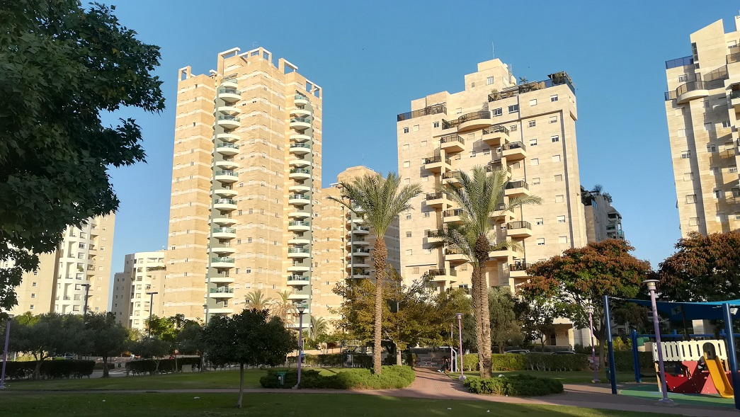
It captures the character of the "new" part of Givat Shmuel: high-rise apartment blocks, ever increasing in number, and a central park with excellent play facilities for young children. The one thing missing from the picture is the modern, pedestrianised shopping mall area, specifically geared towards luring children into emotionally blackmailing their parents into buying.
Jessica wrote this description: "Take Hampstead Garden Suburb. Make it high-rise. Pave over all gardens leaving only ruler-straight flower-beds policed by maintenance companies who are charged with pulling out all flowers before they finish flowering and replacing them with new ones. Then remove all traces of quaint, hippy influence, history and environmental consciousness. Substitute Hebrew for all other languages but French. Right - that's Givat Shmuel".
But, by way of defence, I would point out that Givat Shmuel is catering for a very significant population increase each year, and also that it provides an environment where young children are free to play, unsupervised, unrestricted, and safe.
12-12-18
Another Givat Shmuel – the part that I live in, with Bar Ilan University across the road. I took these two photographs today from the same spot:
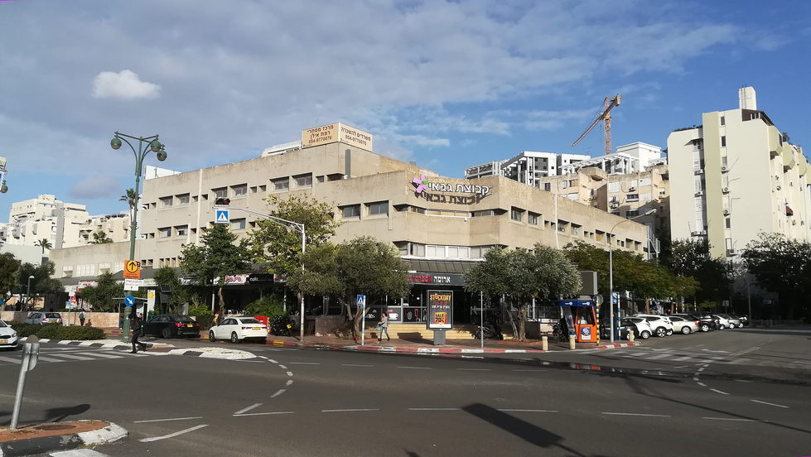
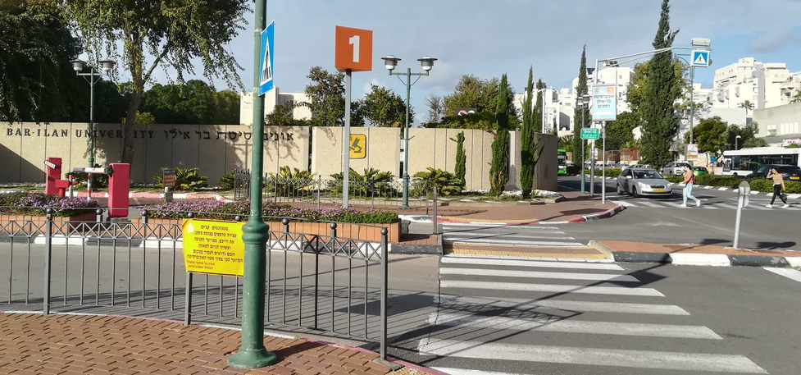
The block that I am living in is one of the ones on the left of the top photo, on the right of the bottom photo. To quote Passenger, "a little bit faded, a little bit jaded". But, for at least the next eight months, home!

I read recently, "You can't be a true Tel Avivian unless you love dogs". That was illustrated for me today by this canine refreshment stand that I saw at the Dizengoff Centre.  Another incident today gave me further warning of the dire consequences of coming between a Tel Avivian and his dog. I was at a bus stop, looking up to check that my desired bus stopped there, and someone shouted at me, "Don't look up, look down! There is a dog here!" Yes, there was a miniscule dog – and there I was, daring to  look up and endanger the life of that defenceless creature. | 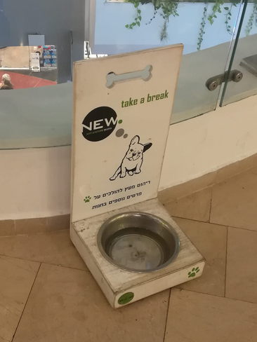

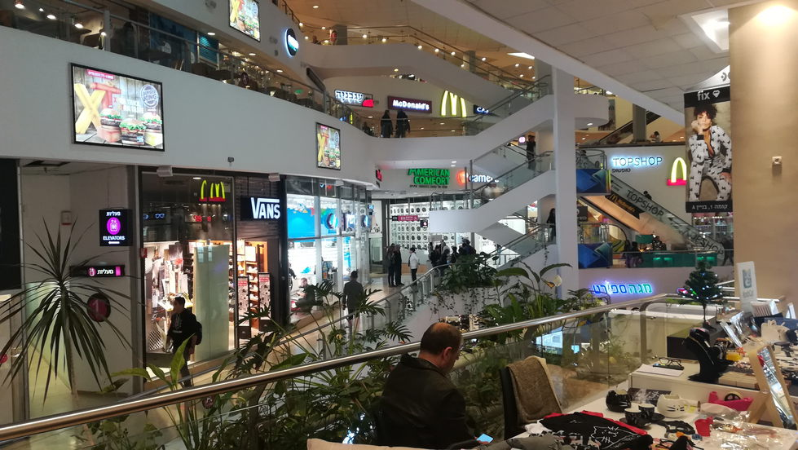

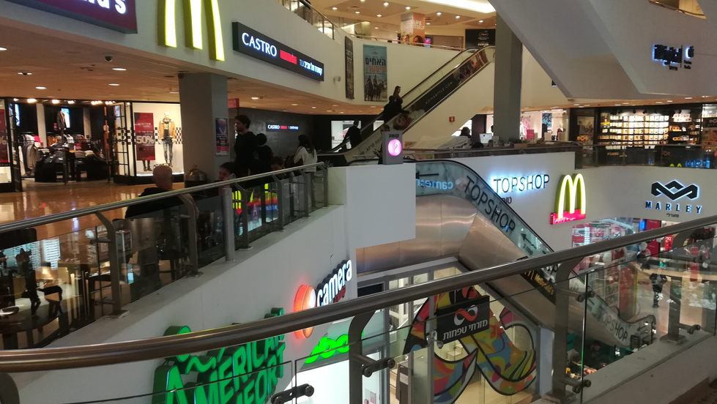

It seems that however often I go to the Dizengoff Centre, it becomes no easier for me to find my way around. I suppose it doesn't help that, at any given time, one’s current floor number is not simply a positive integer, but a real number (possibly irrational) in the range zero to three.

17-12-18
Recently I seem to have been rewarded with fine weather each time a Health Clinic appointment has induced me to be up and out of the flat early in the morning. Today, rather than taking the bus, I walked to the Kiryat Ono clinic, along roads that I had never traversed before. Clear blue skies and relatively traffic-free, tree-lined roads can gladden the heart even ahead of a less-than-sweet morning at the clinic. I should point out that this round of tests speaks of the thoroughness of the Israeli health system rather than of any deterioration in my own personal health.
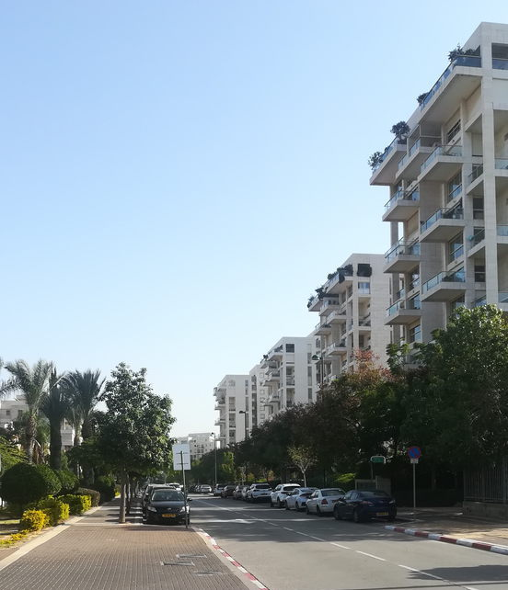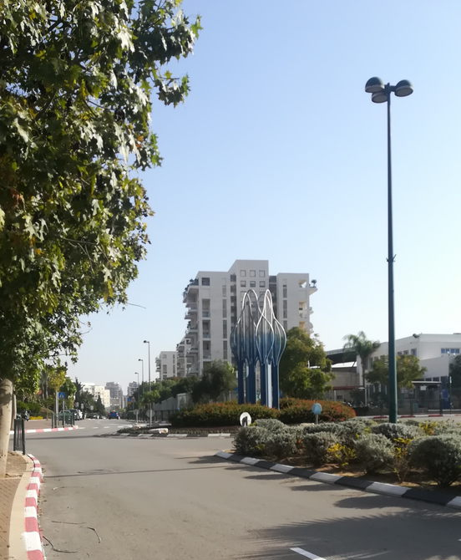
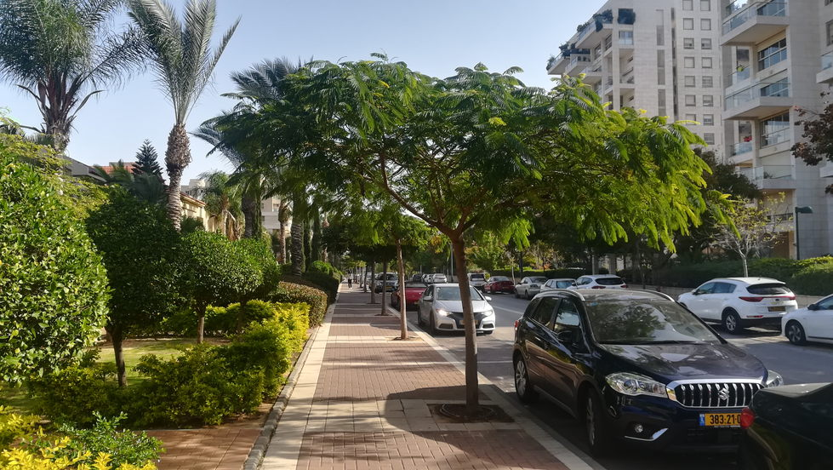
19-12-18
The Joys of Hebrew
The other day I saw the header for my daily "Word of the Day" email and thought to myself "I know this – Tikan - that's a cockroach!" Then I clicked on the message and saw “Tiken” – “he mended”. Both words sounding different from each other but having the same consonants, and so the same written spelling. Or as illustrated by Google Translate:
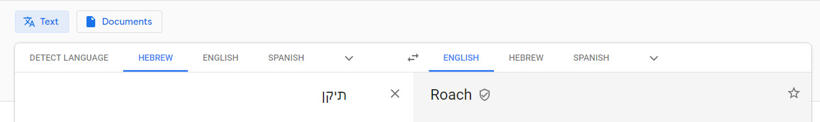
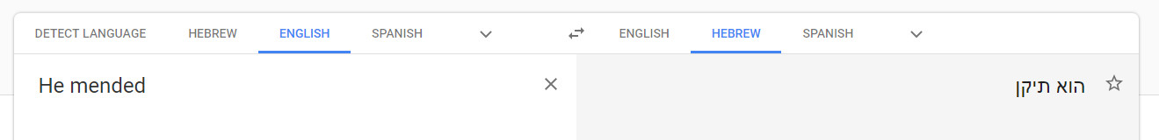
Another example of the consequences of written Hebrew not having vowels is that "I will learn" and "I will teach" are written exactly the same:
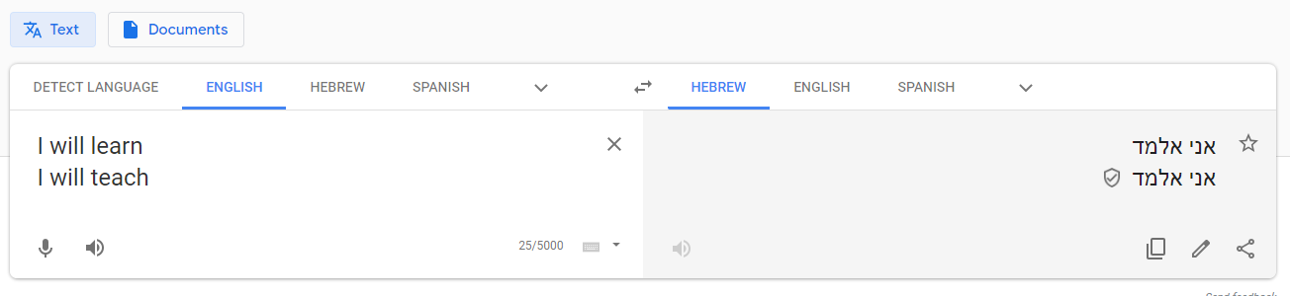
All of this brings home to me how amazing is a young child's brain. Israeli children initially read with vowels included, but from third grade, or age 7 to 8, they are reading without vowels, taking in their stride all the resulting ambiguities. By this time they will have picked up a vocabulary in excess of 10,000 words. Oh to have the brain of a four-year-old!

20-12-18
Persistence, in the form of a letter to the Deputy Medical Director of Maccabi, has paid off, and I now have the English Language version of "Know your Rights". I was somewhat bemused, however, by the notice on the last page, which I invite you to read for yourself.
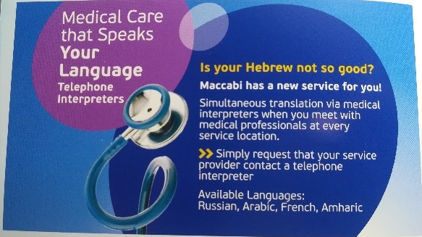

24-12-18
A Christian friend of mine asked me what impact Christmas was making here. So far, I have seen nothing at all.
But Christmas had its impact on me, growing up and today. During my childhood, not necessarily on Christmas Day but within a few days of it, my mother would make a Christmas pudding, full of currants and Golden Syrup. My brothers and I would re-watch "Help" or "Hard Day’s Night" on TV and suffer my father's exhortations to re-watch "Mary Poppins".
Skipping over a little more than half a century to today: From my point of view it is coincidental, but over the last two evenings I have watched two movies from 1941, both with a strongly Christian theme: "Meet John Doe", and "How Green was my Valley". I would recommend both; each can be currently found in good quality on YouTube.
The Christian theme running through "Meet John Doe" was how the world could be transformed if we all made an effort to befriend and watch out for our next door neighbours, and how we might find that that cranky, crusty neighbour was actually a fragile but pleasant person.
"How Green was my Valley" is a story told by a man looking back on his childhood in the late 19th century. It is a portrait of a Welsh mining village community, in which life was essentially transcribed by the family, the church and the coal mine. As a man, you had work, a meagre livelihood, and a reason to get out of bed if you had a job that day at the coal face. And that was dependent on the whims of the mine owner.
Christianity, for better and for worse, was portrayed through the eyes of the village preacher: the hypocrisy of his parishioners, going to church on a Sunday to earn brownie points for the afterlife, and merciless in casting out the "sinner"; and his thoughts on prayer, told to the story narrator in his boyhood: "And by prayer, I don't mean shouting, mumbling, and wallowing like a hog in religious sentiment. Prayer is only another name for good, clean, direct thinking. When you pray, think. Think well what you're saying. Make your thoughts into things that are solid. In that way, your prayer will have strength, and that strength will become a part of you, body, mind, and spirit".
It is sobering for me to think that if I had been born a century earlier, in a valley in Wales, then instead of receiving an education and earning my living through my mental talents such as they are, I might be coughing out my lungs and shortening my life down a coal mine. And across time and across place and across upbringing, human spirit is the same.
In the last few days I watched another video on a not-too-dissimilar theme. Again, it may or may not be coincidence that it was published at this time of year:
http://rabbisacks.org/rabbi-sacks-home-build-together/
One slight adjustment to the opening sentence of this diary entry: as we left this evening, our language teacher wished us "Happy Christmas!"

25-12-18
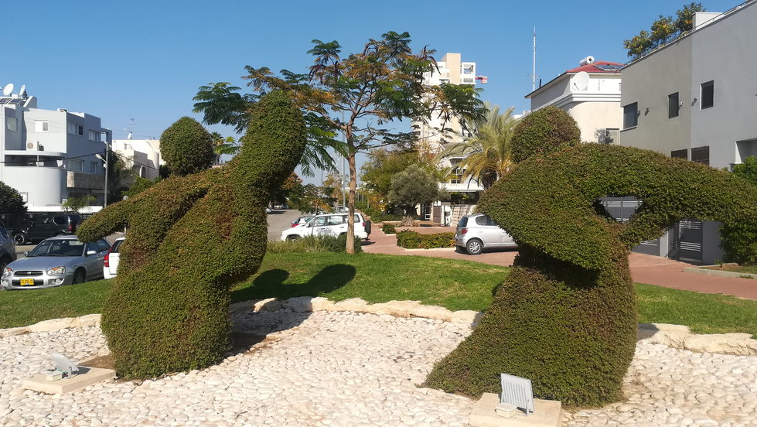
Spending the afternoon with Tzviya, enjoying blue skies and warm sunshine in the park, streets and malls of Givat Shmuel, I did not see a single indication that December 25 was anything other than a normal weekday. But I did collect one gift at the post office today, from the State of Israel itself...
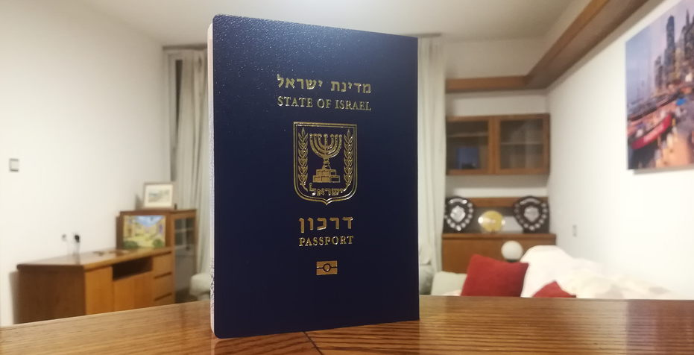

26-12-18
At 10 o'clock this morning a loud siren of alternating pitch began to sound outside. It took me some moments to weigh up the possibilities in my mind. I knew that Israel had carried out a raid on Iranian installations in Syria overnight, angering Russia in the process. So I thought that the siren could well be a warning of an imminent attack. As against that, looking out of the window, I could only see one person in the street, and he did not seem to be exhibiting any signs of panic.
I prepared to leave the flat and seek shelter in the safe room on the ground floor – a room with a huge iron door that I have only ever seen locked with a forbidding padlock. But then the siren ceased, I rang my daughter, and she told me that it was a test that "people in the know" were aware of in advance. That had not included me. There had been no notification in my letter box, I don't have a TV or listen to Israeli radio, and my Hebrew is too weak to actually learn anything from those sources anyway.
I was glad that I was in no way panicked by the event, realising that even if it was a real attack, my chances of coming to grief were significantly smaller than my chances of being run over by an electric scooter on a typical walk on the streets of Tel Aviv. But the event does reinforce an awareness of my need to learn more about the safe room, and to try to obtain a key for its padlock.

Moving on from the risks of Tel Aviv to its rewards, as I walked to a restaurant in Habima Square this evening, I felt that I had to stop and take this photo:
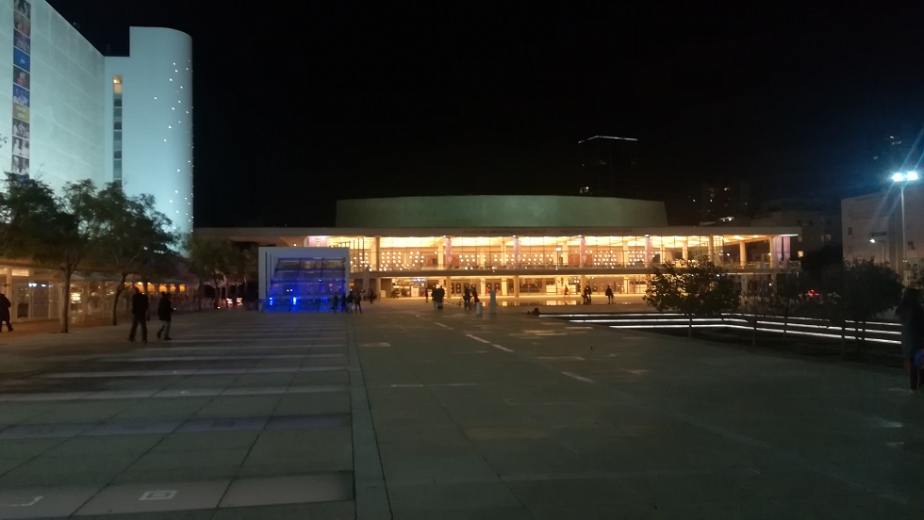

31-12-18
Continuing with the theme of the rewards of Israeli life:
The vista as I stepped off the bus yesterday to attend a wedding in Tel Aviv:
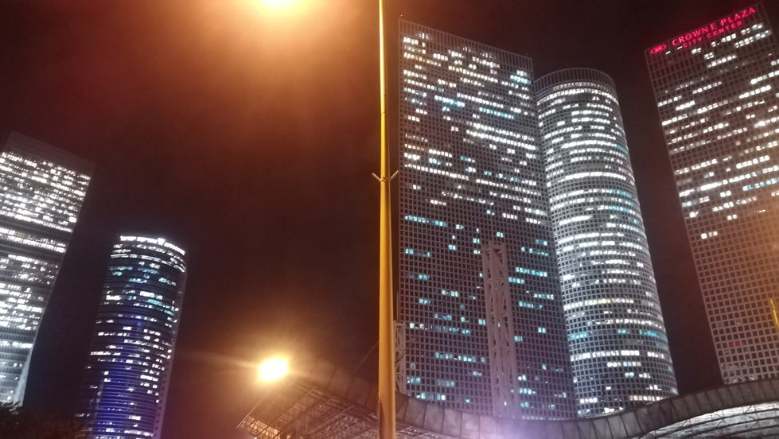
and the walk through Bar Ilan to the Health Centre this morning...  while at the Health Centre, it seems that my letter to the Deputy Medical Director has paid off! |  | 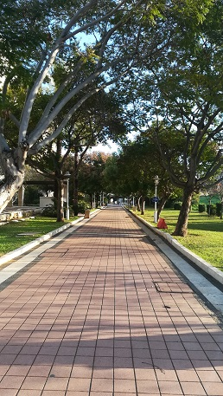
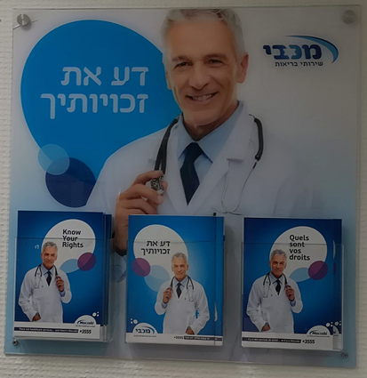
31-12-18
Last day of 2018, and the completion of five months in Israel: a suitable time to take some stock.
Two significant aims in coming to Israel were to become more of a part of my grandchildren's lives, and to put myself in a learning environment, with a specific objective of learning Hebrew. So these five months have been advancing those aims. The Hebrew lessons are sometimes frustrating, such as when the incomplete understanding of a text message results in one attending an appointment on the right day but the wrong month, or visiting the wrong post office to pick up a package. Both of these have happened to me within the last week.
I came here with three suitcases, whose contents have now been augmented by basic purchases of a few plates, a microwave and a vacuum cleaner, and other necessities and niceties as already written about in this diary. I have no car or dishwasher or washing machine, nor even the use of a launderette - I am limited to handing over my washing to the laundry service in the local shopping centre and coming back a day or two later to pick it up. So I am certainly living a more basic, student-like lifestyle in comparison to life in London, but this, of course, is part-and-parcel of the adventure.
I was asked what do I most miss that is available in London and not here. Some of the things that stand out are:
- streets that are not strewn with thrown out washing machines and the cardboard and polythene packaging of replacement washing machines. Dog mess is also fractionally less prevalent on the streets of London
- supermarkets with straight-line aisles more than thirty centimetres wide, and supermarket checkouts that do not involve endless waits due to product codes not scanning, combined with the effects of Murphy's Law
- the cinemas and shows in London, and the ease of obtaining tickets to attend them.
I have not yet integrated into a community at large here. Certainly an objective adviser to a sixty-something-year-old single Englishman would probably suggest that he live in a community such as Netanya or Ra'anana, where, again it is suggested, he might find others of a similar age and background. However, the aforesaid objective adviser probably would not realise what an atypical Englishman he has on his hands in the person of Brian Sacks! All things considered, I am in an excellent location here, less than fifteen minutes’ walk from Jessica, David, Tzviya and Amit, and with excellent transport links to Tel Aviv. I have been maintaining good telephone and written contact with friends in England, and delight in spending half an hour or an hour a day talking to and seeing Lyn on WhatsApp.
Wishing us all a Happy and Successful 2019!

