August to October 2018: www.briansacks.com/Israel_Diary_Aug_to_Oct_2018.docx
November to December 2018: www.briansacks.com/Israel_Diary_Nov_to_Dec_2018.docx
06-01-19
I can see that I will be writing in this diary less frequently this year, as I gradually become more accustomed to Israeli life. But I am sure that there will continue to be happenings that frustrate, delight, surprise and shock.
It took the fierce winds of Storm Norma for it to really register with me that there are orange trees outside of my building. Today the windfalls were plentiful.
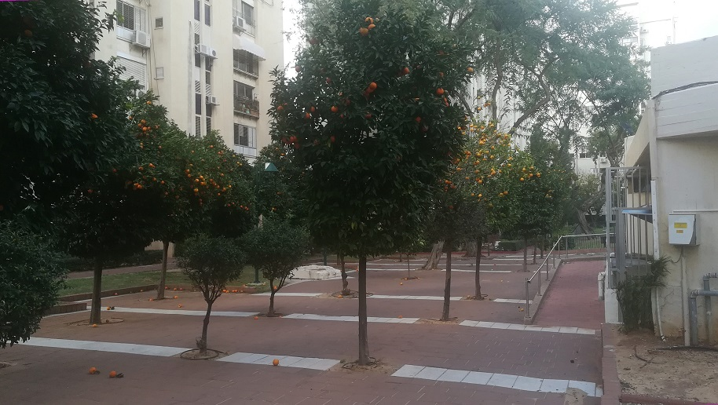

15-01-19
Tel Aviv can be cold, windy and very wet during the winter, but then there are days like today..
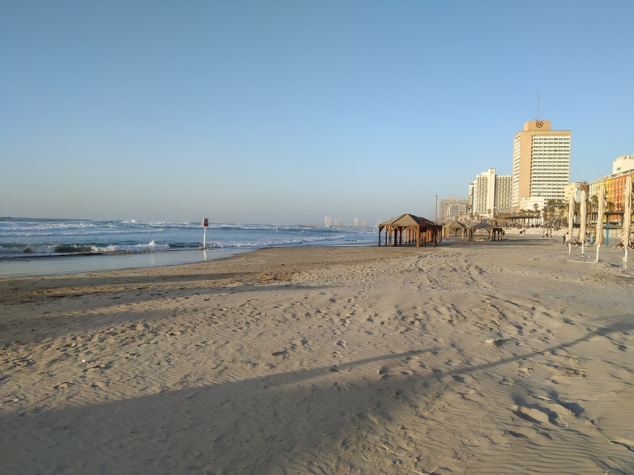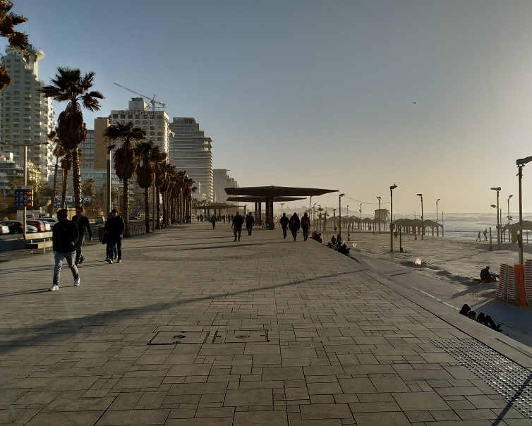

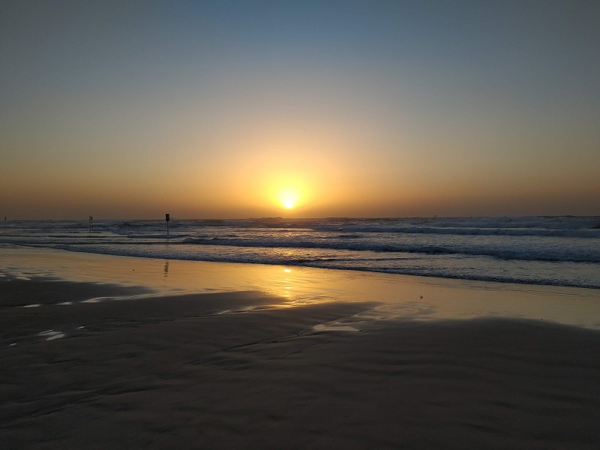
19-01-19
Yesterday, for the first time, I walked to Tel Aviv and back – just under 10 miles altogether. The event at Tel Aviv was a Friday night meal for ‘Olim’ - immigrants. My table comprised three South Americans, two South Africans, a married couple hailing from Greece and Austria respectively, and myself.
Much of the dinner table conversation revolved around the Israeli manner and way of life – non-existence of customer service, directness and lack of politeness, living day-to-day and in debt, and the like. Should we accept it and ‘go native’, or should we try to change it?
One lady explained that she had been taught that in Israel one doesn't signal if one wishes to change lanes while driving. One simply changes lanes, aggressively and without notification other than the blaring of one’s horn. She also told that the back of her car had been driven into while she was stopped at a traffic light, and there was no telling the offending driver that it was not wrong to have stopped at the stop signal.
As for me, in this new year, I do need to become more accepting of the Israeli manner. It is a young country that has been threatened by war for its entire existence. National service is mandatory and gruelling. More than half the Jews in the country originate from Arab or African countries, they or their parents having come as refugees. And this is why my diary entries are becoming less frequent. It is no longer desirable for me, or interesting for anyone else, to relate more instances of poor service at shops or at the bank. It is better instead to go with the flow, learn the language and find pleasure in family, friends, the pleasant climate and the beauty of the country.
01-02-19
I have been in Israel for exactly six months!
Notable happenings in the last few weeks have been: having nineteen tooth x-rays taken one after the other at my first dental appointment in Israel; presenting the ninth annual Daniel Sacks Awards for Outstanding Young Athletic Achievements via Skype-link to London; and choosing last Wednesday to make a beach-and-shopping trip to Tel Aviv.
Unbeknown to me until it was too late to change course, Tel Aviv was gridlocked that day. Hundreds of Ethiopian Israelis were protesting against police and institutional racism, and much of the centre of the city was cordoned off to road traffic. The protest was sparked by an Ethiopian Israeli having been shot dead by a police officer earlier in the month. The police state that the victim was shot as he charged towards the officer with a knife.
I jumped off my bus as soon as I could see that it could make no further progress at beyond a snail's pace. I walked the rest of the way to the coast to a deafening accompaniment of car horns. As I walked I tried to analyse what role the car horn exactly plays in the psyche of the typical Israeli driver. I first thought that he was principally using it as an instrument to express road rage, but then realised that Israelis, shown in survey after survey to be some of the happiest people on the planet, cannot spend their entire time behind the wheel in a state of rage. So it is presumably closer to the truth to state that Israelis love to blast their horns as a form of greeting, or sometimes to express mild irritation, or to indicate direction or lane change as would be signalled, in any other Western country, by the use of direction indicator lights.
As I walked down Arlozorov Street I noticed, in the distance along a side street, a white painted building shaped with dramatic Art Deco curves. I walked up and found that it was even more stunning at close quarters. This was the Hechal Yehuda Synagogue.
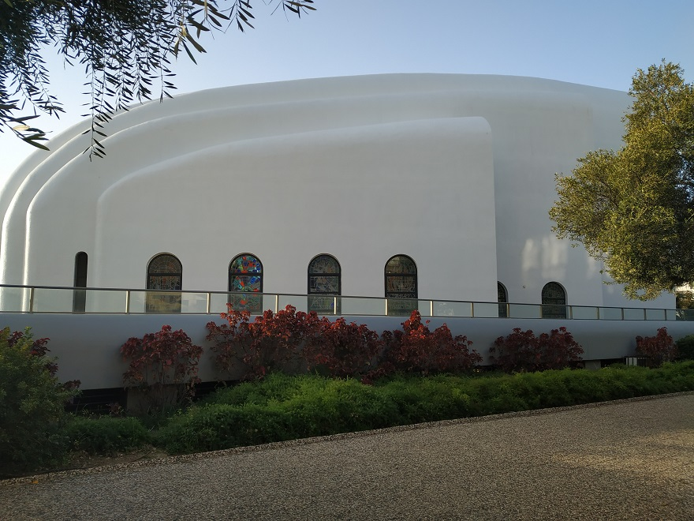
Hechal Yehuda Synagogue as seen from Ben Saruk Street
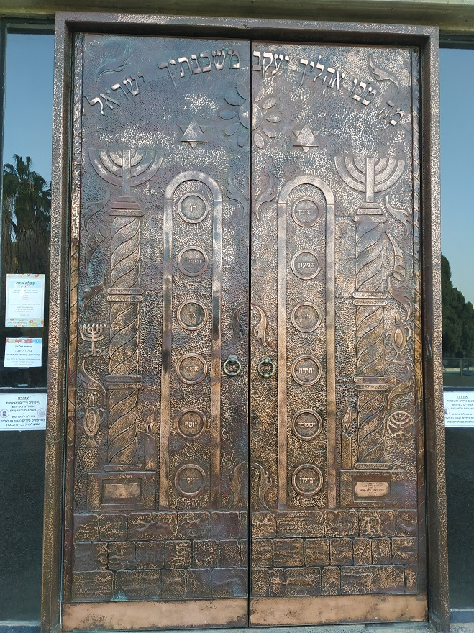
Gates of the Hechal Yehuda Synagogue
The front of the building was too imposing, in relation to the limited size of its courtyard, to capture with a single photograph. Instead I took a video, which I have placed here.

When I finally reached the coast, the sunset made the lengthy, noisy walk to reach it worthwhile.
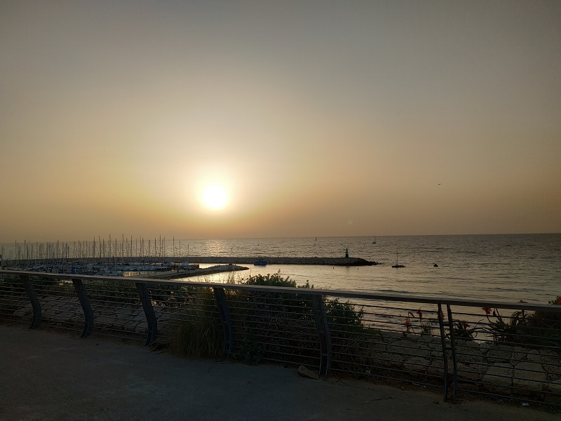
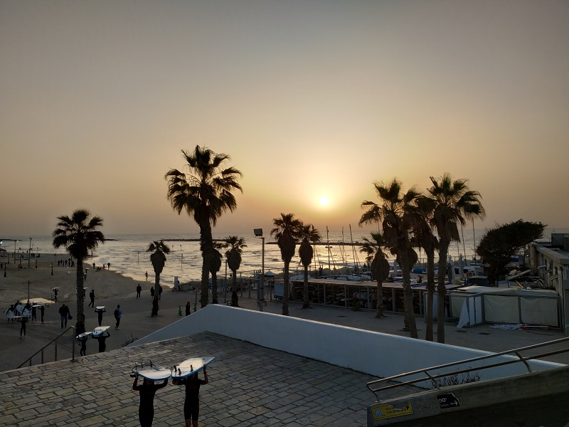
15-02-19
The last fortnight began with a pleasing renewal of my acquaintance with the famous athlete David Bedford. The chain of coincidences leading to this began with another David, namely David Stone, winning the Under-17 South of England cross-country title. David is the son of my long-time friend and neighbour Sheldon, and his victory means that he is now the reigning Under-17 cross-country champion for both the South of England and All England.
In talking to Sheldon after the race, David Bedford's name came up. Leaving out some of the links in the chain, suffice it to say that Sheldon passed to David Bedford a Jewish Folk Tale that I had written. I think it is fair to assume that my Jewish folk tale is unique in having David Bedford as a central character. Anyway, I'm pleased to say that this one-time world record holder enjoyed the story, and as such I have incorporated it into my website here.
I also carried out another exercise in keeping my website skills fresh, by publishing the pictures from last month’s Daniel Sacks Awards presentation here.
I lost the best part of a week suffering a heavy cold. It seems that one is as susceptible to winter infections in Israel as one is in England, seeing as flats are built to dissipate heat in summer rather than to retain heat in winter. Freed by my infection of any guilt for not doing something more productive, I watched a few youtube films, and particularly enjoyed Tiger Bay and the performance by 12-year-old Hayley Mills. Once over my cold, I joined friends for my first cinema visit since arriving in Israel. We saw "The Green Book" and I highly recommend it.

22-02-19
The Na-Nachers (the followers of Rabbi Nachman) made a valiant attempt to liven up a damp, grey Wednesday afternoon at the Shuk Ironi market, Petach Tikva. With music blasting out from the loudspeakers mounted on their car roof, they made brief attempts at their trademark dance, which consists of bouncing up and down like band members of "Madness" ( see https://www.youtube.com/watch?v=ny2s9TIG0Us ). But I did not see anyone else joining in.
And the car was certainly striking, plastered over with their trademark graffiti (Na, Nach, Nachma, Nachman) and, this a new one for me, the multicoloured "Granddad, the King". The poster in the back passenger window proclaims "King Messiah, Rabbi Nachman". So this is a different Messiah from my 03-11-18 entry. I am reminded of the line in Dire Straits’ "Industrial Disease": "Two men say they’re Jesus, one of them must be wrong".
A rather more gentle song is pumped into the air each Friday afternoon where I live, with words "Welcome, Sabbath Angels; come in peace, bless me in peace, go in peace". I recorded a snippet this afternoon as the sun was setting over Tel Aviv to usher in a day of rest:
http://www.briansacks.com/assets/Bar_Ilan_Street_shalom_aleichem.mp3
For a more distinct and beautiful version of this song of welcome to the Sabbath, click here . Or if you prefer a stronger beat and a touch of the oriental, click here .
02-03-19
I, and I suspect many Israelis, am not sad to see the back of the month of February. While England has been enjoying unseasonably balmy weather, it has been cold and wet in Tel Aviv. For the last week I have been fighting, without success, a cold/sore throat that just does not seem to want to clear up. I would guess that my anaemia is part of the problem, together with the newcomer’s lack of built-up immunity to Israeli bugs. It does not help that there is no such thing as central heating, or wall insulation, or double glazing in Israel, and most certainly not in my flat.
I'm also finding the seasonality of certain foods a problem. I am not a meat-eater, and the only frozen fish I seem to be able to buy at the moment is so unpalatable that I need to drown it in soy sauce and then wash the taste away with a glass of Diet Sprite afterwards.
On a brighter note: Jessica, David, Tzviya, Amit and Givat Shmuel are featured in this video produced by Focolare, an Italian Catholic Organisation: The Holy Land: Stories of Dialogue. I suspect that this video location is temporary, so if I am informed that the link no longer works, I will upload the video into my own web space and make it available that way.
14-03-19
Having spent a number of weeks with a cold that waxed and waned between being a real annoyance and merely being an irritant:
In my lower moments, I started thinking about my level of existence over the last several months: somewhat hand-to-mouth, with only basic cutlery and crockery, no washing machine, no dishwasher, no car; and, most keenly felt in recent times, very inadequate means of keeping my living area heated.
I am a great fan of spartan living. If one makes friends with spartan living, one need never be trapped in one's current situation, and one has freedom of choice in how to change that situation. But I can only be really comfortable with spartan living for a limited time. I have started to feel that it is time to trade away some of my rootlessness. As I have written previously, there are several new apartment blocks being built between where I live now and where Jessica, David, Tzviya and Amit live. They have intended completion dates ranging between one and three years’ time. There has been a lot of related advertising material posted through my letterbox.
I am tempted.
15-03-19
At yesterday's Hebrew language class, the focus changed. It was the 61st session out of 64. The previous 60 sessions comprised Levels 4, 5 and 6, each level consisting of 20 sessions. The final four sessions will be preparation towards a Ministry of Education exam taking place in early April.
The session was also exceptional in quite a different way. Halfway through it, the air raid sirens sounded continuously in the street for a period of minutes. The course tutor gradually realised that we needed to take refuge in the designated air-raid shelter. She also realised that she did not know where that shelter was. Being a late-night class, there was nobody else in the building to ask.
Anyway, as we dithered in the classroom, a boom was heard, a shockwave felt, and the sirens stopped. It was the first time since 2014 that rockets had been fired from Gaza towards Tel Aviv.
The joys of Hebrew continued
When trying to make sense of articles in newspapers, I have found myself sometimes making the basic mistake of thinking that a word begins with its first letter. It has then dawned on me that in fact the first letter of the word that I'm trying to decipher is a prefix, and the basic word that I need to translate begins with the second letter.
If you ever see a book that contains Hebrew together with its English translation, you will note that the Hebrew is much more compact than the English. This is because a word in Hebrew often translates to three words in English, as the Hebrew word may include a prefix and a suffix which each themselves correspond to a word in English. As I was walking in the street a few days ago I did a mental count and found that of the 22 Hebrew letters, a full 11 of them have meanings as prefixes. Here is a tabulation:
Hebrew Letter | Meaning as prefix
א | I (in future tense of a verb)
ב | in
ה | the
ו | and
י | He (in future tense of a verb)
כ | Like, as
ל | to
מ | from
נ | We (in future tense of a verb)
ש | that
ת | You / she (in future tense of a verb)
19-03-19
A friend, who states that he recently emerged from a three-year depression, asked me whether I suffered from depression in a similar way. I replied no. I described how my state of mind diverged from being perennially equable, but pointed out how different that was from depression as he described it.
However, yesterday I was definitely in a subdued mood; partly because of my sleep being foreshortened and disrupted by the need to get up early for a meeting, and partly because that meeting represented a significant decision point in my life.
Then, in the evening, there was a Purim party in my Hebrew Learning Centre, but no one I knew turned up until an hour late – and I'm not too comfortable in parties where I know nobody.
In the evening (I use that word figuratively; to be exact, at around four o'clock in the morning) youTube prompted me to watch a couple of video interviews of Brian May (I have been in a Queen mood – at least according to youTube – since seeing the film Bohemian Rhapsody a little over two weeks ago). And Brian May talked about depression in those interviews.
So depression and life-changing decisions were definitely sitting in my mental space when I finally went to sleep. And during the night I was reminded of what depression is for me, and how I deal with it. For me, depression is associated with lack of sleep and with those decision points in life that used to bring me migraines; thankfully I have grown out of the migraines. And I deal with it by sleeping and by dreaming my way out of it.
In the academic year 1982-3 I was studying for an MSc in Computer Science, and the post-exam period of mid-June to the end of September was to be devoted to a major project. As I was entering the last ten days of July I still hadn't decided between two suggested projects, and was walking the streets giving myself a migraine trying to choose. Then one night I literally dreamed my project.
“She said, ‘Why don't we both just sleep on it tonight, and I believe that in the morning you'll begin to see the light’, and then she kissed me and I realized she probably was right, there must be fifty ways to leave your lover". Thus wrote Paul Simon in a totally different context.
I slept late today, and feel all the better for it.

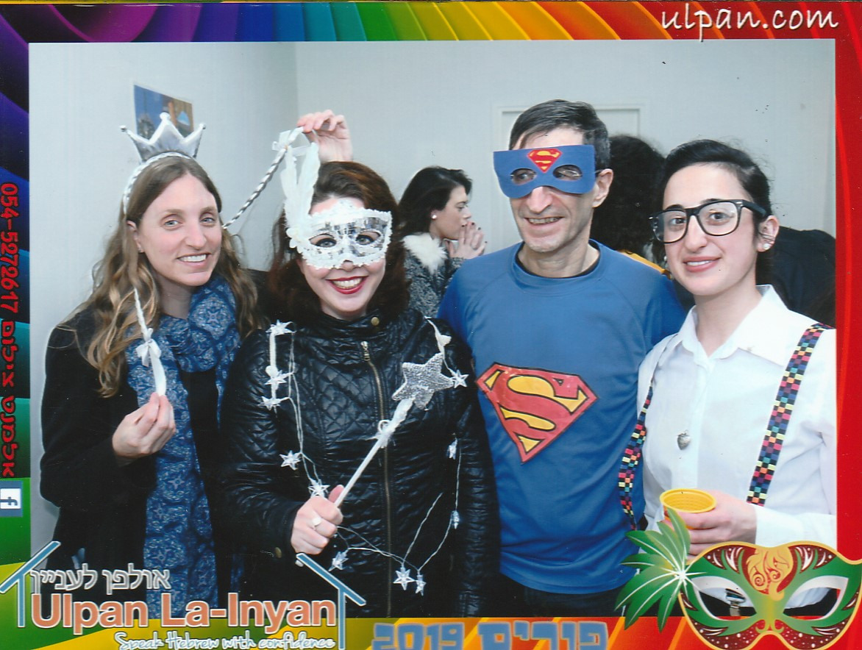
Purim party at La-Inyan Learning Centre, with fellow students Orli and Erica, and tutor Eden
21-03-19
I enjoyed an evening of cultural diversity at David and Jessica's Purim meal. I was talking to a Christian who is over here from America for four years, studying for a Ph.D. at Bar Ilan University. The subject of his thesis is in the domain of the translation of the Hebrew Bible into Greek (the Septuagint) and subsequently from Greek into English. His specific focus is the Construct state – see https://en.m.wikipedia.org/wiki/Construct_state. He gave as an example the phrase translated into English as "the God of my righteousness". The Classical Hebrew Construct state leaves the relationship between "God", "me" and "righteousness" as ambiguous and open to interpretation. Apparently, a Ph.D. can be built around investigating such biblical instances and how they have been translated or mis-translated.
Meanwhile, his wife told me that she was fully occupied with looking after their four children, aged between three months and four years. They are being raised quadri-lingual, to speak English, Hebrew, Ghanaian African (from the father) and Korean (from the mother).
Today's Hebrew oddity: a message left by a neighbour on the building WhatsApp group used the wordשתינו , which I translated as "we drank" when trying to decipher the message. And that is a correct translation. However, it left me mystified as to the meaning of the message. Google Translate, being rather more intelligent than I am, correctly translated the word as "the two of us". The fact is, there are two different words for "the two of us", depending on whether "us" are male or female. If "us" are female, the word also means "we drank". If "us" are male, the word also means "we repeated".
Benny Hill could have a field day.
01-04-19
In recent days I have been working through test papers for the Hebrew exam that I will take this Sunday; and this is certainly an instance where you can have too much of a good thing.
However, it has had the positive spin-off of taking my mind off of worries (as hinted at in my entry of March 19) and the news which seems equally depressing in both Israel and the UK.
Also, it has been a learning experience, because my Hebrew Language class has concentrated totally on speaking and vocabulary, with virtually no writing or grammar. Working through the test papers has been resetting the balance. Our class teacher has been apologizing that the level of the exam is far above the level of our sessions; but what will be will be.
In terms of available marks, the most significant part of the exam is a short essay. The test papers mark out fifteen lines for the written answer, so I am guessing that 120 words will suffice. I wrote out today an answer to the test question: What is Israel in your eyes? What is special about Israelis? My answers, in English and in Hebrew, are here (the answer is brief and limited in scope and the English is quite trite, but I have to restrict myself to vocabulary that I can translate into Hebrew under exam conditions):
In my eyes, Israel is the vision of Theodore Herzl as a home and a refuge for any Jew from anywhere in the world.
Israel is parks filled with the sounds of children playing and elderly people being wheeled in wheelchairs.
Israel is cafés full of enthusiastic young people; Israel is people walking their dogs or riding their bicycles on the pavement, all the while talking on their telephone.
Israel is streets filled with the sights and sounds of new buildings being constructed.
Israel is the small country, the Start-up Nation, that sent a spaceship to the moon.
What is special about Israelis? They do not lack self-confidence; it doesn't matter if a person with a different opinion is their boss or is a subject expert, they know that they themselves are right. They will push in front of you in the queue at a bus stop or the bank; but they will always help you if they see that you need help.
3000 years ago Moses said: I have set before you life and death, the blessing and curse; therefore choose life.
What is Israel in my eyes? Israel is life.
בעיני, ישראל היא החזון של תיאודור הרצל כבית ומקלט לכל יהודי מכל מקום בעולם..
ישראל היא פארקים מלאים בילדים משחקים וקשישים בכסאות גלגלים.
ישראל היא בתי קפה מלאים צעירים מאושרים, ישראל היא אנשים אשר צועדים עם כלביהם או רוכבים על אופניים במדרכה תוך כדי שיחת טלפון
ישראל היא רחובות מלאים במראות ורעשים של בניינים חדשים שנבנו.
ישראל היא מדינה קטנה, העם הסטארטאפ ששיגר חללית לירח.
מה מיוחד בישראלים? הם אינם חסרי ביטחון עצמי; זה לא משנה אם אדם עם דעה אחרת הוא הבוס או המומחה, הישראלי יודע שהוא צודק. הוא (או היא) יקפץ לפניך בתור בתחנת האוטובוס או בבנק; אבל הוא תמיד יעזור לך אם הוא רואה שאתה צריך עזרה.
לפני 3000 שנים אמר משה::
הַחַיִּים וְהַמָּוֶת נָתַתִּי לְפָנֶיךָ, הַבְּרָכָה וְהַקְּלָלָה; וּבָחַרְתָּ, בַּחַיִּים
מה ישראל בעיני? ישראל היא החיים
Having worked through that, I braved the rain for a shopping expedition, and on the way back felt that I must capture, to set down in this diary, the actualisation of the choice that Moses presented more than 3000 years ago: the choice between life and death, the blessing and the curse.
In Tehran, a clock is counting down to the death of Israel:
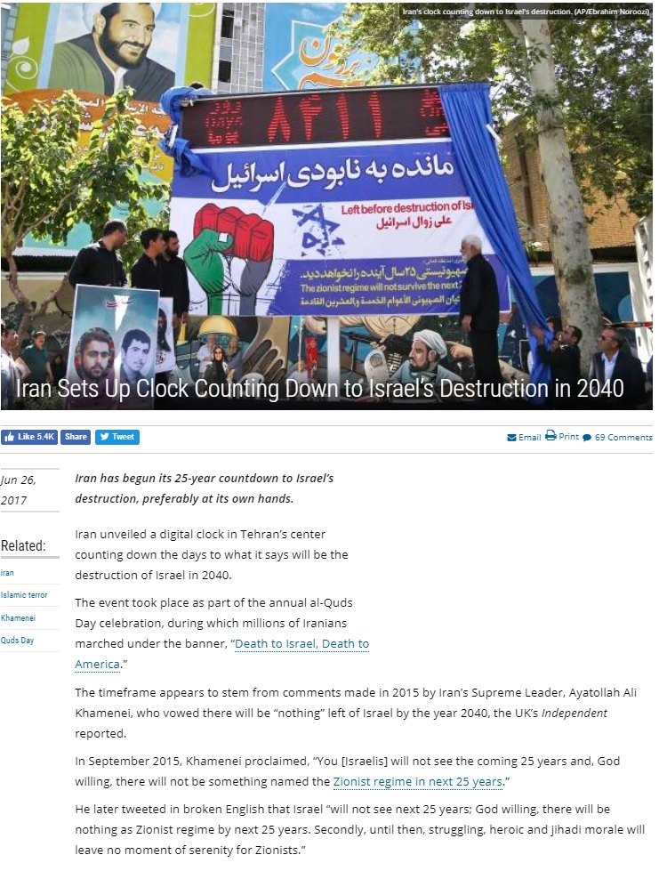
Whereas, all around me, Israel is looking to the future with confidence. At a point midway between where Jessica lives and where I live, I took this video by rotating around almost 360°
http://www.briansacks.com/assets/Building_work_in_GS_01_04_19.mp4
03-04-19
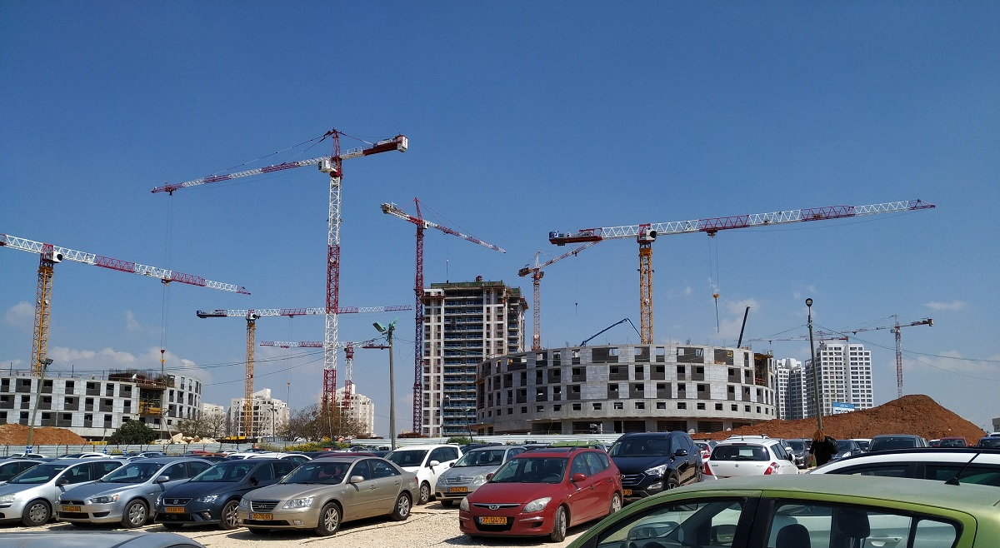
Bar Ilan University and Givat Shmuel: Faith in the Future
07-04-19
Letter to the administrator of the "Ulpan La-Inyan" Hebrew Language School, sent immediately after my Hebrew exam today (Misrad Hachinuch is the Ministry of Education):
Dear Rena
I wish to thank Misrad Hachinuch for my final lesson at Ulpan La-Inyan. It was indeed an education - a real-life experience of an exam in Israel. Coming from England, I am accustomed to exams in which the invigilators are silent, always present in the exam room, and try to maintain the silence of that exam room. How refreshing to learn that none of that applies in Israel! Animated conversations between an invigilator sitting in the exam room and a boisterous Frenchman in the corridor certainly add colour to this quintessentially Israeli experience. Also, once I was the only examinee left in the room, and the invigilator was joined by other colleagues, their conversations liberated me into feeling that I could recite my answers as loudly as they were talking – and speaking does help me think.
Just a couple of other points:
Preparing several answers for possible essay questions was a very useful and enjoyable learning experience, and my sincere thanks go to Eden for her help. It was worth it for the sake of the practice alone – which is just as well because the essay question was missing from the paper (Paper ב). As such, I think, the available marks only add up to 80. I hope this wasn't a mistake. Someone who submitted a perfect paper - and that certainly is not me - would be rather miffed to receive a mark of 80% instead of 100%
I would also offer some free careers advice to the teacher who twice promised to bring me some blank paper and never did: don't take up waitressing!
With thanks again, and kind regards
Brian Sacks
--------
On the subject of those essays, I actually prepared ten essays, expecting that one of them would turn up in the exam. All ten are topics from test papers provided by the Israeli Ministry of Education.
So that they not be lost to posterity, I have preserved them here in both Hebrew and English. (There are one or two cases where Microsoft Word has made alphabet soup out of the Hebrew - cutting and pasting in a language that reads from right to left has its dangers). If anyone were ever to express an interest in them, I would suggest looking at numbers 1 (which in fact I posted in my diary entry of 01-04-19), 4, 5 and 10; 4 and 10 are short pieces of fiction, 4 being based on observation of how many of my age group have gone through a divorce later in life, and 10 being "borrowed" from W. Somerset Maugham.
08-04-19
The saga continues, as Brian learns that attempts at humour do not travel well...
Hi Brian!
Thank you so much for your feedback! We really appreciate it! I am glad you had a pleasant experience and will pass it along to the people who send the proctors. I heard from a few students about the essay question missing, I will find out what happened and what Misrad Hachinuch plans on doing.
Best,
Rena
and so Brian switches to deadpan and blunt..
Dear Rena
I am afraid that another necessary element of my Israeli education is appreciation that English attempts at humour are not always understood in Israel. You were correct in your interpretation of my "essay" paragraph, although perhaps I should have added that it was extremely galling to work hard preparing for the essay, and for this to have actually been wasted time if looked at from the point of view of exam performance.
But please see the rest of my email as my way of saying that it was VERY far from satisfactory. I know that other candidates in the room were also disturbed by, not just what I wrote about, but also by the invigilator munching on Bamba, and by the balagan at the start when we all had to change rooms. I would appreciate it if this message is also passed to the people who send feedback to the proctors. With thanks,
Kind regards
Brian

09-04-19
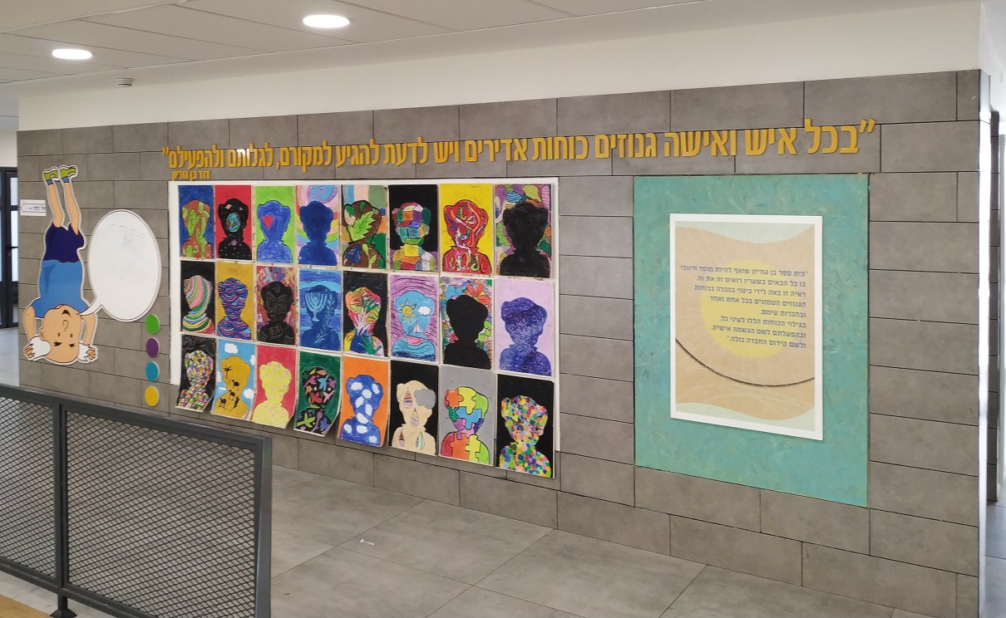
Ben Gurion wall at Ben Gurion School, polling station for the Israeli National elections
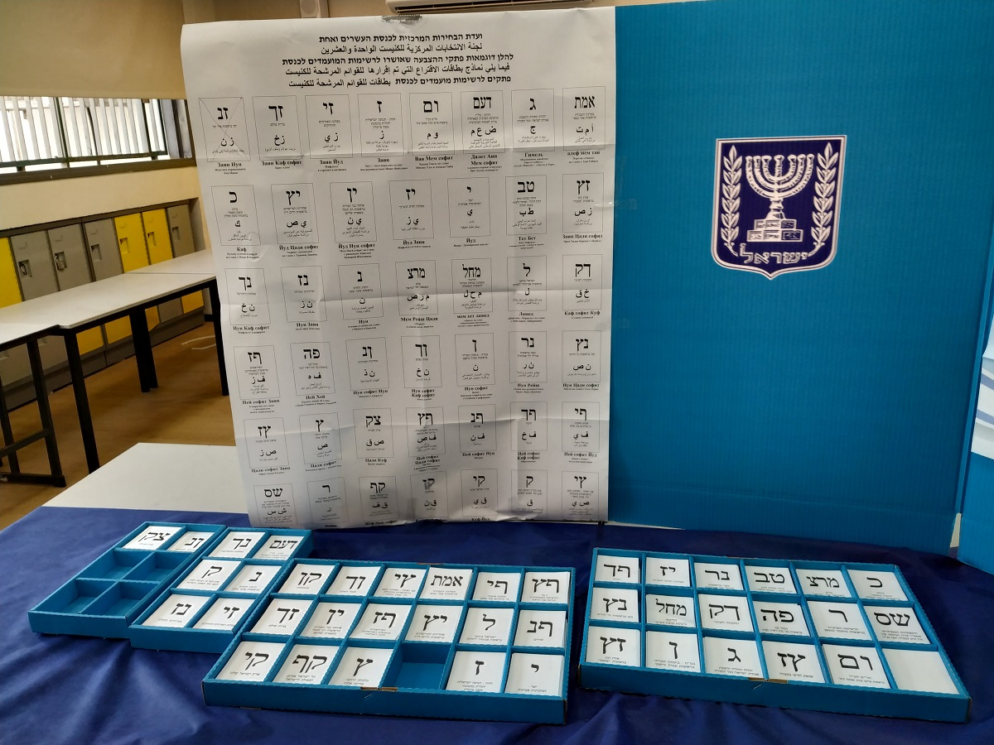
A choice of 43 political parties, with names supplied in Hebrew, Arabic and Russian
10-04-19
Elections over and Benjamin Netanyahu re-elected. I will set down two observations.
Firstly: I found this message from Nas Daily (see my entries for November 1 and November 2 in www.briansacks.com/Israel_Diary_Nov_to_Dec_2018.docx) admirable and inspiring. He posted it in English, Hebrew and Arabic: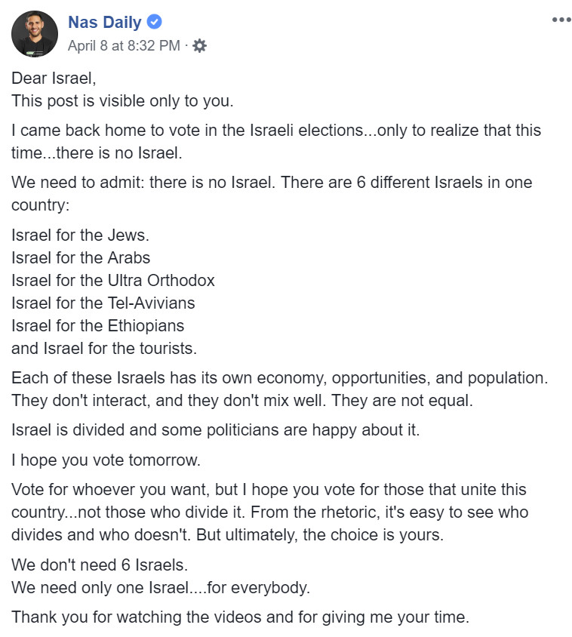
Secondly: Leaving aside the undue influence of the Ultra-Orthodox Haredim, and resisting the temptation to expand that into a rant, maybe the ultimate casting vote in the elections went to the residents of Gaza. They elected to fire rockets at Tel Aviv and its environs, for the first time since 2014, during the election campaign. One of those rockets completely demolished a house at 5:30 in the morning. Only by a miracle did the human occupants, spanning three generations, escape, one member of the family having been woken by the air raid siren. The household pets were killed. That electoral choice by the Gaza population ensured that the Israeli election would be fought on the issue of security, meaning that there could be only one winner.

18-04-19
Today I attended a ceremony at which my nephew received his stripes as a non-commissioned officer. In the UK he would be called a sapper - unexploded bombs, landmines, "Big Bangs ‘R Us". It was quite enlightening to walk around his base, and especially through the reconstructed Hamas tunnel network - and yes, I banged my head.
It took my mind off frustrations regarding the transfer of significant sums of money to go towards payment for my flat, which is due to be completed in a year’s time. Payments had been delayed for several days because of – presumably – "additional checks", and then, separately, it turned out that the transfer company had a temporary technical problem receiving transfers from the UK. Not surprisingly, their Customer Service Department staff did not know what was going on and only offered erroneous and worrying explanations. It is all a bit nerve wracking, when funds seem to disappear into the ether, and there is no £85,000 Financial Services Compensation Scheme guarantee.
I am rushing against a deadline of a few days time, for obtaining quotes and specifying kitchen design changes before the contractors build to default standard.
And tomorrow is the beginning of Holy Week, for Jew and Christian alike!

23-04-19
Over the weekend, I watched a video of Olympic Champion and world record holder for the marathon, Eliud Kipchoge, talking together with David Bedford at the Oxford Union (https://www.youtube.com/watch?v=Tc00mDtzIJU&t=1531s ). I had already watched one or two profiles of Kipchoge prior to this. I have found him very impressive: humble, focused, and with an admirable take on life, and especially on the value of teamwork.
I then watched one or two more videos of Kipchoge and, for old times sake, David Bedford.
I make time wasting an art form. Literally. Although it must be said that one man's art form is another man's time wasting.
On Monday, for the first time in a long time, I wasted time making a poster designed to stop me wasting time. It is pretty topical too - the quote is by Eliud Kipchoge, who made headlines as depicted in the photo, and might make headlines again in London on Sunday.
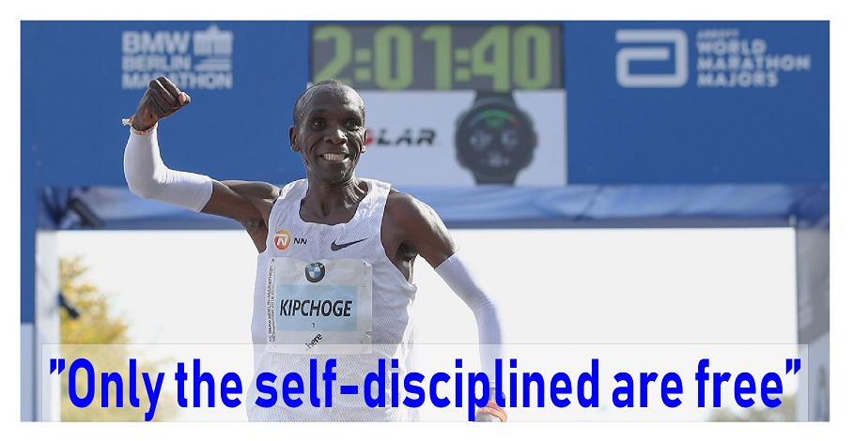

29-04-19
Normal life restarted in Israel yesterday after the Passover. Midway through that week-long break, a deadline passed for me to make personalised choices for various items in the flat that I am buying. Most importantly, I needed to choose any variations that I required from the standard kitchen specification. Being unable to schedule a design meeting during the Passover break, my first outing yesterday was to the kitchen suppliers.
"Yes, back to normal again", I cheerfully said to myself as my bus sailed by, oblivious to my frantic signalling at the bus stop.
But it was a good day all in all, marked by a signed contract for a kitchen design and by a satisfying victory for Eliud Kipchoge on the streets of London.
Normal life intruded again today, as I made the trip to the Post Office to collect an undelivered item of mail. It was a registered letter from the Tax Authority. Ever since the Authority has known of my existence, I have inhabited two Tax Universes and I receive letters from the Authority in pairs. In one universe, the Tax Authority is happy that I have fulfilled my requirements for the year, having paid 6000 Israeli shekels as agreed (on my part, in the expectation that I will receive a refund when end of year accounts show that I have overpaid). In the other universe, the Authority demands 60,000 Israeli shekels for the year.
Today's letter was another demand from that alternative universe. As such, I have written to my accountant:
Dear Binyamin
I had to waste my time going to the post office to collect another registered letter from the Tax Authority (see attached). Is it possible for you to put a rocket up whoever it may concern so that they finally sort out this mistake that is now well beyond a joke?
With thanks and kind regards,
Brian
02-05-19
The responses I received from my accountant were, "It's been overridden, as previously advised" and "They already did correct it". However, that has not prevented a payment book arriving in my letterbox from the Tax Authority today, with counterfoils for monthly payments totalling the 60,000 shekels..

02-05-19
Today was Yom Hashoa, the Holocaust Memorial Day, which takes place each year in Israel on a calendar date related to the Warsaw Ghetto uprising. A siren was sounded for two minutes, throughout which the entire country stood still and silent. Two years ago, I was present in Israel for the other calendar day in which a two minute's silence is observed: Yom Hazikaron, the Memorial Day for Fallen Soldiers and Victims of Terrorism. It was a moving experience, which I captured in this video.
I did not expect to refer to Yom Hashoa in this diary. But as I was walking around the Bar Ilan campus this afternoon, I noticed the names Anna and Max Webb on a vast glass wall of benefactors. | 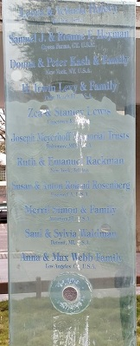
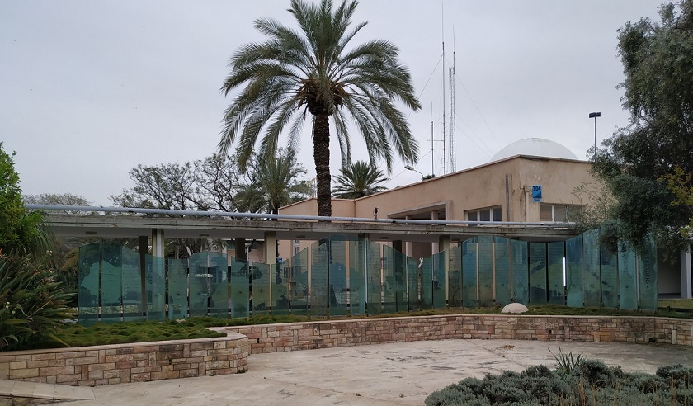

The road in front of my building is Max and Anna Webb Street, and it extends for almost a full mile to left and right. |  | I had also noted on my earliest walks on campus the imposing Anna and Max Webb Psychology Building.  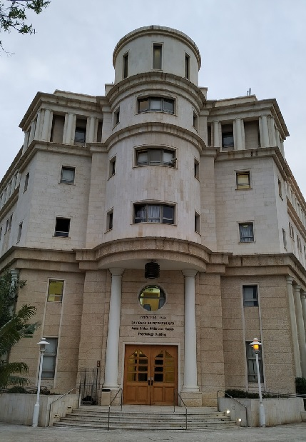
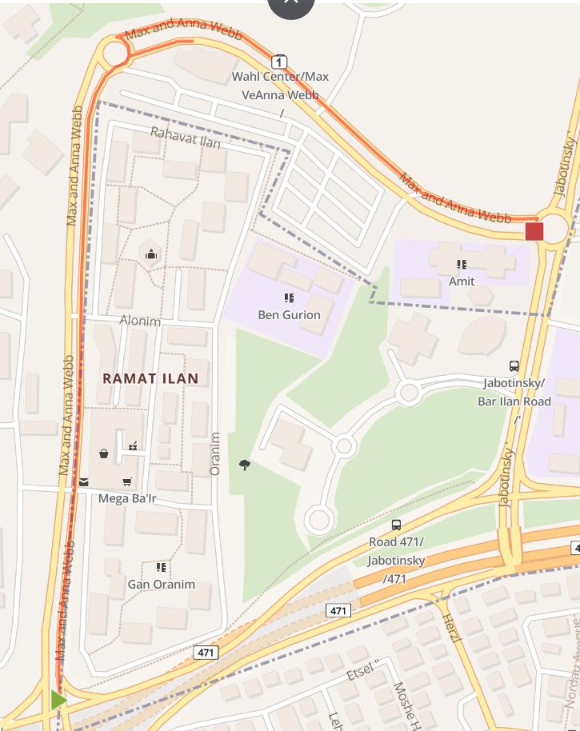

But I had never found out anything about Max Webb until seeing his name on the benefactors wall prompted me to enquire this afternoon. This account is courtesy of Wikipedia.

Max Webb died six months ago. He was 101 years old. He was born in 1917, in Łódź, Poland, and had five sisters and a brother. He grew up in a poor family and stopped going to school at an early age.
During World War II, he was deported to the Auschwitz concentration camp in 1943. He survived the Death March of 1944, as well as twelve labour camps and six concentration camps. Both his parents as well as four of his sisters were murdered by the Nazis. Webb was liberated on May 8, 1945.
In 1951, he stayed on Coney Island for ten months to get a visa for the United States. By 1952, he had moved to Los Angeles with his wife and brother-in-law, and started a career in real estate development. His company became one of the largest real estate development companies in Southern California.
His philanthropy, so self-evident in and around Bar Ilan, extended on as great a scale to Tel Aviv University and to the Cedars-Sinai Medical Center in Los Angeles. He was a founding donor of the United States Holocaust Memorial Museum in Washington, D.C.
On August 22 last year, after my first walk around the Bar Ilan campus, I wrote, "The faculty buildings of the campus are set amongst flower gardens with benches and sculptures. Virtually every building, garden and sculpture bore the name of a benefactor, who typically donated in memory of a parent or a relative who had died in the Holocaust. An emotionally mature, admirable and touching response to tragedy."
I still feel the same awe for Israel's response to tragedy.
06-05-19
For the first time in three nights, I will be able to go to sleep without keeping one ear open for an air-raid siren. If it had been sounded, and I had heard it, presumably I would have tried to make my way to the stairwell, seeing as the building's air-raid shelter is below ground level while I am on Floor 5. In 48 hours over the weekend, 690 rockets were fired at Israel from Gaza, which clearly has money for what it sees as its main priority. When I take possession of my new flat some time next year, I will be able to switch to sleeping in the safe room in similar circumstances.
On a lighter note, 65 years ago today Roger Bannister became the first man to run one mile in less than four minutes.
07-05-19
Carrying out errands on the day before my first trip back to the UK, I felt this very keenly: the unjust way in which Israel is portrayed in Western media, with Hamas claims being printed as fact without any attempt at verification. The day's news provided a typical example.
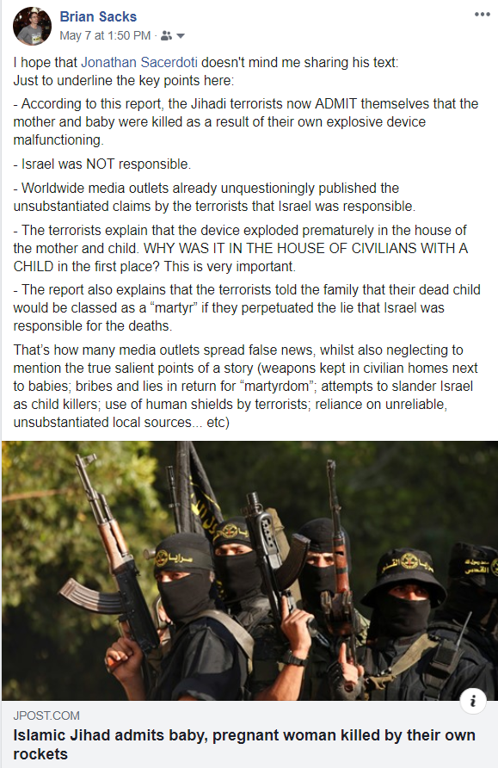
20-05-19
I returned today from twelve days in England, the dates of the trip set so that I could attend Ari’s Barmitzvah – Ari is my brother Jonathan's grandson. I began the trip with a thoroughly enjoyable reunion of college mathematicians in Cambridge – and my great thanks go to hosts Shannon, Joel, Julie and Jeff. After the barmitzvah celebration, Lyn and I went down to Margate for five days and were blessed with blue skies throughout (photos with musical accompaniment here).
The whole trip was a very pleasant break from ever-present worries about wars current and future. It was nice to return, however briefly, to life lived at a normal pace, in a language that I could read, write and understand; to expanses of cliff-top grassland; and to getting behind the wheel of a car (albeit learning an expensive lesson in how hire companies pile on the unexpected charges).
So today I return to my life choice of being able to enjoy, at close quarters, my grandchildren growing up. My life seems to consist of a series of choices reminiscent of Luke Reinhardt's "Dice Man". The decision-making process for each major choice is clouded by mammoth anxiety and awfulizing, combined with major worries about "being seen to be a good bloke" and "doing the right thing". As such, my major life decisions are seldom taken coolly. The effect is that I never feel to be on a straight and level road to a peaceful and happy future. I was born to run, though now it seems also to slow to a walk; but I was certainly not born for sitting. But maybe that's what keeps me young.

23-05-19
Lamp-posts and bus stops smothered with these "charity" boxes are the norm in Bnei Brak, the ultra-Orthodox district to which I try, as much as I can, to give a wide berth.  But this lamp-post is not in Bnei Brak. It is adjacent to the bus stop that I use most frequently, immediately outside Bar Ilan University. I took the photo partly because of the lamp-post’s incongruity with its location.  The large, ground level donation box has the legend "City Cash Desk – Bnei Brak" above the photo of the elderly, white-bearded personage. The box that he is opening has printed on it, "Charity for thousands of needy families". Below the photo is the message "Donate and see salvations".  Moving to the two smaller donation boxes on the left-hand side: The lower one is for "hungry children" and makes the identical claim, "Donate and see salvations". The upper one, collecting for a "Rabbinical committee for charity" proclaims the message "For blessing, success, salvation, for healing".  But my attention was really caught by the box on the top right (see below for an enlarged picture), for an organisation called "Yad L’Achim" (literally, Hand for Brothers").  You will notice arrows left and right pointing to the slot for donations. Below that is a wider slot intended for pieces of paper.  The message between these slots reads, "Insert here names for blessing at Amuka, for proper pairing soon."  I was intrigued.  My thanks go to Jessica and to Wikipedia for enlightenment as follows: "Amuka, in Northern Israel, is the place where Rabbi Jonathan ben Uzziel was buried around two thousand years ago. Beginning in the 17th century, a practice arose to pray at the grave site for a good marriage partner, for children, a good livelihood, health and happiness. Many unmarried men and women pray there for a match. Doing so is considered a "segula" (propitious remedy) for finding one’s mate within the coming year."  For good measure, below the phone number, the message reads: "Donate to Yad L’Achim and, with the help of God, see salvations". | 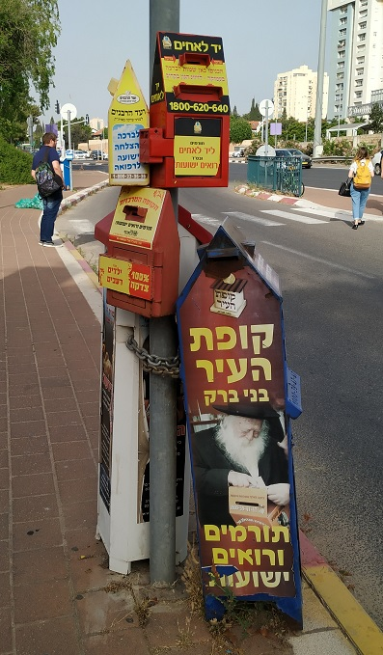

28-05-19
The first of three days illustrating the joys and consolations of living in Israel:
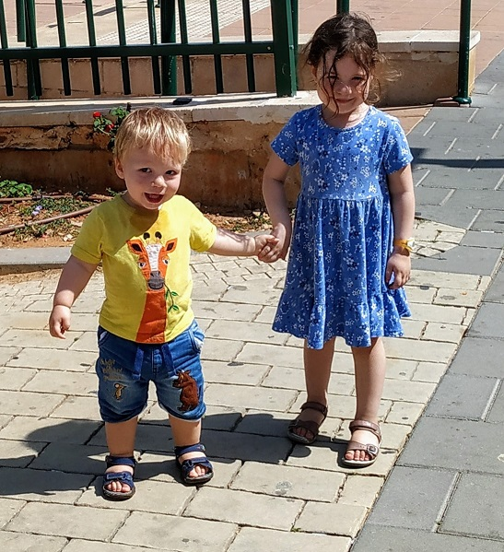
Need I say more?
29-05-19
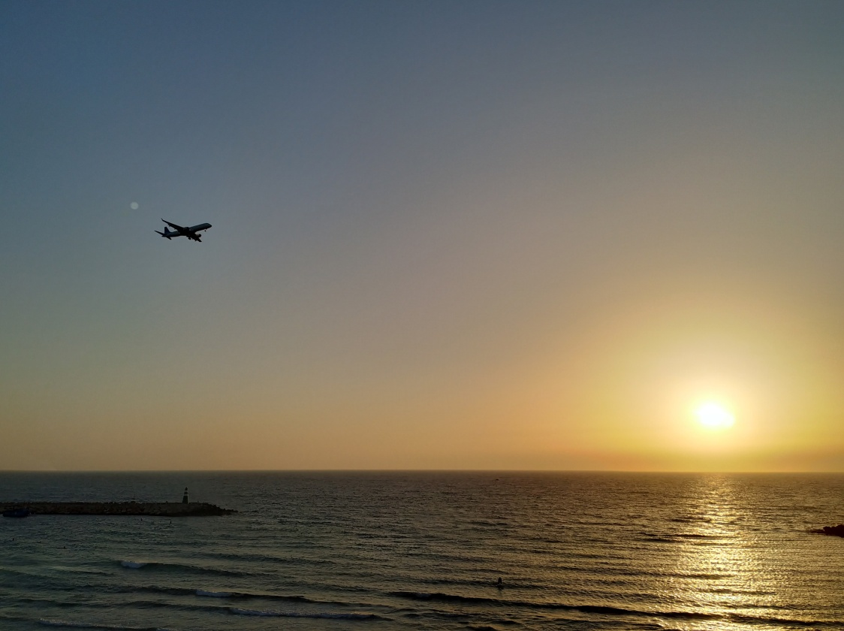
Sunset over Tel Aviv beach
30-05-19
A walk in Hayarkon Park, North Tel Aviv:
