Israel Diary
22-10-18: Prologue
Perhaps it was pre-destined that I would write this account. Nonetheless, I certainly did not pre-plan it, nor did it start out as a diary. Its beginning was as a text exchange with a friend, in which I described the difficulties I had been having with the Israeli banking system, and the seeming impossibility of complying with the requirements of the Israeli Immigration Authority. Having thus vented my frustration in text form, I reworded the exchange as a diary entry. Then one diary entry led to another.
But I did not step off the plane on August 1st straight into the Kiryat Ono branch of Bank Hapoalim. At Ben Gurion airport, just before the entrance to Passport Control, I and two others were whisked away into a side room where our photographs were taken, various formalities were dealt with, and we left, with Israeli identity cards, as new Israeli citizens. It was an emotional moment. Whether I live in Israel in the long term or not, I will certainly always be spending a lot of time in Israel, and I will be proud of my citizenship. It is not an unthinking pride, or one based on any messages drummed into me in my not-so-impressionable youth. It is only in the last twenty years that I have really taken an interest in the history of Zionism, and I find that history inspiring, even as recounted dispassionately and objectively in the British Government Peel Commission Report.
On collecting my three suitcases and hand luggage, a taxi took me to my AirBnB in Ganei Tikva. Jessica, David, Tzviya and Amit were there waiting for me, Tzviya with a drawing of a duck she had made for me, with the message "Welcome Saba” (Saba is Hebrew for Granddad). Yes, I was home.

06-08-18
I've been experiencing the intense frustrations of trying to set up a bank account in a language that I don't understand. I set my bank account up today, but the branch where I set my account up would not let me deposit any money! Meanwhile, the Ministry of Absorption will need to see, on Wednesday, a bank statement showing money in the account. I gave daughter Jessica 100 shekels and got son-in-law David to transfer it into my account, so it should be there by Tuesday. So hopefully Tuesday evening we will negotiate the other issue of not having a printer to print a statement! All these hurdles one has to negotiate seem to assume that everything will work like a well oiled machine. But, for example, leaving aside the fact that the bank would not let me deposit money, it sent a verification code to my email address that I was to type into a return SMS. Then my phone refused to send the SMS, or it may have been that the bank refused to accept it! Needless to say, I have tons of paper from the bank, all in Hebrew that I cannot decipher. Everything that I do on the phone is accompanied by written Hebrew instructions that I can't fully understand or satisfy. So my basic phone settings are incorrect, quite apart from the settings on any banking app for example.
One is really bootstrapping a life. But Jessica and David are a great help, and there are other help resources. I have enough to live on without question, but it's a question of logistics. Apparently if I want to transfer a significant sum across, like enough to pay for rental, I need to get a character reference from my UK bank, certification from an accountant that the money has been appropriately taxed, and a statement of where the money came from, presumably with some proof. All of it is doable I'm sure, but together with setting up my tenancy for my flat in Hendon, finding somewhere to live in Israel, and everything else, it's an interesting time.
I have never had an accountant in my life, and don't as of this moment, but I probably will have within a day or two. I have met him in London and semi-coincidentally he is my son-in-law's accountant. My son-in-law is quite canny so it is a good recommendation.
So hurdles to get over, but they are not impossibly high. And in the spare 5 minutes before I went for the bus, Jessica went on to a property site, and it seems that the rents around here are significantly more affordable than Tel Aviv, seeing as it is five or 6 miles inland. But for me it is an excellent position, because I can walk to Jessica, or there is a single bus to Jessica, and there is a single bus to Tel Aviv, and the bus doesn't pass through the area that would raise my hackles!
12-08-18
I am in an airBnB in Ganei Tikva, 4 km away from Jessica and 10 km away from Tel Aviv, until the end of the month. I went looking at possible apartments to rent for the first time today. I was really only interested in one, but ended up seeing three. The one that I was really interested in was actually beautiful and suited me down to the ground, so I hope I secure it. It is where I want to be, that is, Kiryat Ono - very well positioned for walking to Jessica and using public transport to either Jessica or Tel Aviv. It was a nice end to the day that began with an ant swarm in the flat.
21-08-18
Recapping the last few days: Friday, August 17 I went to Jerusalem for nephew Gad’s aufruf (presumably the word is Yiddish, and it denotes calling up to the Law scroll in the synagogue, on the Sabbath before his wedding). I returned on Sunday, having been forced to walk from the old train station to the Jerusalem Central Bus Station (45 min in baking hot sunshine, wheeling my hand-luggage case) because Jerusalem buses no longer permitted payment by cash; one needed the Israeli equivalent of the Oyster card, called a Rav Kav card. I also learnt on Sunday that my prospective landlady had decided that she wasn't going to rent her flat out anyway.
Monday was a depressing day from the point of view of flat hunting. That evening I realised I needed to widen my search criteria, and so I also looked at four-room apartments (which in England would be termed three-bedroom flats). Then today, August 21, I visited a flat in Ramat Ilan, just 1.3 km away from Jessica. Having checked that there was nothing better available, I negotiated a price, for the rental to begin in a week’s time, August 28. I also had my first Israeli haircut, and acquired for myself the Rav Kav card so that when I am in Jerusalem this weekend, I will be able to use the buses. So it was a successful day! But perhaps a feeling of minor euphoria caused me to temporarily forget the necessity of washing up the moment one had finished one’s meal. The ants soon reminded me.
22-08-18
Today I signed a one-year contract to rent a flat in Ramat Ilan, virtually across the road from the campus of Bar Ilan University. Although it is not exactly where I was hoping to live, it does have the advantage of being less than a mile away from Jessica, and several bus routes to Tel Aviv (though not, apparently, direct buses to the beaches). Not feeling awake enough to venture further afield, after my session with the landlords I wandered through the university campus. It was almost deserted, and the campus supermarket had a sign in the window saying that it was closed all week. It was a very pleasant experience having the campus to myself, and being able to lie full-length along a bench without embarrassment, to shut my eyes for a few minutes. The faculty buildings of the campus are set amongst flower gardens with benches and sculptures. Virtually every building, garden and sculpture bore the name of a benefactor, who typically donated in memory of a parent or a relative who had died in the Holocaust. An emotionally mature, admirable and touching response to tragedy.
26-08-18
I spent Thursday to Saturday in Jerusalem for the extended celebrations of the wedding of Sarena to my nephew Gad. The wedding took place on Thursday evening at sunset in a beautiful setting in the hills outside of Jerusalem. Then over the Sabbath, Friday evening to Saturday evening, three sets of relatives of the bride and groom hosted celebratory “Sheva Berachot” meals. (“Sheva Berachot” translates to "Seven Blessings", which, on the occasion of a wedding, are added to the set of short thanksgiving prayers recited after a meal). So it was a weekend of expressing our celebration and good wishes to the newly married couple through the medium of eating, praying and getting to know the wider family. As such I found myself present, over a 24-hour period, in more prayer services than I normally experience over, shall we say, a month. Though I do not possess the level of belief that would allow me to pray with any meaning, I was struck in seeing the joy and pride in the face of a five-year-old great-nephew as he took part in the ritual of re-adorning the Scroll of the Law in its velvet cover and silver chain, after the weekly Reading of the Law. It reminded me of my older brother describing his pride in taking part in the same ceremony at a similar age, and its deep effect on him. Much of what my brother says about the values of tradition, ritual and community seemed to be captured in the smile on that young child's face.
28-08-18
My telephone step counter for the last two days has recorded 25,303 steps for Monday and 22,288 steps for Tuesday. Tuesday's exertions included around 600 metres carrying a fairly hefty microwave from the University supermarket back to my flat, and a somewhat smaller trip carrying a slightly lighter vacuum cleaner. Having also bought a basic set of crockery and glassware over these two days I'm gradually assembling the necessities for the flat that I have now begun renting.
Having experienced this month the two processes of renting out a flat in London and renting a flat in Israel, the contrast between them is stark, and shows the UK rental market in a very good light. In England I cleared and cleaned my flat as well as I possibly could, so that the inventory report would be favourable and would require my tenants to leave the property in an equally good state at the end of their tenancy, barring legitimate wear and tear. For that matter, I also assembled a very comprehensive Tenants' Pack, including instruction manuals for virtually every item in the flat for which a manual had been produced.
In Israel there is no comparable system. Most flats are left unfurnished, and the so-called furnished flats leave much to be desired. The flat I have rented has a single bed, just 84 cm wide, with a spare bed underneath it. This "spare" is a shallow Ottoman bed, so has next to no padding whatsoever. The single bed was covered with a dusty fitted sheet. On removing this fitted sheet, I was presented with a sight that was stomach turning. I bought two mattress protectors to use one on top of the other, but when, in a video chat, Lyn saw the bed she warned me that if I slept on it I would get fleas. So I will use the spare Ottoman bed and endure a couple of night’s poor sleep before deciding how to best improve matters. If I were in England I would buy a thick mattress topper straight away, but such things are harder to find here.
Today's purchase of a vacuum cleaner was an immediate necessity as the flat is extremely musty and dusty. Cupboards, railings and drawers are in a very dirty state, and in some cases falling apart. Tomorrow I will renew my search for reasonably priced cleaning materials, and set to work.
Yesterday I met my family doctor for the first time, and was very impressed by her professionalism and bedside manner. However, on my way to the appointment I had quite an unsettling experience. I guess that something similar happens to many new Israelis. However, I was totally unprepared for this initiation rite. By chance, my daughter rang me while I was in the lift to the clinic. I managed to speak only a word or two to her before someone shouted in extreme agitation, "Turn the phone off!". I assumed that it was considered anti-social to speak on the phone in a lift, so I stopped speaking. She continued shouting, "It's still open – shut it off!".
Jessica later explained that there is a received wisdom in Israel that if you use a mobile phone in a lift then you are frying the other occupants. I did a quick Google search, which indicated that there is some paranoia about reflected waves, standing waves and the like, but also that it's a bit of a fuss about nothing. Anyway, I'm assured that beneath the brusque exterior, there is a warmth to the Israeli personality. So that's all right then. And I know it is only sensible to be upbeat about the range of experiences I will encounter. I am here to enjoy the ride.
01-09-18
My last four days have been dominated by moving to my new flat and making it habitable. For much of this time I have been cleaning, scrubbing and vacuuming cupboards, drawers, shelves and surfaces throughout the flat. I developed minor hay fever and certainly felt that the copious dust was not doing my bronchial tubes or lungs any good at all.
I actually made the move from AirBnB to rented flat on Friday. I took a taxi from Ganei Tikva to Ramat Ilan, my luggage consisting of three full suitcases, a hand luggage case and a brown paper carrier bag. I had the taxi drop me off at a point which meant that he did not need to ride all the way along my circular one-way road to get me virtually back to the start. So I had a little bit of a walk myself, employing the mechanical advantage / velocity ratio payoff trick that meant that so long as I was prepared to walk each little journey segment three times over, then I only needed to transport one third of the luggage at any one time. Later that evening, I took advantage of my new location to enjoy a pleasant and delicious shabbat supper with Jessica, David and Tzviya (Amit kissed me goodnight having supped earlier).
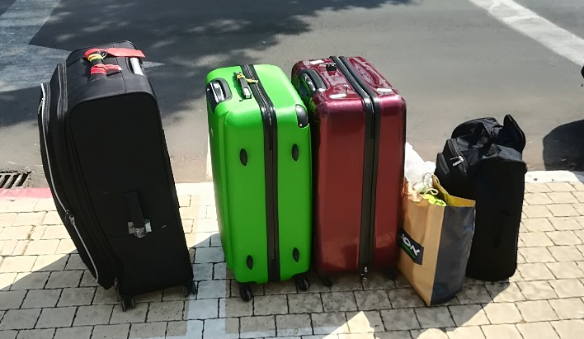
Travellin’ Light..
Since Friday I have also been unpacking and trying to create order out of chaos. It was early Saturday morning that I tried out the bed and it was as uncomfortable as I had expected. I fell asleep at about 6:30 AM, having been forced to take a sleep aid and more of a midnight feast than was good for me. I have been researching mattresses ever since.
Living in Israel does challenge the instinctive actions and muscle memory built up over a lifetime. Of course, the childhood rule of "Before crossing the road, stop, look right, look left, look right again" has to be replaced by "Look left, right, left, right, left, right until you are safely on the pavement at the other side" – after all, we are talking Israeli drivers here.
One aspect of muscle memory that I am finding hard to reverse concerns light switches. In England, one always presses the bottom of the switch to turn it on, and the top of the switch to turn it off. One does it without thinking. But throughout this flat, the opposite applies. I certainly have not yet internalised the change.
After taking my shower yesterday, I found that I had used the shampoo as body wash and vice versa, having made an unconscious, and erroneous, equation between the shape of a bottle and its function. Of course, I don't think it made a blind bit of difference to either my bodily cleanliness or the state of my hair.
03-09-18
Three days after moving to within a quarter of an hour walk from my grandchildren, I plunged into grandfatherly duties big-time. I turned up at Jessica and David's flat at 7:45 a.m. for a six and a half hour stint of babysitting. Thankfully both grandchildren gave me an easy ride. Tzviya knows exactly what she wants, and her day’s plan started with me taking her to the University (to eat a ‘Bamba’ snack in a stimulating environment) and then for me to host her for elevenses at my flat. She approved of both the flat and my hospitality. Amit spent most of the morning at his Gan (i.e. kindergarten). He is remarkably placid, and after we picked him up at lunchtime he was happy to act as Tzviya's sparring partner.
A printer that was supposed to arrive tomorrow came today, and so I had to direct the deliveryman to Jessica’s address. So, laden with the printer in addition to some moderately heavy shopping that I (and Tzviya) had already bought, I had to take the bus back to my flat. The minibus, racing round the corner, sent me rotating virtually full circle around the pole I was clinging to, and sent the printer crashing to the floor. Thankfully both I and it survived unscathed.
The printer, once installed, immediately proved its worth by scanning previously undecipherable letters I had received from the electricity company and the National Insurance Institute. I could then upload the scanned documents to the internet for optical character recognition, and then plug the output into Google Translate. The documents were now intelligible!
I picked up my full month's washing from the local laundry; they provided a great service although I think I might have made a mistake entrusting my good shirts to them. On putting some of the clean washing away, a three-or-four centimetre long cockroach emerged from the shelf on which I had stacked my jogging trousers. It gave me a run for my money but I'm afraid its seconds were numbered. Inspection showed that it had left a few calling cards of its own. Welcome to the Middle East!
04-09-18
As part of my continuing enrollment into Israeli society, I had my first Israeli shout-out. A fierce-looking dog came barking and running menacingly straight at me, twice within the space of twenty seconds. "That's not nice, that's not fair, it's very scary", I called out to the owner. My feeling somewhat shook-up was slightly tempered by my minor satisfaction in having expressed my emotion in Hebrew.
Note to reader: Skip all this stuff in small print.
(If you are nerdy enough to actually read it, an update is that connectivity is no longer a problem, or at least, the work-around is straightforward. It remains true that there is no method of printer/scanner close down other than switching off the electric supply.) My second day with the printer/scanner went less smoothly than the first. I am using my phone as a Wi-Fi hotspot, and that may have something to do with it. Also the printer is vintage 2013, and its idea of how to connect to a Wi-Fi network may be equally antediluvian. Anyway, it seems that it refuses to actively find the network, but insists on being found first by a print request rather than by a scan request. I will have to get into the habit of printing out a blank page before attempting to scan. As another little feature, it refuses to close down. I must physically pull the plug out of the socket, and suffer its little admonishment about inappropriate shut-down when I start it up again next time. Yes, I did a Google search, and yes, I am not alone with the problem, but nobody has come up with a solution.
05-09-18
Profuse thanks to Alan for making possible a trip to IKEA, a 25 minute drive there (so away from Tel Aviv) and a 45 minute drive back (thus suffering the ever-present Tel Aviv traffic jam). It enabled me to buy, most importantly, a mattress, to double my number of chairs from two to four, and to enhance them with comfortable seat cushions.
06-09-18
Life can definitely be frustrating here!
One of the tasks I had set down in my orderly plan for the day was to attempt to update my address and telephone details at such institutions as the Ministry of Absorption, Ministry of the Interior, my bank and my health care provider. I decided to start with the Ministry of Absorption, assuming that seeing as it is the institution specifically there to facilitate matters for new immigrants with limited knowledge of the language, it would be the simplest. With my machine-and-internet-assisted ability to scan, character recognise and translate, I deciphered the document that the ministry had given me detailing their website and my allotted password. I duly entered my national identity number and password onto the site, only for the password to be rejected as containing letters and digits but not the necessary special characters. The password I had entered was, exactly, the password that they had allotted to me, and it was failing their own basic verification process. So I rang them up, and after waiting through 10 minutes of hold music, I was told that there was nobody there who could speak English.
Roll on the days when such frustrations occur less often! Meanwhile, yes, dear reader, I will definitely and speedily enrol onto a language course.
----
As a postscript to the above, I should mention that I immediately rang up Miriam, my contact in Nefesh B'Nefesh, the charity that helps new immigrants to Israel. Together we went through the list of relevant organisations, and the two outdated addresses that they might have on their systems (my daughter's address and my airBnB address). She decided that actually, I didn't need to worry about updating any of them. So there is a lesson for me - don't worry, be happy... I suppose that as long as I pay my taxes and my National Insurance contributions, the authorities can't get too upset.
08-09-18
After the incident with the cockroach some days ago, I went looking for a spray that might prevent the incident from recurring. I already knew two Hebrew words for cockroach: juk (וק'ג) and makak (מקק). But an element of uncertainty was introduced into my search because the cans instead used a third word for cockroach: tikan (תִיקָן). My older brother has noted the number of Hebrew words for joy, reflecting the importance of that state to Hebrew culture. People refer, in a similar vein, to the number of Inuit words for snow. I will say no more.
11-09-18
It has been Rosh Hashana – the Jewish New Year – for the last two days. The first evening of the festival – Sunday – Jessica, David, Tzviya, Amit and I enjoyed a very pleasant meal with friends. I duly put in a one-hour-plus appearance at the synagogue on Monday, before fear of catching cold sent me out. The synagogue is just 20 yards away from my building, and its design is pleasantly modest and tasteful. Fondness for my bed got the better of me today (Tuesday), but later, when walking, an Orthodox gentleman – weighing me up, no doubt, as "secular", gave me a personal ‘shofar’ (ram’s horn) service of my own, first coaching me through the two preliminary blessings: for listening to the shofar, and for God having sustained me to reach this time. He then performed quite an extended series of blows on the shofar. As I had been in conversation with Lyn at the time, she was able to vicariously participate, and it was really quite moving.
In the evening I went on a wild goose chase to find a SIM card, whereby I could hopefully improve my available internet bandwidth beyond the pitiful. It was a thankless task, but the search will resume, with son-in-law David's help, tomorrow.
While writing this I have been intermittently shortening the lifespan of various ants on a one-by-one basis – I haven't encountered colonies of ants as I did at my airBnB. I am sure that it is excellent cognitive behavioural therapy for my cleanliness phobias, though whether I respond like a good cognitive behavioural therapee is another matter entirely.
12-09-18
I was confined to my flat throughout the morning and early afternoon as contractors commissioned by the landlord changed a window in the one bedroom that I don't use. This ruled out any furtherance of administrative issues since most municipal activity and the like is conducted in the morning. I spent the afternoon with Tzviya. Much progress on the purchasing of homewares - pedal bin and floor cloths and the like - less progress on the internet front. David kindly obtained a SIM card, but unforeseen difficulties left the new card inactive and the old card disabled. But this did lead me to discover that if one stands in the street next to Bar Ilan University, one can make use of their unrestricted Wi-Fi to the extent that its signal reaches that far.
One consequence of my extremely limited internet bandwidth over the last week has been my inability to upload this diary beyond the confines of my PC hard disc. I remain hopeful for tomorrow.
13-09-18
At times during the day I seemed stripped of my usual life support systems to the extent of needing to rely on homespun musings along the lines of “Well, I'd rather be in this position than have a serious health problem..."
In brief, I started the day with no working internet or phone, and with the belief that I had lost my passport. After spending perhaps half an hour searching in vain for the passport, I decided to go to the Town Hall, to set up automatic payment of my arnona (Council Tax) and to apply for my new immigrant's discount. Finding my way there was "interesting", guided by Google Maps, which broke down every few yards as it lost its connection into the Bar Ilan University Wi-Fi. But the walk led me for the first time through the full extent of the campus, and again I was struck by the buildings, streams and community park, all endowed by benefactors.
On reaching the Town Hall, I was faced with a machine that allocated one a place in the queue once one had typed in one's National ID Number and password. Surprise, surprise, this was the first I had ever heard about a password. This was not going to be my day.
Thankfully, on entering the room of counter staff, I could just sit down, state my business, and all got sorted. My day was getting better. I went home, with a new burst of inspiration found my passport, had a lunchtime nap, washed the floors of the flat for the first time, inserted my new SIM card and found it working! To cap it all, I registered myself on the government website and set up a password, which is maybe the password that the Town Hall system was referring to. The process involved jumping through several verification hoops, and of course dealing with the Hebrew language. The only Hebrew keyboard at my disposal is the on-screen one provided by Google Translate, and so typing "Brian" in Hebrew told me incidentally that my name means "Best regards". Well, waddayaknow!
16-09-18
One small step at a time, my quality of life is improving. My telephone package, costing just 30 shekels per month (around six pounds) should provide 50 gigabytes of data monthly, which hopefully will suffice even for those bloated Windows 10 updates. I have been able to negotiate the Israeli bank site to print off account and credit card statements, and I am homing in on an appropriate Ulpan course. I have cleaned my picture window looking out over Tel Aviv as much as I can whilst paying due respect to the fact that on the other side of it is a sheer drop from the fifth floor to a concrete car park. I have managed to transform sofas from looking unspeakable to almost passable.
Settees 21-08-18, the day I first visited | Settees 16-09-18
I had another afternoon and evening gated in the flat, waiting for the air conditioning repair man. But having given a two-hour window and then turning up an hour and a half after the end of it, he also repaired a couple of broken cupboard hinges. As an additional benefit, the trail of dirt that he left behind gave me another opportunity to clean the floors, and now the flat is suffused with the pleasant aroma of cockroach repellent!
19-09-18
My first Yom Kippur (Day of Atonement) in Israel was an affecting experience. After our pre-fast meal, I accompanied Jessica, David, Tzviya and Amit to synagogue yesterday evening. Despite dressing more warmly than on my previous synagogue visit, the air conditioning and my fear of catching cold again sent me out after a time. It gave me the opportunity of looking after Amit and allowing Jessica to spend more time in the service herself. It also gave me the opportunity to wander down the middle of a road in which there was no traffic other than children meandering up and down on bicycles. At the bottom of the road I crossed a small bit of wasteland and found myself on Route 4, a major road traversing the coastal centre of the country from Haifa in the North to Gaza in the South. In England it would be considered a motorway. I was at a straight stretch of the road in which I could see probably a full mile in both directions. I stayed for 20 minutes, transfixed by the scene. During that time not a single car or motorbike went by. Every now and then, somebody passed by on a bicycle that was presumably assisted by an electric motor. But there was no traffic noise at all. The only noise was that of the many adults and children pedalling up and down the middle of each carriageway, seemingly with no need to worry about any danger or to obey any rules of the road. One of the children on a bicycle was being accompanied by his father on a skateboard.
Just as I was leaving to walk back over the wasteland, I heard a vehicle driving by. I turned around to see that it was a van, and it was immediately followed by an ambulance with flashing red lamp. Clearly the two were connected and presumably were rushing to an emergency situation.
The following afternoon, the situation was the same. There was not a single moving car or motorised vehicle on the road. All the shops were shut, there was no noise of industry or of building work. But the roads were full of children pedalling up and down in loose orbits around groups of parents gathered in the middle of the road. For the “chilonim” - the "seculars" – the day was seemingly also a festival, one of bicycle riding for children and socialising in the middle of the road for adults. A day when there was no fear of children being run over by cars.
A day when one could find calm, peace and quiet in the middle of a car park, in which one could take a brief moment of introspection to take stock of oneself, take a mental ethics questionnaire, note one’s few good points and show some compassion for one’s several not-so-good points.
Or, by contrast, one could go to synagogue. The synagogue was certainly fuller than over the New Year, but one could still find a place to stand in comfort. This was now the time of the Closing service, throughout which the Ark (containing the Scrolls of the Law) remained open, and everyone who felt capable of it stood standing. But by half an hour before the end of the Day, things were changing. By this time, most of the bicycles and all the groups of parents were off the road – presumably anticipating the resumption of normal traffic. The synagogue was filling to burst point, and the service was reaching a crescendo. The Shofar (ram’s horn) was sounded, and immediately after that a few people left even though it was in the middle of a prayer (this synagogue was one of the few that blow the shofar slightly earlier than most). The Closing Service finished in a way I had not experienced in England: the congregation singing "Next Year in Jerusalem" with gusto. That short prayer had sustained Jewish hopes for two thousand years, but it did seem a bit whimsical coming out of the mouths of Israelis living an hour’s bus ride away from the Holy City.
With the Closing service thus finishing a full 10 minutes before the astronomical end of Day itself, around half the congregation promptly left while an announcer notified them of the exact time that the Day, and the fast itself, terminated.
Not wishing to join the undignified mob beating their retreat, I waited several minutes and then walked out to the road to see the first moving car I had seen during the Day of Atonement. The 25 hour day still had two and a half minutes to run.
19-09-18
Yom Kippur sharply highlighted the Givat Shmuel community divide between the "dati’im" (the religious) and the "chilonim" (the secular). The differing aspirations of these two sectors of society is clearly a prominent issue for the upcoming mayoral elections, as there are posters in the streets for one party with a banner message "Supporting the needs of the chilonim”.
There is a rather more disturbing advertising display along a stretch of road on the walk from my flat to Jessica's. A housing development is in its early stages of construction on one side of the road, and along its full length there are about half a dozen identical hoardings advertising the development. The advertisement features a happy family of father, mother and three children, two girls and a boy. On each hoarding, all female faces have been obliterated. I assume that this vandalism is an instance of religious fanaticism. To me it is very surprising as the Givat Shmuel community would be described as "modern Orthodox" rather than "ultra orthodox" – “knitted yarmulke” rather than "black hat". Perhaps, as John Cleese says in the Life of Brian, "there's always one, isn't there..".
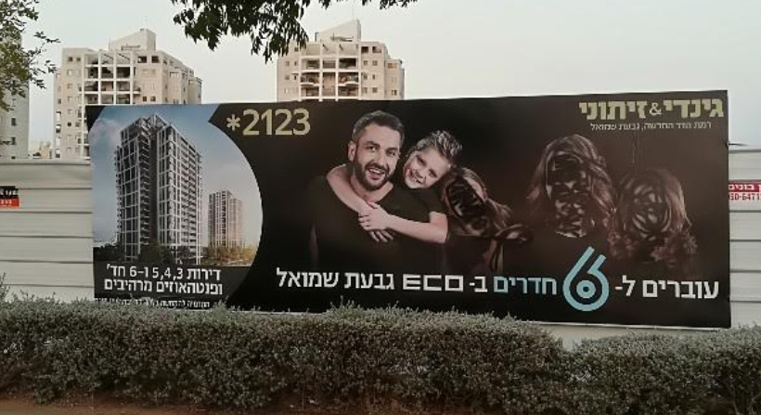
Presumed religious extremism
Postscript: On my mentioning, a day later, the obliteration of female faces in the posters, my dinner companion opined that "That wouldn't be locals, that would be the Haredim (that is, ultra orthodox) from Bnei Brak”. Incidentally, Bnei Brak is the neighbourhood I was referring to when I wrote, at the end of my first diary entry, “But for me it is an excellent position, because I can walk to Jessica, or there is a single bus to Jessica, and there is a single bus to Tel Aviv, and the bus doesn't pass through the area that would raise my hackles!”
22-09-18
Last night again re-emphasised the urgency of further softening my bed. It took me till past 6 AM to fall asleep, and then only through reliance on over-the-counter sleep medication.
I had travelled some distance to a "Dreams" bed shop on the day before Yom Kippur, only to find it closed up, in contradiction to its advertised opening hours. This is a typical occurrence – pre-advertised or pre-notified opening hours are not adhered to. Shops are shut on Sabbath and festivals, and only open in the morning on the days before these, and that itself cannot be relied upon. It means that during the "Jewish Holidays" period, the country shuts down to a large extent. I must resume my quest on Tuesday.
But during my waking hours I started reading the book "Reuben Sachs”, written in 1889, and learned about its author, Amy Levy, the first or second Jewess to study at Cambridge University, and a suicide at age 27.
22-09-18
The Bar Ilan University campus is a real amenity for me. I approached the main entrance at 9 PM after the end of Shabbat, expecting to be summarily turned away. But the guard waved me through when I showed my national identity card, and from then on I had only cats for company. In human terms, I had the campus to myself. I was seeking some well-lit, soft ground to attempt a few, faltering running strides. The temperature was still 27° and humidity 73%, but in my isolation I was able to run bare-topped without any fear of causing offence. And to stop running almost immediately with no need for embarrassment.
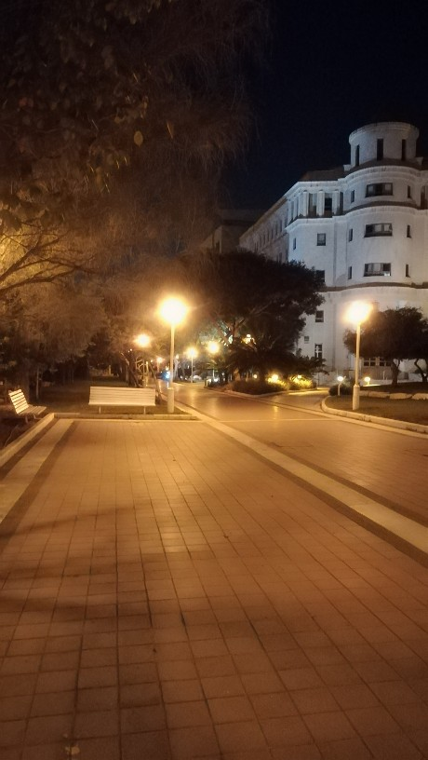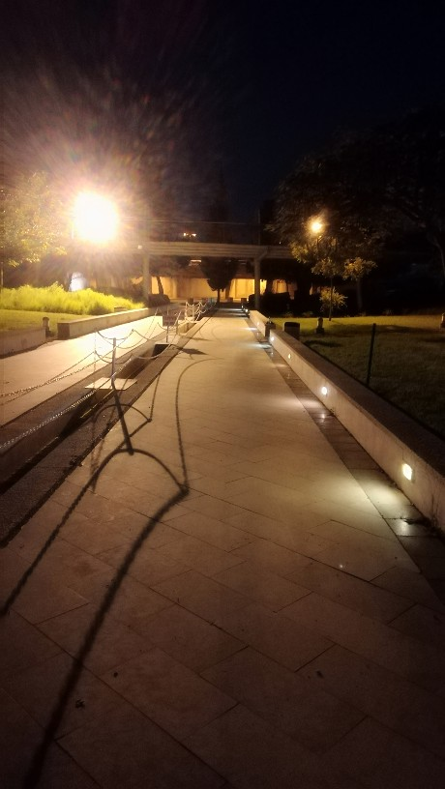
Bar Ilan campus grounds, with only cats for company
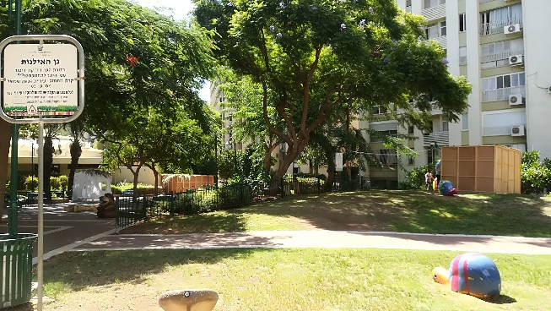 | 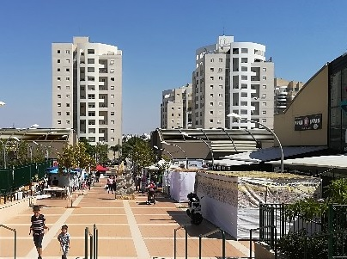
Immediately outside my apartment building | At the Givat Shmuel mall
"You shall live in Tabernacles for seven days": Leviticus 23:42
25-09-18
The downside of the Jewish Holiday period in Israel – shops shut with no prior notification – caught me out today. Having started the day by hauling 5 kg of washing to the laundry down the street, I had to haul it back home again. A trip to two bedding shops in Bnei Brak established that one did not exist and the other was closed with no prior notification. At day's end, my purchases on the bedding front consisted of one single duvet, which, doubled up and used as a mattress topper, will hopefully result in a better night’s sleep!
26-09-18
A very pleasant day! Sorted out electricity and gas payment issues in the morning, had a productive shopping trip to Tel Aviv in the afternoon, and a satisfying power walk in the evening.
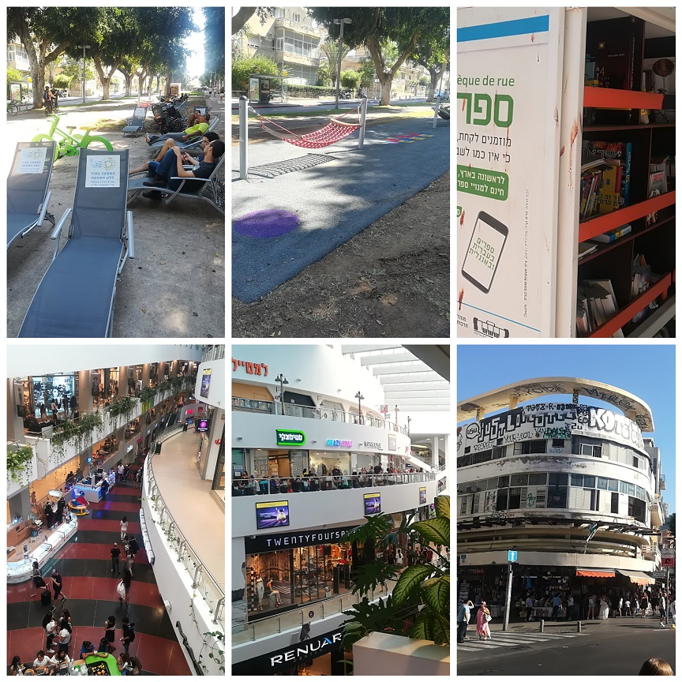
Top: Rothschild Boulevard Tel Aviv invites you to sit down, lie back and read a book
Bottom: The screw-thread walkway of the Dizengoff Centre allows you to traverse the mall from bottom to top without taking the stairs or a lift. Out in the street we are enjoined to "Respect your local vandals".
01-10-18
Today is a milestone in a number of ways. Firstly, I have now been in Israel for exactly two months. Secondly, it is the start of the month in which I turn 67 and, as far as Israel is concerned, I become “kashish” - elderly. Thirdly, this evening brings to a close the period of the “Chagim”, the Jewish Festivals, during which, to a significant extent, the country comes to a standstill.
To mark my coming of (old) age, the National Insurance Institute has sent me a raft of paper. Much of it comprises an application form for an old age pension. Thankfully, regardless of how little I may or may not qualify in terms of residence and contribution history, I certainly don't qualify in terms of need. So that is one application form that I can ignore.
The Institute also sent me a document listing the various counselling services available for the elderly. Amongst the categories of help was one for "Families employing foreign workers", and prominent in the Help topics was "Rights of foreign workers". In reality, the category largely refers to the Filipino carers that so many people here employ.
The popular travel vlogger Nas Daily has devoted several videos to the Philippines, including one expressing gratitude for the care services that Philippine nationals provide throughout the world. Certainly when one walks the streets of Tel Aviv one is made aware of this debt of gratitude owed to carers whose work means that many old people can continue living in their own home while not being trapped inside of it.
Regarding the country returning to normal functioning, it is a toss-up which is more of a relief to me: being able to make further progress on joining a language class, or being finally able to take my washing to the laundry!
2-10-18
I woke up this morning exactly at the conclusion of a running dream; not surprisingly, running features a lot of my dream life.
I finished the run more-or-less together with someone who does not exist in my "real" life; he seemed perhaps Scandinavian, a bit taller, stockier and younger than I am. As he finished he exclaimed, "We finished together – and in parallel!". It was a statement of pure camaraderie and encouragement. This was a person so happy in his own skin, and with such generous personality, that he could see that I lacked confidence and could do with a boost, and it was natural for him to give it.
When I am awake I often ask myself, "Why, when I can construct people in my dream life who are managerial, or extrovert, or self-confident or whatever, can I not switch on those qualitaties myself in real life?"
To anyone reading this: Thoughts? Do you experience the same or similar? By all means drop me a note.
2-10-18
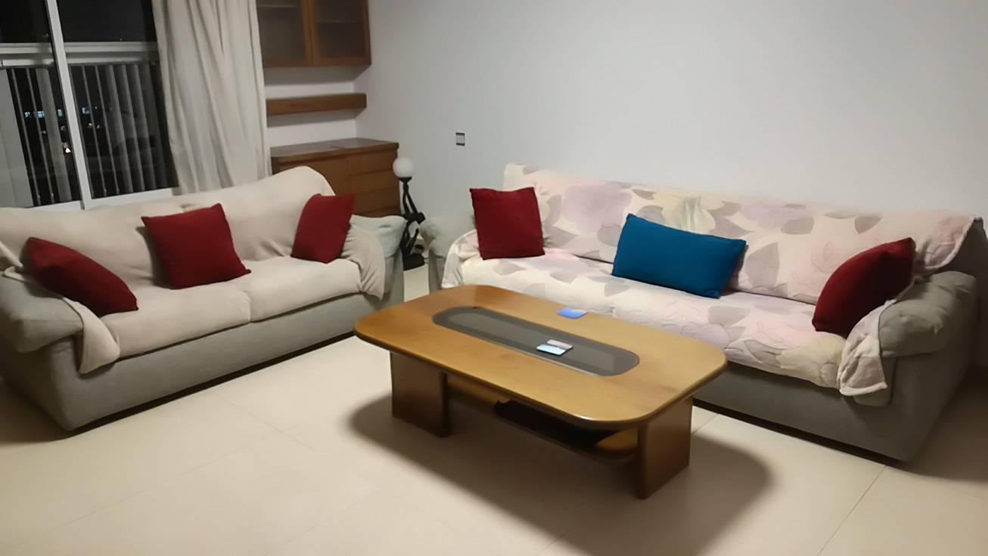
A trip into Tel Aviv for a cheap and cheerful attempt to address the shortcomings of my sofas

04-10-18
It sweetens the pill when, after a blood test, you can walk out of the clinic and jump onto a bus going straight to Tel Aviv beach
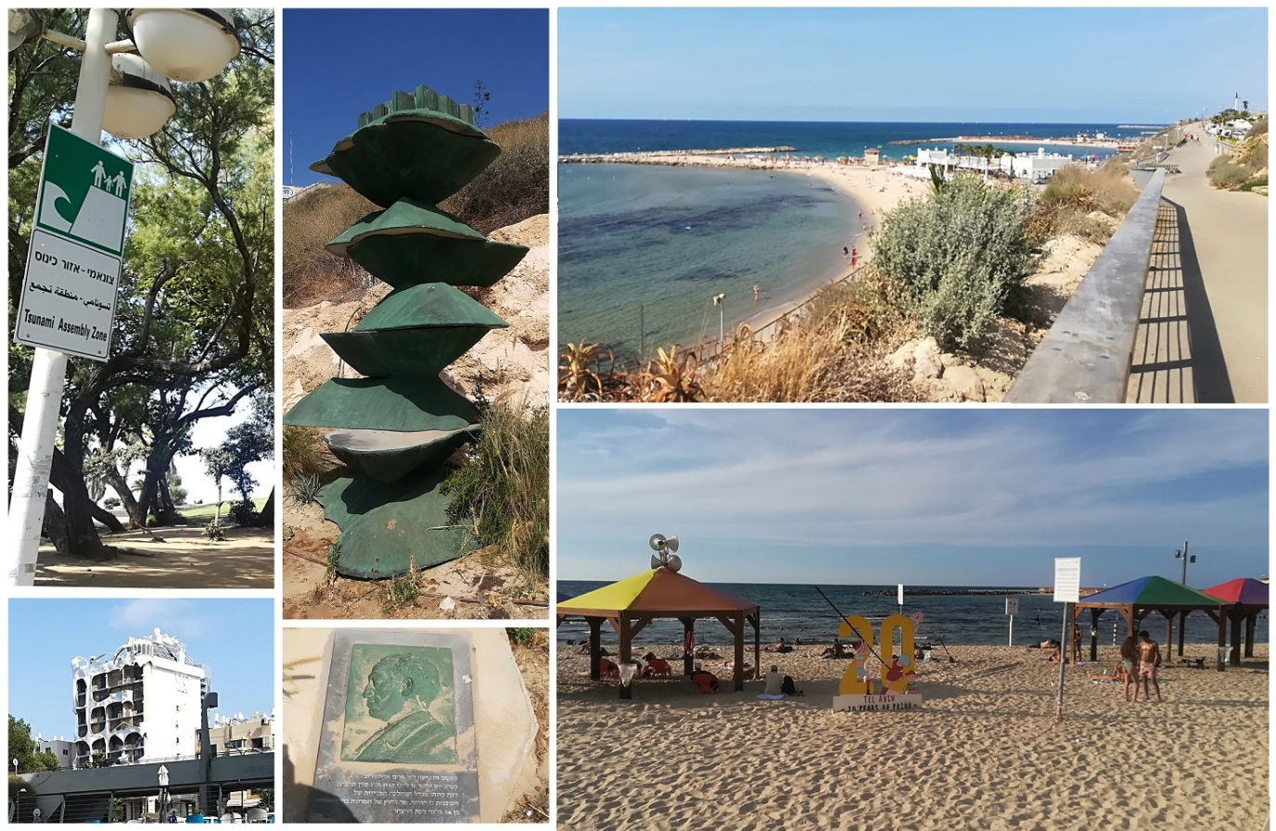
Worthy of note: Bottom left: surrealist architecture in North Tel Aviv
Centre, top and bottom: memorial to Chaim Arlozorov, erected at the point where he was assassinated in 1933. Arlozorov negotiated the Ha’avara Agreement, about which Ken Livingstone has his rather controversial views.
Bottom right: Twenty years of Pride celebrated at the Tel Aviv Gay beach.

05-10-18
It took some persuasion on my part to gain entry to Bar Ilan at four o'clock this afternoon. But then I had the entire campus to myself.
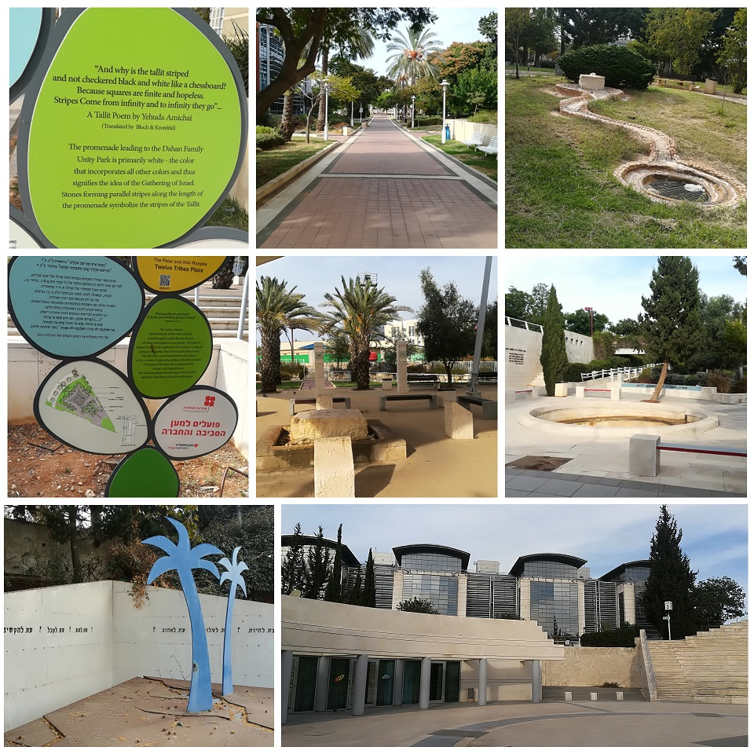
Top: walkway leading to the Dahan Family Unity Park.
Middle (left and centre): Twelve Tribes Plaza
Bottom: at Dahan Family Unity Park: Left: the Hebrew visible in the picture reads, "A time to live, a time to forgive, a time to love, a time to give, a time to receive, a time to listen". Right: in the background behind an amphitheatre, four identical buildings, each devoted to an engineering discipline, each named in honour of a benefactor.

06-10-18
The day of rest can also be a day of stimulating the mind, and I began re-reading Pete O'Connor's visionary book "The Stars Beneath our Feet". It promises to be even more impressive second time around.
I also learned how the Babylonians, the Greeks and the Hindus obtained square roots! Three separate methods, and the Hindu method was quite ingenious. Wikipedia and YouTube are amazing resources. In recent days, I have also dipped my toes into Group Theory for the first time in 45 years. I don't know whether I will wade in beyond getting my ankles wet.
In the evening I ambled around the vicinity of my flat and found this amazing playground. Tzviya and Amit, fancy a test flight?
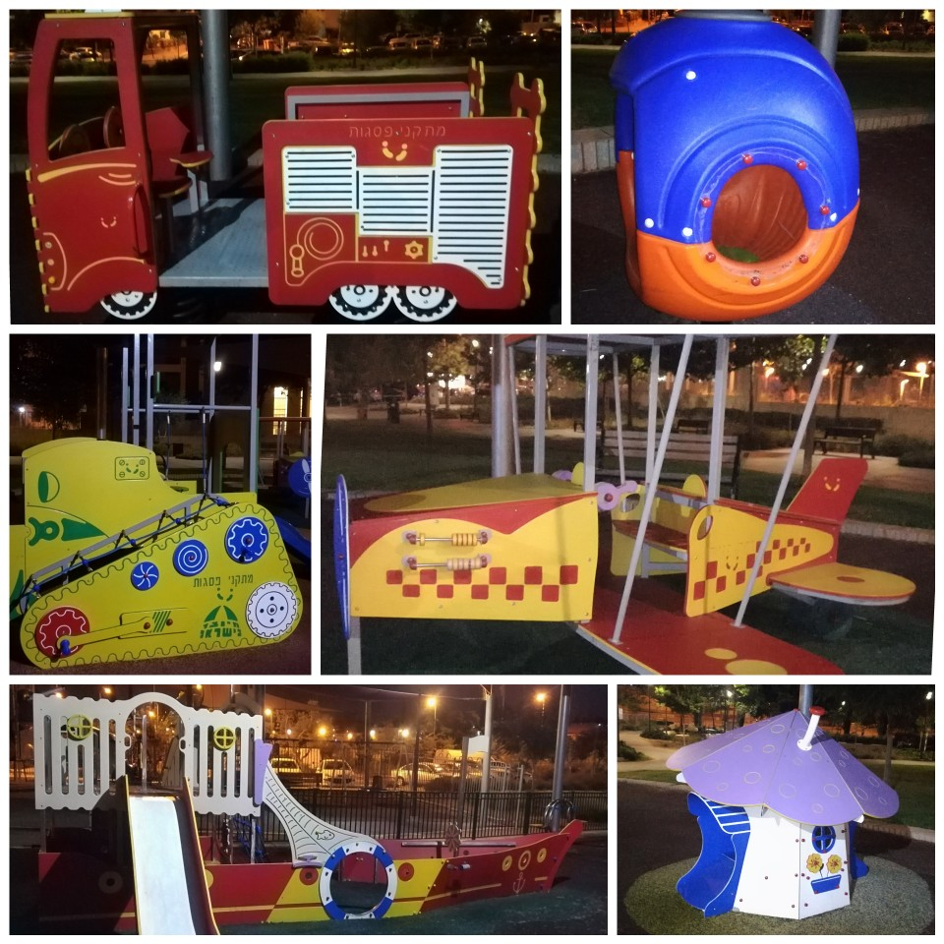

09-10-18
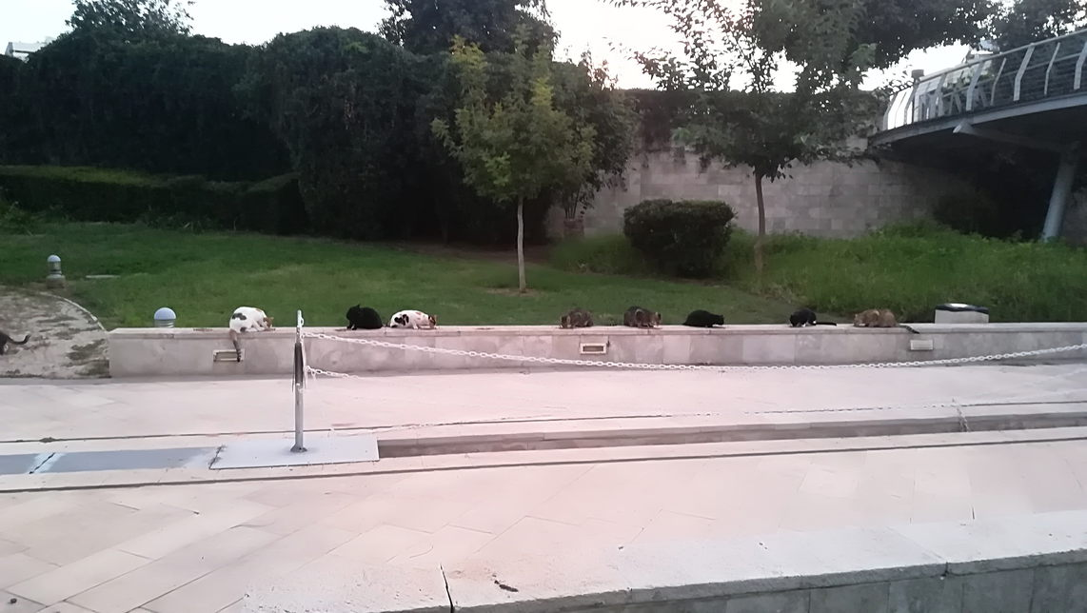
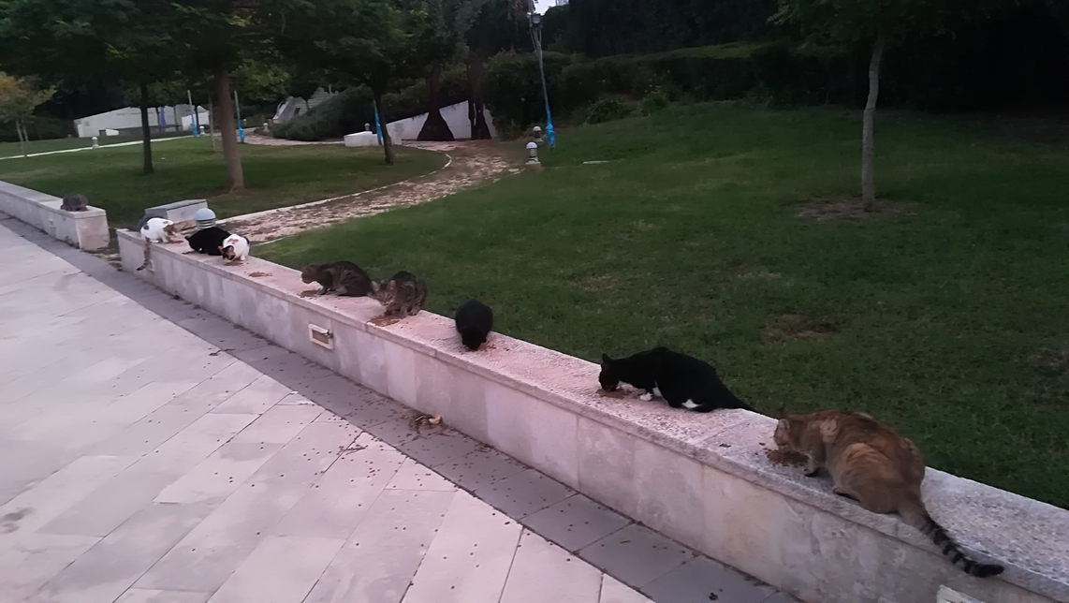
Just cats for company again at Dahan Family Unity Park
13-10-18
In the first half of last week I was diving into mathematics, partly prompted by being in the company of Group Theoreticians, and also by learning of an ex-colleague who was reading up about Linear Algebra. So it was a return to a pleasure ground of my youth that had turned into a battleground; an arena that once gave me a false sense of self-satisfaction but then implanted a false sense of inadequacy. The brief return to those pastures also reminded me how maths used to make me tense, and that I am now no longer able physically to run that tension off on the streets.
It was nice to absorb mathematics through the medium of YouTube videos watched on a bus or at the beach. But it was also refreshing to realise that I can let go and have no need to keep fighting the demons of forty five years ago.
On Thursday I went for the first time to the health clinic in Givat Shmuel; I was there for my flu shot and a lifetime pneumonia injection. The clinic was full, mainly of rather boisterous children and their mothers. As in previous encounters with the health care system, I found it very disorienting, with signage only in Hebrew. Rather than a receptionist at the entrance, there was a machine to allocate a number in the queue and for you to select the service that you required. It was only after struggling with the machine and its options that I found out that instead I needed to go to a different queue allocator elsewhere on the floor. As I sat down to wait my turn I saw opposite me an information display with three pockets, for three versions of the same booklet. This was "Know your Rights”, and the versions were Hebrew, Russian and French. In my temporary feeling of alienation, I found that quite telling.
There is a kindergarten immediately behind my building. Now that the children have returned after the Jewish Festival season, I was finding that I was being woken up by the noise in the playground. So on Friday I decided to move into the unused bedroom at the far end of the flat. I spent much of the day making the room habitable, moving bedding and furniture and cleaning shelves and floor. I was returning to the "house proud" frame of mind of six weeks ago, one that had slipped away in the interim. I then found myself cleaning the floors elsewhere in the flat that I had been starting to neglect. The experience was a gentle reminder of how easily one can slip into a comfortable state of apathy and complacency.
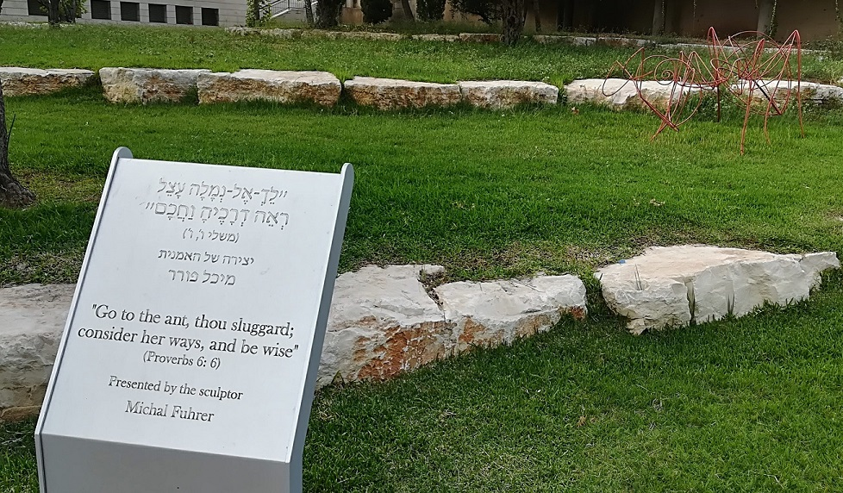
At the Bar Ilan campus: A biblical quote I knew since schooldays, through reading the John Wyndham novella "Consider her Ways"

14-10-18
My Ulpan (language course) was due to start this evening in Tel Aviv, but two days ago I was notified that the start was postponed because the class was now inquorate; one of the participants had dropped out.
Nonetheless, I enjoyed a satisfying few hours in the city, following up an afternoon spell on the beach with an evening concert by the Israel Philharmonic Orchestra, broadcast into Habima Square over closed-circuit television.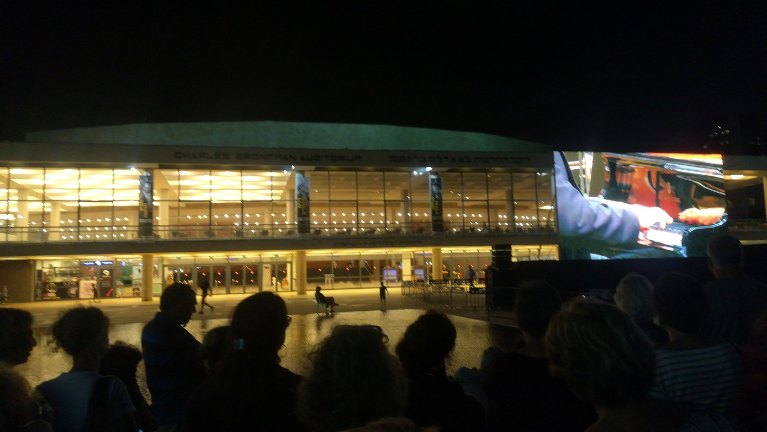
Then on return home I was notified that the class will start tomorrow!

15-10-18
On my return home at night after my first Ulpan session, I was greeted by this beautiful neighbourhood stray with an expensive taste in cars
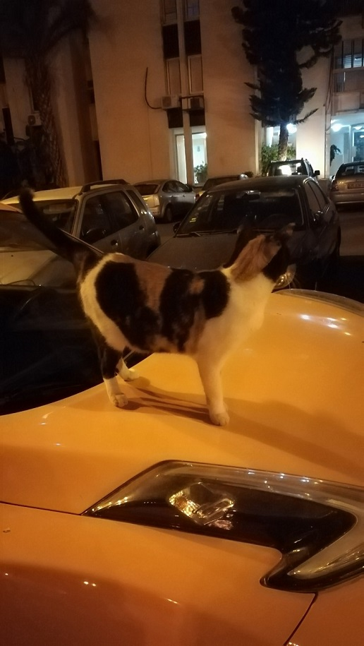

20-10-18
Climbing further up the hierarchy of needs in terms of transforming the flat into a home, I started thinking about artwork for the walls. There is a twice-weekly art market in an area of Tel Aviv called Nachlat Binyamin, so I went there on Tuesday and bought these from the artist
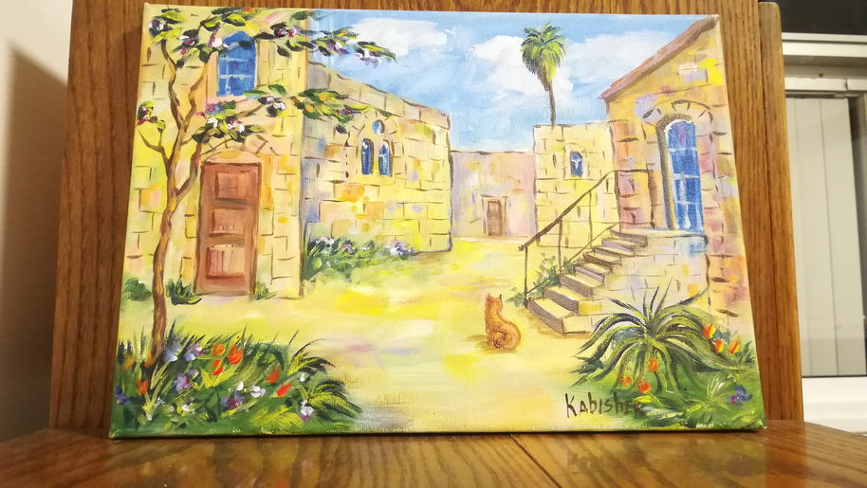
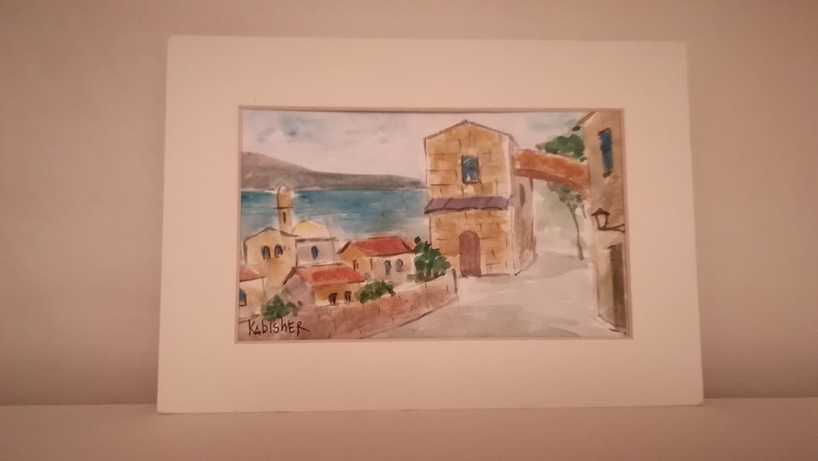
I had been keeping my eyes open for several weeks for a rug for what was, until a week ago, my bedroom; simply to reduce the assault on the senses by its ghastly floor tiles. They are of a design that is, unfortunately, ubiquitous in Israel, so I apologize to those Israeli readers who have it in their own flats. It is only my opinion!...
The only rug shops I had seen were filled with Persian rug designs more suited to my grandparents’ tastes of a century ago. But on my way to pick up some cash for the art market, I found two shops next to each other that seemed more hopeful. After making my purchases in the market I returned. I spent several minutes pondering the offerings of the rug shop but left having only mentally bookmarked one or two possibilities. I then popped next door to the cheap-and-cheerful shop, full of cheap bedding, cheap toys, cheap anything, but no rugs. But I thought: 20 shekels, that’s four pounds, why not?
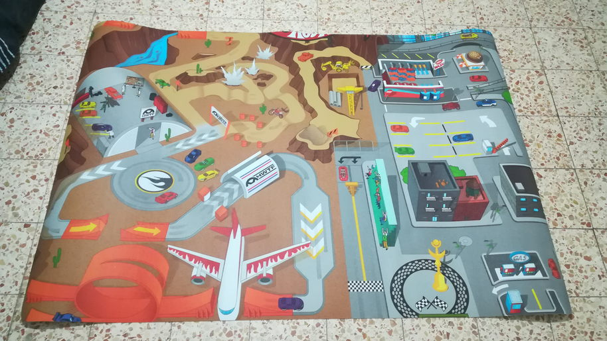
The floor remains a work in progress...
I also invested 10 shekels in a beach towel, and one can start to imagine the room as maybe a chill room, an exercise room, the possibilities are endless! As Arthur Daley would say, the world is my lobster!
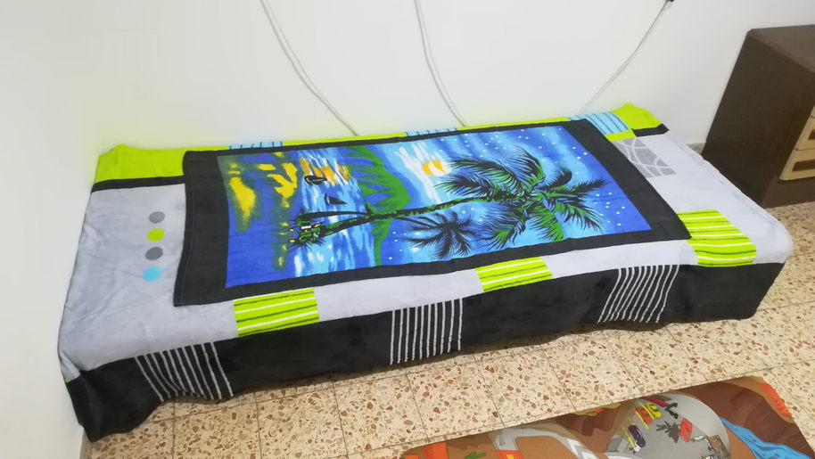

And for the living room, a cheap-and-cheerful canvas print:
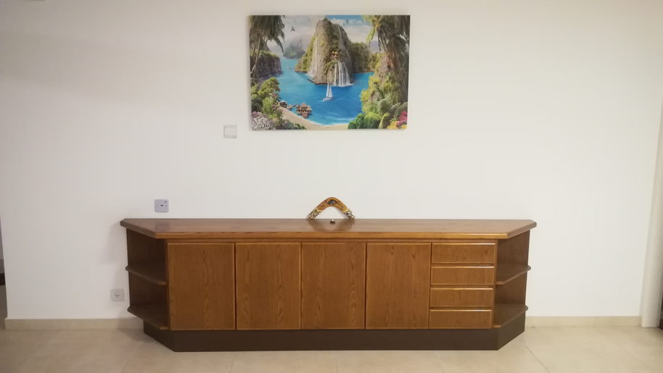

Election fever appears to be taking hold in Givat Shmuel,
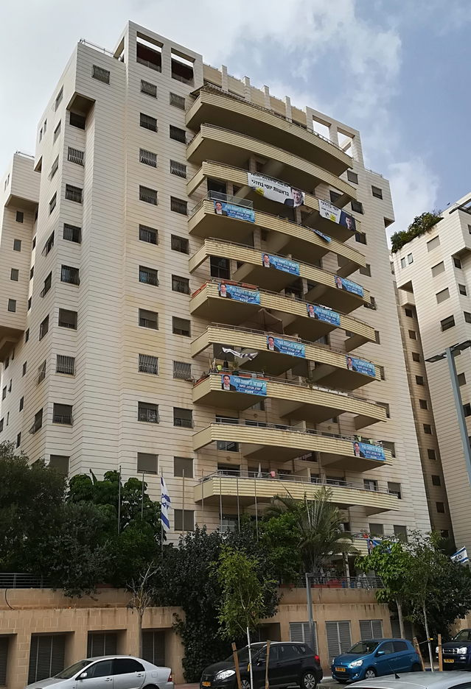
but a recent opinion poll shows the two women mayoral candidates totalling less than 8% of the predicted vote. So Naomi Annie Feldman has an impressive poster,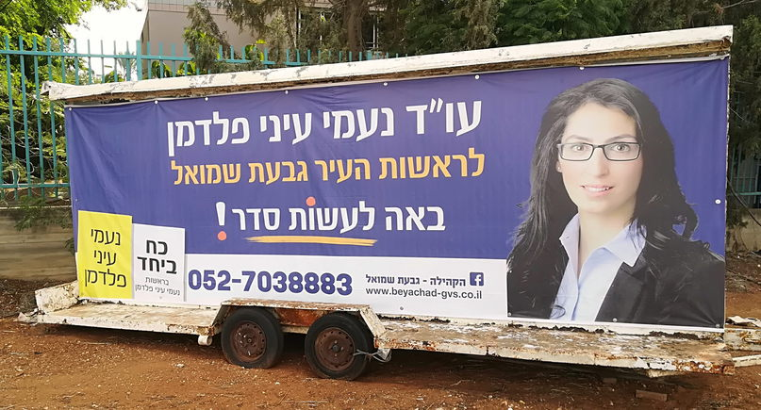
but a predicted 0.7% share of the vote..

I have never abseiled in my life, so I can only be impressed by the Givat Shmuel playground that makes abseiling freely available to every child..
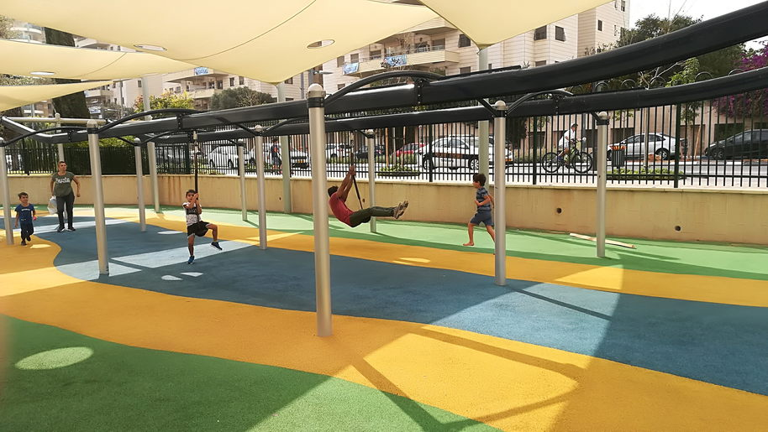
This playground, incidentally, is in the Ramon Park, named after Ilan Ramon, the first Israeli astronaut for NASA, who died in the fatal Columbia mission. Ramon was born locally and studied at Tel Aviv University.

20-10-18
It's always good to have a safety net. If I ever chuck it all in and want to go back to London, I should begin by walking south on Rahvat Ilan towards Alonim Street.
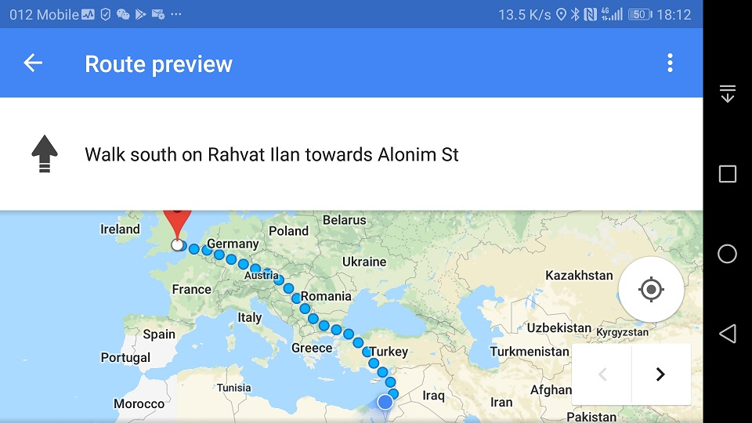
22-10-18
A number of people have written to me remarking in various ways on the difficulties that I described at the start of this diary. This crystallized in me a feeling that I needed to restore the balance with a prologue. You will find this prologue, not unexpectedly, at the start of this diary.

22-10-18
It is difficult to convey energy, noise and sheer spectacle on the printed page, but this was the view as I crossed a bridge walking to my Ulpan this evening. | 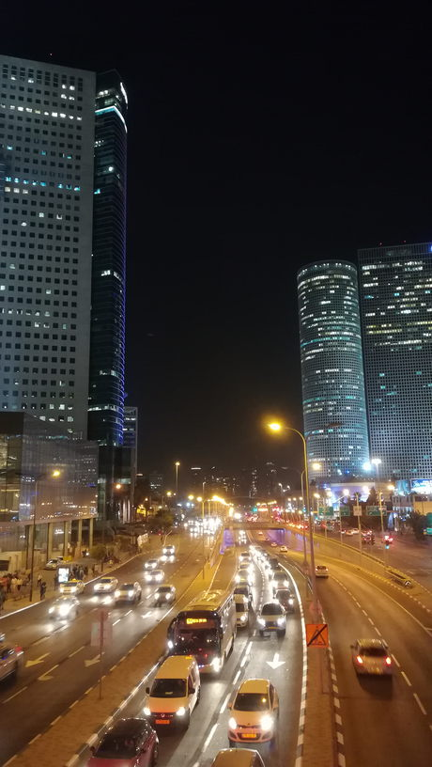

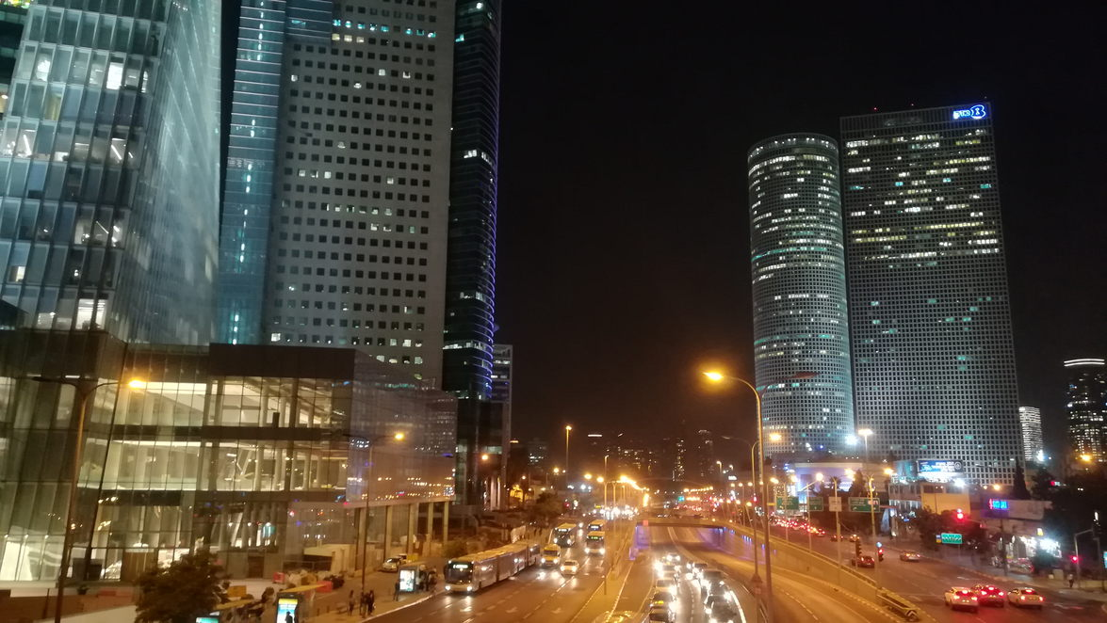
Learning Hebrew is quite a challenge. I have been comfortable with Classical Hebrew since childhood, so the Hebrew alphabet is no problem. Also, Classical Hebrew has given me an understanding of verb conjugations and irregularities that some students of Modern Hebrew do not possess; in the same way that, perhaps, students of English as a foreign language possibly have learned a list of verb conjugations whereas we mother-tongue speakers, well, we just speak it!
The Hebrew alphabet consists of 22 letters, all of which are consonants. In Classical Hebrew, the vowels are denoted by dots and small shapes above or below the letters. But Modern Hebrew presents the new challenge that, in written or printed form, it leaves out all the vowels. So if one is not proficient in the language, reading it requires some guesswork.
I am in a class of four, and the other three students are young women, all of whom are probably in their 20s. It is a very friendly and supportive group, with an excellent teacher. We meet three times a week, from 8 PM to 9:45 PM.
The first part of each lesson involves no reading or writing; just listening, and answering, and repeating.
And repeating.
And repea. And ting.
And repeating.
An eavesdropper who was not aware of what was going on might think that it was a mind-control re-education programme out of George Orwell's 1984. But no, this is the Pimsleur Method. Perhaps it is modelled on the way an infant learns to speak, without inhibitions, at one or two years old. As such, I feel that my habitual state of mental and bodily tension is a barrier to my learning. So I feel I need to consciously relax, and for that part of the lesson, my eyes are shut and my arms and legs are extended. It has been a fact of my life, for almost all my life, that I have needed to be different, to be the odd man out, or, let's face it, to be odd, just to survive. So no change there.
Possibly to everyone’s relief, I am on more familiar, more academic territory for the remainder of each session.
23-10-18
Back to Kabisher at the Tuesday Nachlat Binyamin art market, and back to my shop in Allenby Street, now selling everything with a further 30% off marked price.
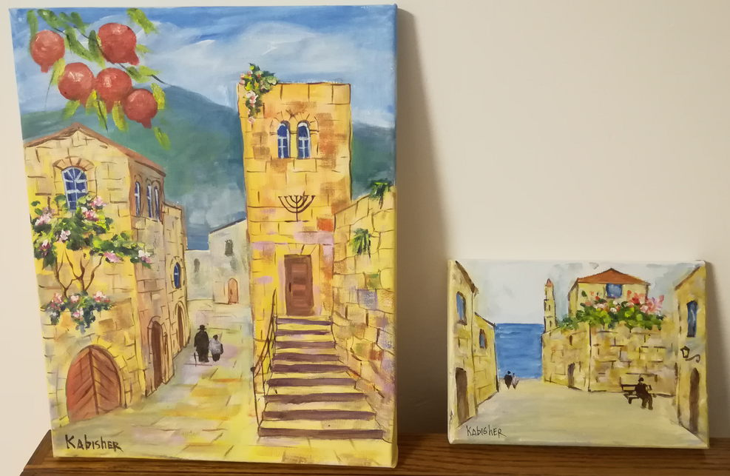

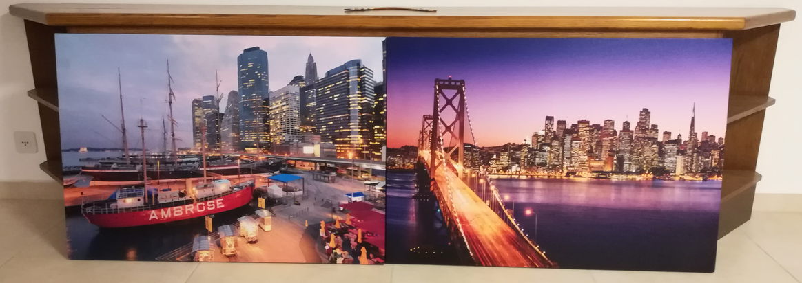
In the evening, listening to the Israeli Nostalgia radio station, I was bemused to hear "Puff the Magic Dragon" in Hebrew!
24-10-18
Returning to the subject of Hebrew, I learned in the last few days that the Hebrew letter 'resh' has a different pronunciation from the English 'R'. I got some help on this from an unexpected source:
http://www.briansacks.com/Temp/Roy_practising_his_resh.mp3

27-10-18
At Thursday's Ulpan session I learned of Galgalatz, the most popular radio station in the country. I listened to it today and found that it broadcasts an excellent mix of Western and Israeli pop music. Despite my owning their Greatest Hits, Volumes 1 and 2, it was the first time I had ever heard Queen's "Love of my Life". Galgalatz is one of two Israeli army radio stations; it reminds me of the days of my early childhood, when radio programs would end with, "brought to you by the American Forces Network in Germany".
On Friday, Jessica, David and Tzviya threw a joint birthday party for Amit (one and a half) and myself (somewhat older); complete with a Sarah & Duck cake, and a dramatic print for my walls: | 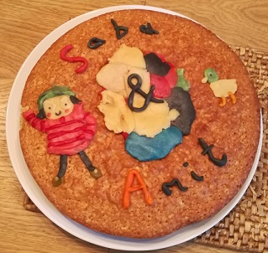

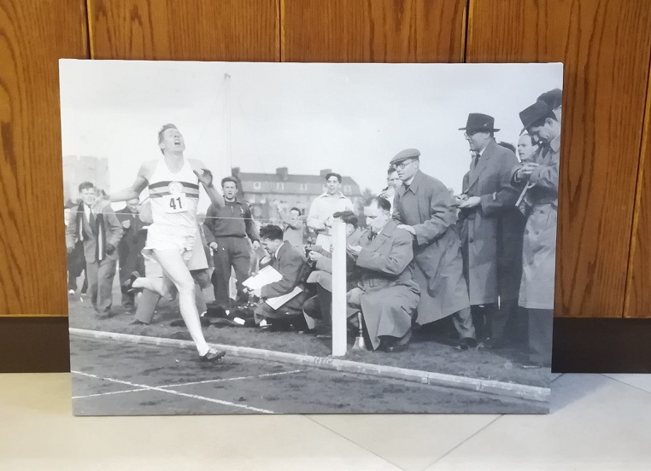

Exploring further this afternoon I found a wonderful outdoor gym, which one can reach by walking right through the Bar Ilan campus and then over the bridge to the other side of Route 4. This picture shows only some of the equipment: | 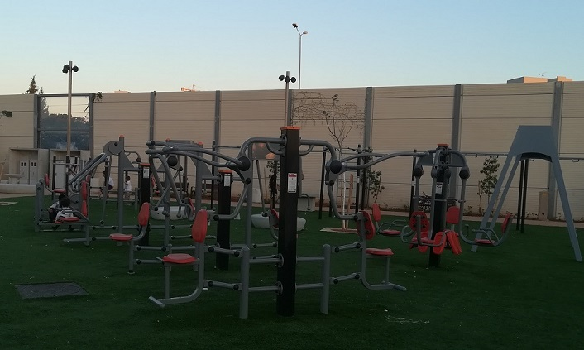
Meanwhile my phone, unbidden, keeps dropping hints! | 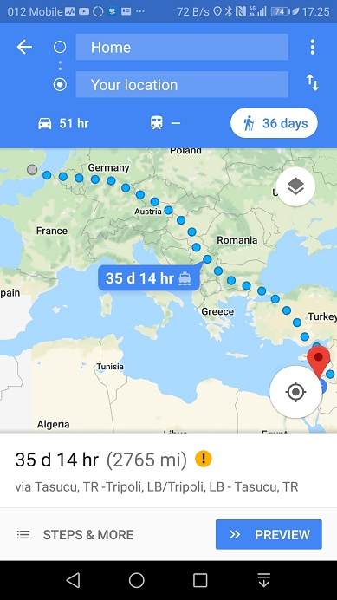
28-10-18
There are at least five different bus routes to Tel Aviv from where I live, and I take the first bus that comes along. So I am liable to get off at a different place and walk each time I travel to my Ulpan.  This was the view when I got off the bus tonight: | 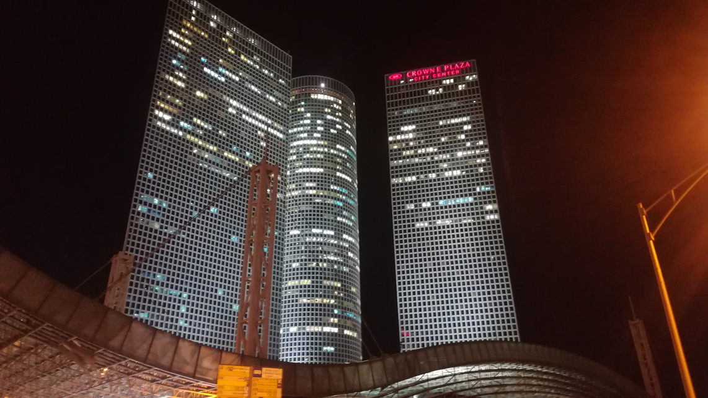
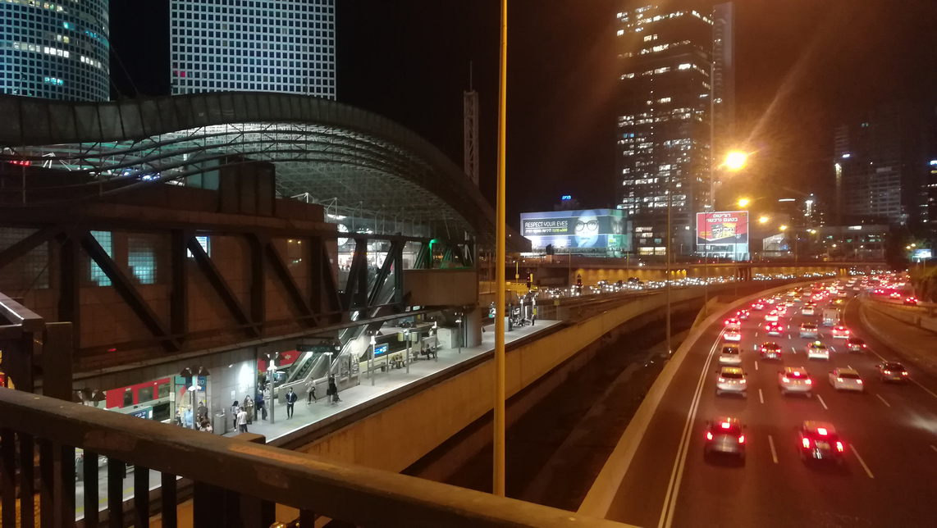
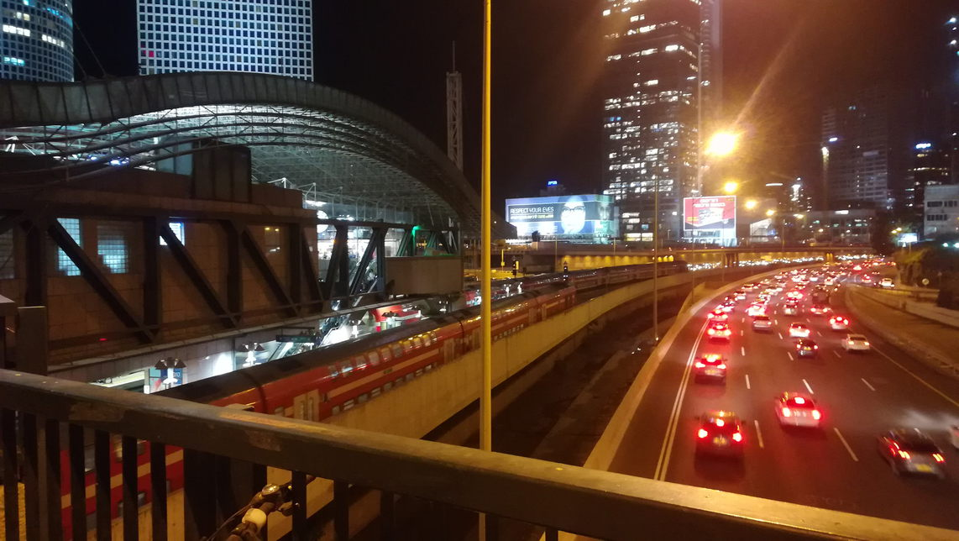
Turning to dramatic cityscapes on a different continent:
Google reverse image search adds information value to the canvas prints that I bought on Tuesday:
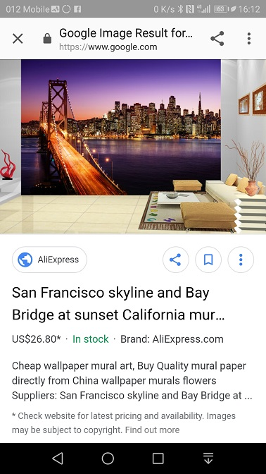
30-10-18
Today was municipal election day throughout the country. One of my fellow Ulpan students took this photo of the available electoral choices at her voting station in Tel Aviv: the yellow slips denote the four mayoral candidates, while each white slip represents a different political party aspiring for representation on the Council. So no shortage of options for the voter...  In the evening I walked through the Bar Ilan campus and across the bridge over Route 4, back to the open-air gym that I found on Saturday. It is clearly in an ultra-Orthodox neighbourhood, and it was surprising and satisfying to see, at eight o'clock in the evening, so many children and their parents working out and playing football: | 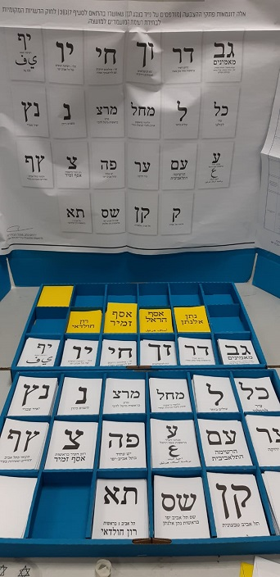
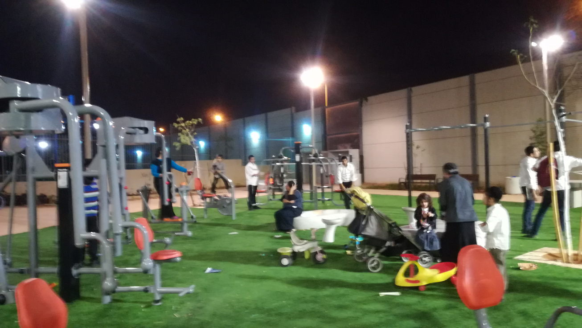
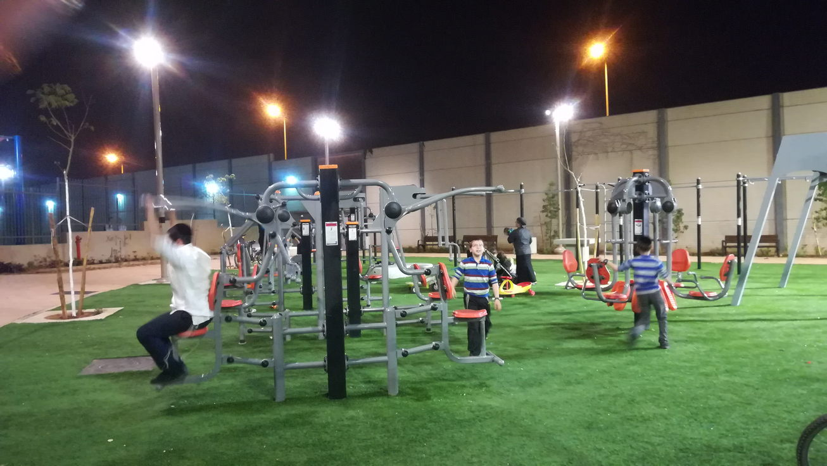
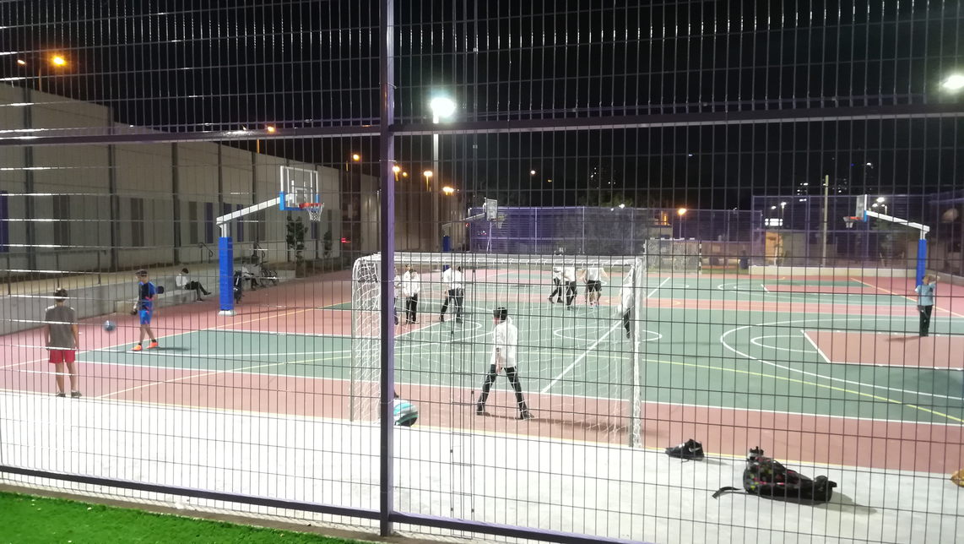
Having lived in my rented flat for a full two months, it is clearly high time to let the Ministry of the Interior know my new address. As such, I have just spent another torrid hour playing the Israeli game of "Can you maintain the balance of your mind while negotiating the obstacle course of Israeli officialdom". Thankfully Lyn rang up just in time to prevent me being sucked into a black hole of frustration. And I have an appointment next Wednesday in which hopefully I will register my new address and also submit an application for my first Israeli passport.

