August to October 2018: www.briansacks.com/Israel_Diary_Aug_to_Oct_2018.docx
November to December 2018: www.briansacks.com/Israel_Diary_Nov_to_Dec_2018.docx
January to May 2019: www.briansacks.com/Israel_Diary_Jan_to_May_2019.docx
01-06-19
I finally got round to piecing together my model of Leonardo da Vinci's self-bearing bridge, made and sold by an Italian toy maker at the Nachalat Binyamin market.  Perching on the side of the bridge are its architect and his cat.  Together with the same toy maker’s da Vinci flier, and violinist balanced atop a logarithmic spiral, they make for quite a satisfying toy shelf. | 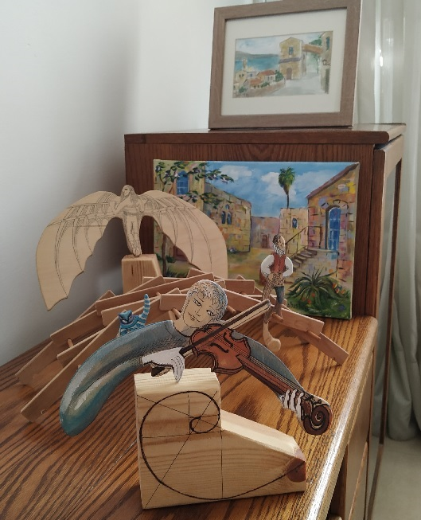

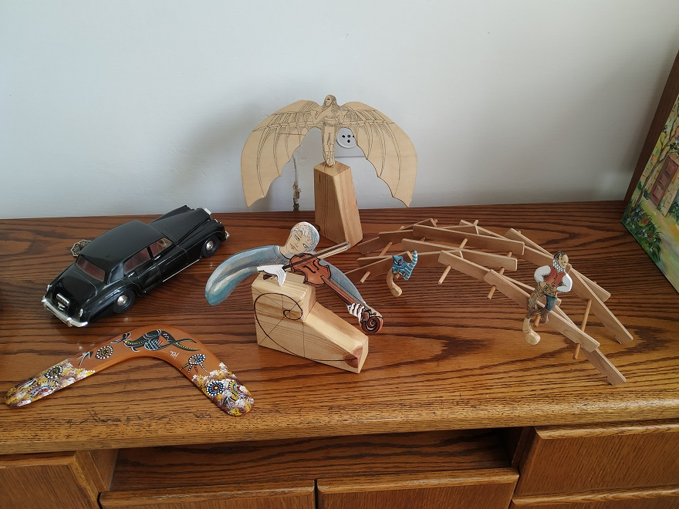
04-06-19
As we approach the 75th anniversary of the D-Day Landings of June 6, 1944, last week I spent some time learning about the barely imaginable heroism, sacrifice and tragedy of those landings. I also gained some appreciation of the technical brilliance that contributed to the success of Operation Overlord; in particular, the design of the Mulberry Harbours, the temporary deep water harbours that were created off the Normandy coast. Individual sections, called caissons, of what were to be the harbour walls, were constructed in various English locations. They were then floated a hundred miles across the English Channel. At Normandy these caissons were "scuttled" by opening a hole near their base, allowing seawater to fill them and cause them to settle into the seabed. These sections, lined up, formed the harbour walls.
****
I spent today in Caesarea, the magnificent port city built by Herod the Great between 22 BCE and 10 BCE, and discovered that this was the first man-made deep water harbour in the world. To my mind, which I must admit is untrained in engineering matters, the methods used by Herod seem very similar to those used at Normandy almost two thousand years later. As with the Mulberry Harbours, Herod assembled the harbour walls from individual floating sections. His sections were rafts, each topped with an empty enclosure, or pen. When each raft was in position, the pen was filled with a volcanic soil which hardened like concrete, and the raft settled into the sea bed. As with the Mulberry Harbours, these sections, lined up, formed the harbour walls. Remain of Herod’s harbour walls can still be seen today.
Caesarea Picture Album

11-06-19
Musings on the day’s trip to Tel Aviv
The trip started at my usual bus stop, at the exit to Bar Ilan University where the lamppost offering a blessing for finding your life partner stands adjacent to the road sign from which King Messiah Menachem Mendel Schneerson waves benignly. (See diary entries 23-05-19 and 03-11-18 respectively). This spot, a major hub for buses, is at a busy and congested road intersection. Being an exit from the University, it is also a point where drivers frequently stop to pick up their student friends. They do this Israeli-style of course, which means without signalling nor drawing particularly close to the kerb, and oblivious to the fact that they are thereby preventing buses from drawing into their stop. But the blaring of car and bus horns does not perturb driver or student passenger, or disrupt their warm smiles of greeting. The Israeli psyche is captured here in microcosm.
An hour or two later I found myself wondering why everyone in Tel Aviv has a dog – until I turned a corner and found that I was wrong: some of them have two dogs.
I wondered why. I tried to put myself into the mindset of a dog lover, and my guess is that he feels: a dog loves you unconditionally; it is always there to talk to, and even though it can't speak, you can speak to it and it understands you and appreciates and empathises with what you are saying.
Coming back to Givat Shmuel, where I live, there are slightly fewer dog lovers, but a higher proportion of God lovers. For the exercise, I tried to put myself into the mindset of a God lover, and my guess is that he feels: God loves you unconditionally; He is always there to talk to, and even though He doesn’t speak to you, you can speak to Him and He understands you and appreciates and empathises with what you are saying.
(The above is an extract from my forthcoming book, "How to lose friends and alienate people". But being a fantasy, please don't take it too seriously)
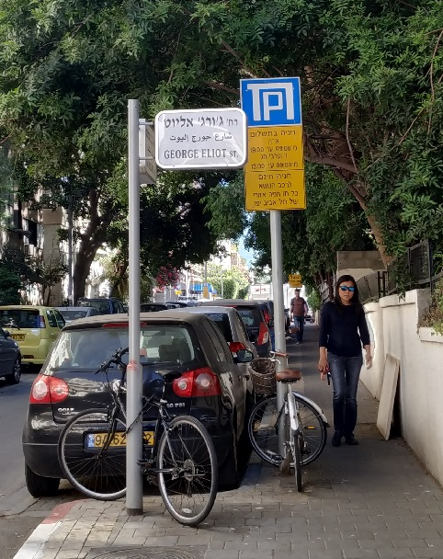 | 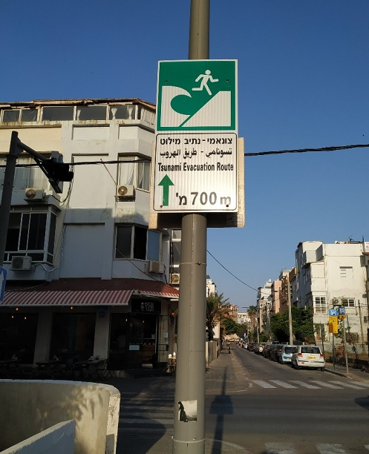
Homage to an English authoress | Let tsunamis be Tel Aviv’s biggest worry

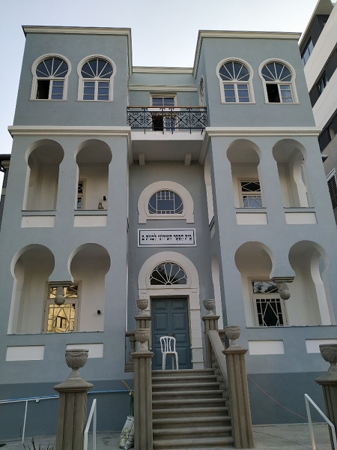 | 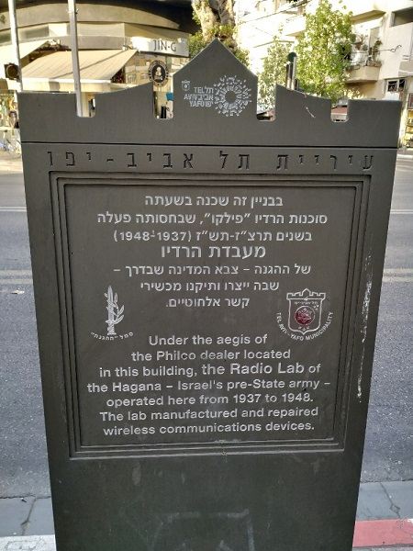
At Allenby Street

16-06-19
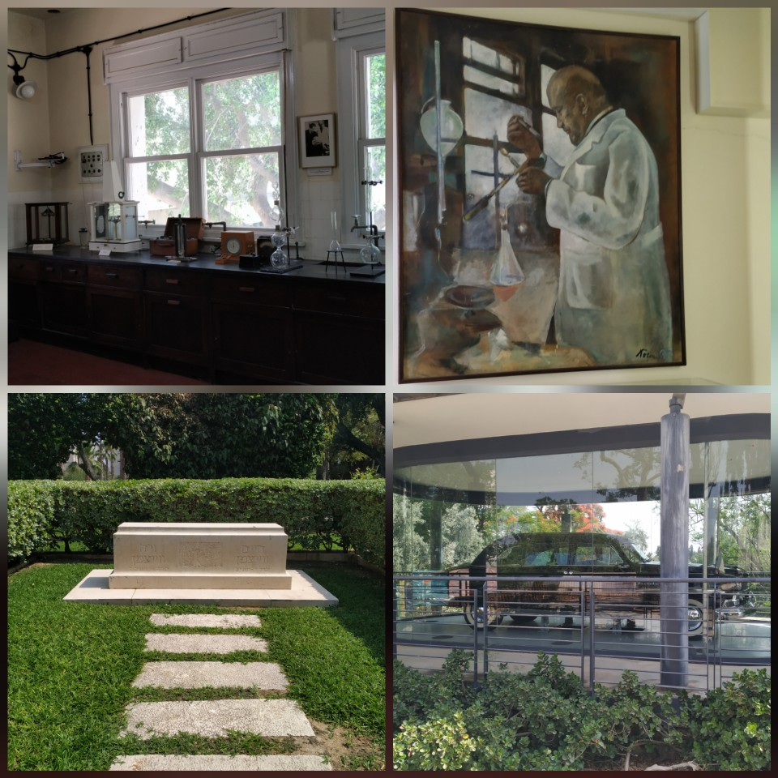
At the Weizmann Institute of Science, Rehovot
Top: Dr. Weizmann’s laboratory and portrait
Bottom: The grave of Weizmann and his wife, and the Presidential car given to him by Henry Ford. It was one of just 18 cars of its type, manufactured according to specifications drawn up for the President of the United States.
The Weizmann Institute, originally called the Daniel Sieff Research Institute, came into being as a result of Chaim Weizmann’s efforts. Weizmann was a towering figure in 20th century Zionism, and the first President of Israel. His scientific work (in the manufacture of acetone through the fermentation of bacteria) was a significant contribution to the Allied victory in World War I.
My thanks to Prof. Peter Rez for the tour.

20-06-19
I took advantage of an offer of a week’s health club membership at a promotional rate, and this is taking me beyond my usual stamping grounds. Here are some street adornments on my walk to the club:
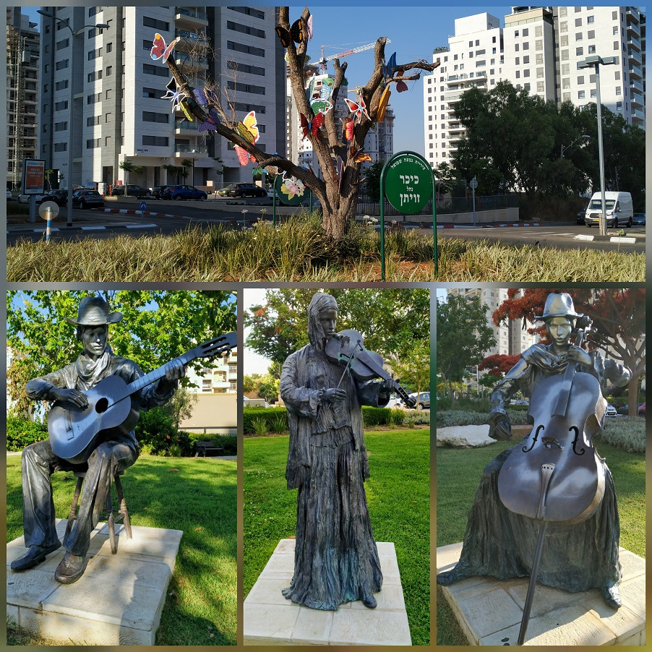
Incidentally, at the club reception yesterday, I was privileged to see a replay of a famous scene from "Fawlty Towers". I was being served at reception when another gentleman butted in with a request. The receptionist replied, "Rak rega" - "Just a minute". He responded, "Efo rak rega" - "What’s this, just a minute?"
The old lady from the Fawlty Towers episode may have passed on, but her spirit still lives. Here is another scene from the same episode: https://youtu.be/tcliR8kAbzc

26-06-19
I ventured to within five miles of Gaza, down the coast to Ashkelon. That is where three thousand years ago Samson fought his battles against the Philistines, only to fall prey to the wiles of Delilah.
As one walks from the Central Bus Station down to the sea along the street 'Sderot David Ben Gurion', the story of Samson and Delilah is told in stone and plaque – see the photos here. A few more snaps I took once I reached the coast are here.
06-07-19
One of the many rounds of the radio programme "Just a Minute" that I have enjoyed listening to was on the subject of "The double-whammy". This week I felt the sting of my own personal double-whammy: the tumbling of the UK housing market combined with the plunging of the UK pound - Israeli shekel exchange-rate. I find myself caught at the wrong end of both of these crashes, needing to sell my London flat in order to pay for the flat that I am buying in Israel. But equally, this stark realisation forces me to reflect on how relatively unimportant all of the above is. Yes, at age 67, health, family, loved ones and friends comprise what matters and what is to be cherished.
07-07-19
Intriguing to see that supermodel Naomi Campbell paid homage today to the Messiah of my Bus Stop, Menachem Mendel Schneerson (see entry for 03-11-18).
Universal Love seems to be a common message of more than one man revered as Messiah. I guess that the Messianic Age will be when that message prevails - at least in one place, at one time..
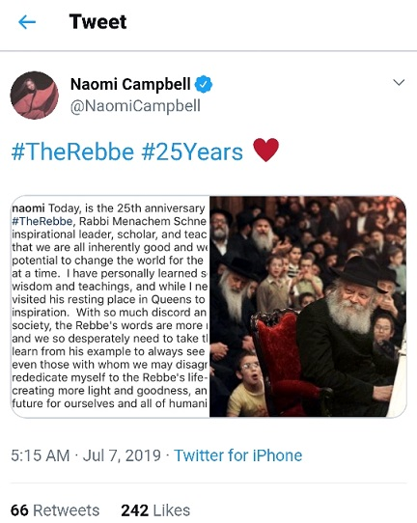 | 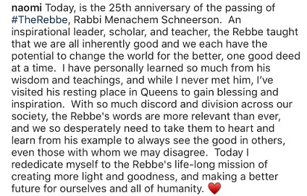

14-07-19
It may be two and a half thousand years old, but Zeno’s Paradox still has its present day relevance.
When one buys a new flat in Israel, still under construction, one pays for it in stages. At any time, the outstanding balance is subject to indexation, up to the current month's Construction Index figure. However, this figure is only published on the first day of the following month.
Hence, if one clears one's balance at any time, one finds, at the start of the following month, that in fact one’s payment didn't clear the balance, because it was not up to date with the index - which was only published after the end of the month of one's payment.
Thus one still has a balance to pay...
And so on ad infinitum...
in much the same way as Achilles could not overtake his tortoise two and a half thousand years ago.

10-08-19
August 1 was the first anniversary of my arrival in Israel. Much as I might have been tempted to celebrate and to spend time looking back over the year, I was instead pre-occupied with preparations for temporarily leaving Israel. Any celebratory mood was rendered almost impossible by the continuing haemorrhaging of the pound’s value against the shekel, which is correspondingly ramping up the amount I owe on the flat that I am buying.
On August 6 I was to move out of my rented flat in Givat Shmuel and move back into my Finchley flat, newly vacated by its tenants. The plan is to stay in Finchley until I succeed in selling the flat, and then return to Israel in late 2019 or early 2020. I should receive the keys to my new Israeli flat in late April 2020. Beyond those details, nothing is fixed.
Back to my situation in Givat Shmuel on August 1: Within the first six days of the month I needed to move all my possessions out of my rented flat and into a storage room in David and Jessica's building, 1300 metres away. Of course in England, this would be a simple matter of a few trips by car. In Israel I have no car, and feel less inclined than I would be in England to look for "a man with a van". As such, I carried most of it across on foot, taking just a few bus journeys for the more unwieldy loads. As I sweated through temperatures that were well into the 30’s Celsius most of the time, I reflected that, while some people climb Kilimanjaro or cycle from John O'Groats to Land’s End, at least my physical challenge had some practical purpose to it.
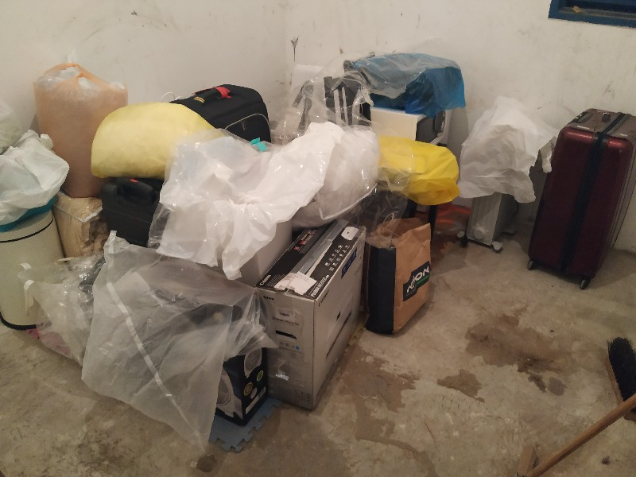
My possessions now carried across to storage
Stepping onto the plane at Ben Gurion airport represented an End of Part 1. Stepping off at Luton was the Start of Part 2. I knew that I was returning to a flat that was literally empty apart from furniture, and I included in my luggage a toilet roll, some liquid soap, a hand towel, a blanket and a pillow slip, all representing a survival kit until the new day dawned. Flight and bus delays meant that I arrived home at around 3:25 AM.
When I surfaced on the afternoon of August 7, I was faced by the need to make a big supermarket trip without the use of a car. I remembered that, in my mother's final years, her carer used to use her suitcase as a shopping trolley, so I decided to do the same. I weighed it on my return: full suitcase 22 kg, plus an additional 4 kg in shoulder bags.
I now had the laborious job of bringing my UK possessions out of my garage - again by muscle power alone. But this time the separation between storage area and apartment building was less than a hundred metres.
Coming back to England reminded me of the tricks that muscle memory plays: I have to relearn that, in England, pressing the bottom of an electric switch turns the power on, not off!
10-08-19
I was taken by surprise by an incident that happened on my second trip to Tesco's on my first day back, August 7. It was just before midnight, with very few customers left in the store. I noticed someone with a T-shirt bearing the legend "אני אקטן". I asked him why he wore the Hebrew message "I will become small", and as he turned I saw that the front of his T-shirt read "שהוא יגדל" - "so that he will become large". It also sported a Star of David. He explained that they were the words of John the Baptist, heralding the greater One who was to come after.

23-08-19
In the late afternoon of Monday, August 12, I wanted to get to my solicitor to hand over the lease of my London flat and other documents. These had been requested by my prospective purchaser's solicitor some weeks previously, but they were locked in my garage in Finchley while I was living in Givat Shmuel more than two thousand miles away. My solicitor's office was due to close, and so when a bus went by I sprinted to catch it. This was not a wise move. I went splat on the pavement.
The bus waited for me to pick myself up and stagger aboard - something that would be perhaps unlikely to happen in Israel. I had the meeting with my solicitor and he then tried to call a minicab for me. But none were available, so I made my way to the Royal Free Hospital Accident & Emergency Department on foot and via Underground.
An x-ray showed that my left humerus was broken at the top into two pieces. But the pieces were, and so far continue to be, well aligned, and so hopefully the bone will heal without needing an operation. I am lucky that it was not a worse break. I must keep my left arm supported in a collar and cuff that I wear all the time except when showering and when, four times a day, I do basic exercises to maintain mobility in my hand.
So I am now restricted to only using my right hand – and I am left-handed. I am living in interesting times.
The x-ray below was taken on August 20, eight days after the fracture happened. The specialist was pleased that the bone alignment was excellent. The mirror-image selfie was taken at the house of my brother and sister-in-law, with whom I stayed for the first two days after my fall.
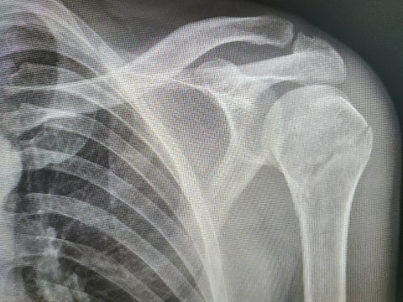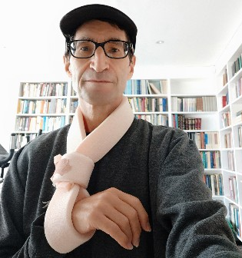
In terms of the impact of my current situation on my daily living, I will only mention the biggest inconvenience: I cannot put any garment onto my upper body by myself. This means that whatever I am wearing at any time on my upper body is what I will be wearing outdoors, indoors and in bed until I next meet Lyn. So every two days I shower, every two days I change my upper body clothes.
Having thought that it was only a matter of time before I would be mowed down by an electric bicycle or a scooter on the pavements of Tel Aviv, I came to grief on the relatively safe and vehicle-free pavements of Finchley. As a professional-level worrier, there is a moral in the incident for me: Cheer up, yes it will happen, but "it" will be something completely different from what you spent all those days and weeks worrying about.

03-11-19
I have now been back in Israel for a few days, having returned on my birthday. It is delightful to be back with the family, and my grandchildren Tzviya and Amit are overjoyed that I have returned to them. My London flat is sold, and the proceeds enabled me to pay for the flat that I have been buying in givat shmuel. It looks as if it will be ready on schedule, for handover in April 2020, or possibly even earlier.
I have arrived at an airBnB that is a fifteen minute walk away from the family. It is astonishingly nice and reasonably priced, and I am the first person to ever stay here. Almost everything about it is brand new; the towels, the cutlery, the crockery, the washing machine and much else besides have never been used before. I think I will be lucky enough to stay here for almost all the time until the keys of my new flat are handed over.
I flew into Tel Aviv not directly from London, but from Budapest, where I enjoyed five full days of sightseeing and unseasonably pleasant weather. Photos at https://photos.app.goo.gl/baBtbBHoTwddpfao6.
It is now close to twelve weeks since my left arm came crashing down on pavement and fractured. I needed to wear my 'collar and cuff' for four weeks and I then moved on to physiotherapy sessions, at which I was prescribed three-times-per-day exercises. The arm has been improving well both in terms of strength and in terms of range of movement. I do experience some pain, especially during the night. The exercises themselves, in which I am trying to extend my range of motion, seem to contribute significantly to the pain. But it is manageable, and if I do take a pain killer it is only once or at most twice a day. If my mind is properly occupied or I am in company I forget about it.
It has been quite a learning experience. So many habitual tasks of daily living become significant challenges when one has only one arm that works, and that being the non-dextrous arm. A day or two before I flew to Budapest I tied shoelaces for the first time since my fracture. It had taken weeks for me to be able to wash my right underarm with my left hand, rather than with my right hand gorilla-fashion. Even now, that operation represents the very limit of my left hand’s range of motion.
24-11-19
I return to my AirBnB tomorrow for another forty-eight day stay, having been compelled to temporarily make way for a prior booking. But I have enjoyed these ten days, dividing my time between Jerusalem, Mitzpe Ramon and Eilat.
It was a long-awaited first visit to Mitzpe Ramon, the world's largest erosion cirque (thank you, Wikipedia – and no, I had never heard of the term either). It is a place of beauty, quiet and solitude, provided one is dogged enough to keep walking on until voices are no longer heard.

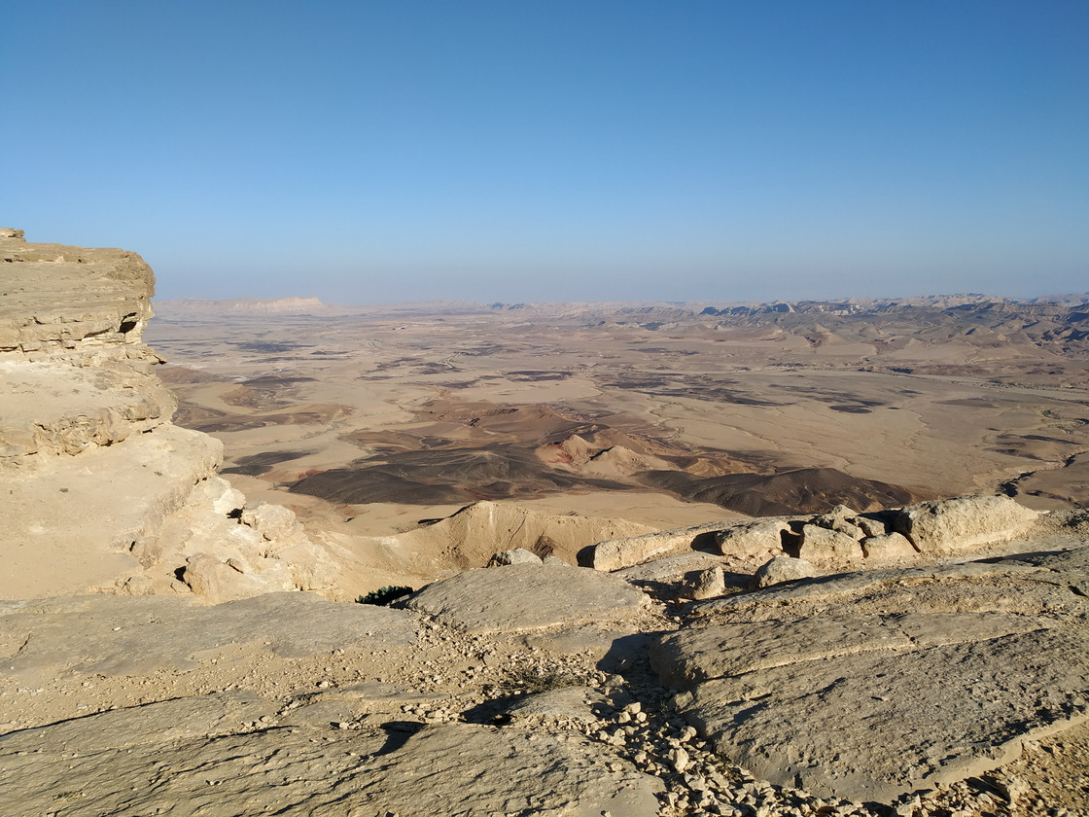
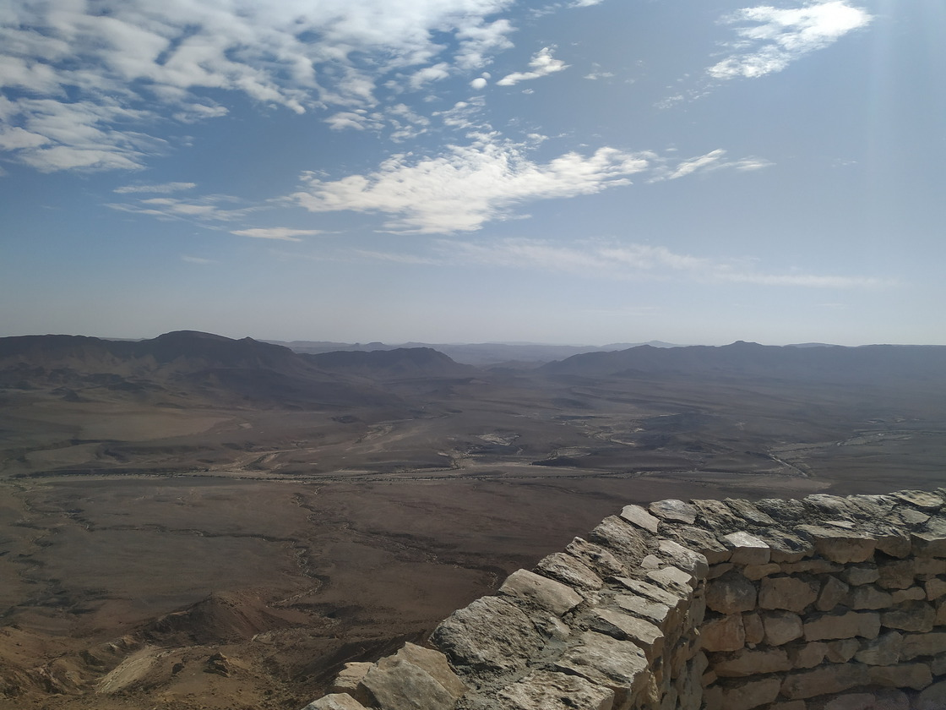
By contrast, I have been to Eilat at least eight times before, probably more. I used to come for winter holidays during the nineties, when Eilat was a popular destination for Britons seeking winter sunshine. Then, during the early years of this century, the regular flights to Eilat from the UK stopped and the resort became tatty and appeared to cater just for Israelis. But it has definitely revived, and has much to recommend it. The weather is beautiful, warm and dry. The light blue waters of the Red Sea lap placidly, surrounded by mountains that turn red as the sun sets. The pace is calm and unhurried, and in place of the constant clack-clack-clack of the Tel Aviv matkot (that is, bat-and-ball) there is the sound of gentle, and often pleasing, music drifting across from the promenade public grand piano.
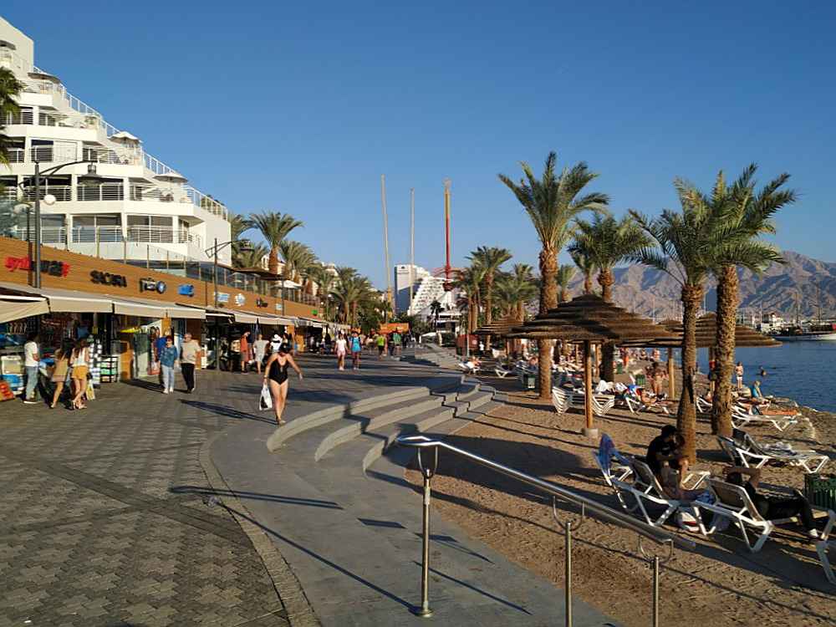
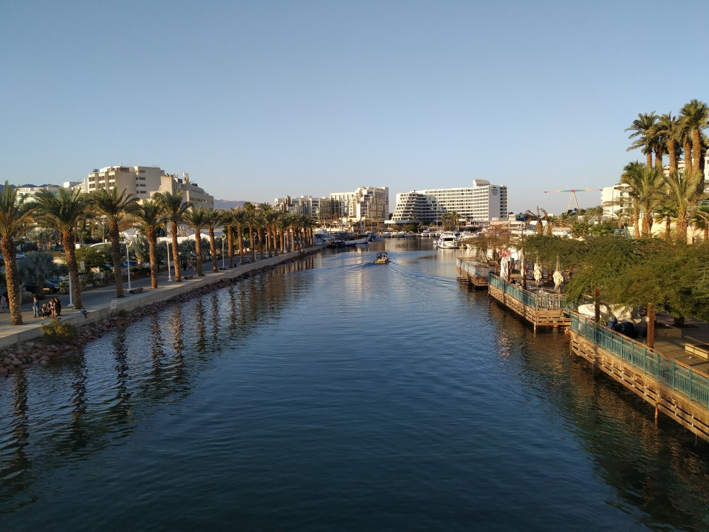
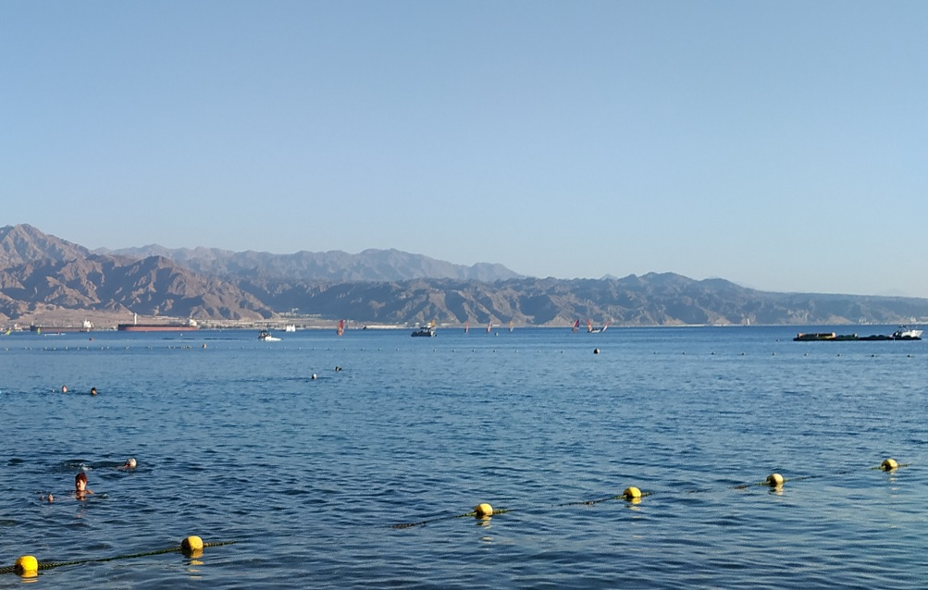
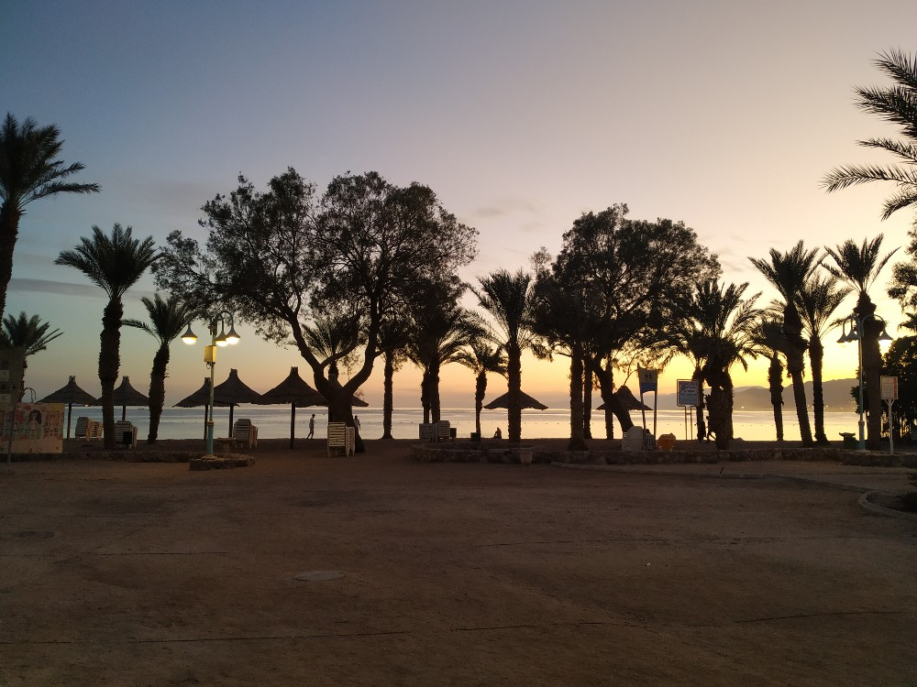

29-11-19
Stumbled onto Donald Trump Square in a rather downmarket part of Petach Tikva today.. | 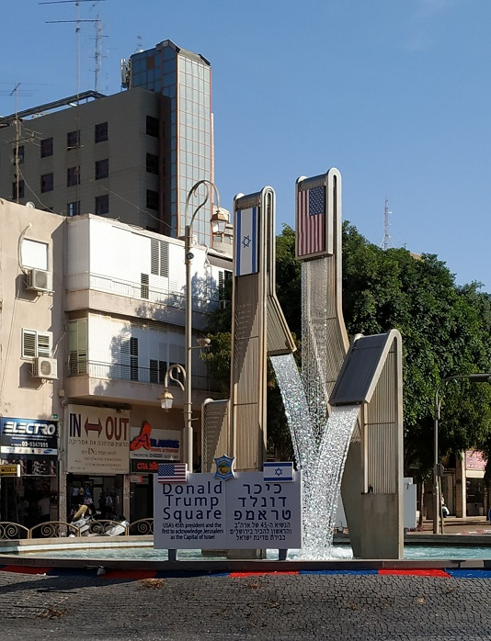

01-12-19
The hottest topic locally in Givat Shmuel is the light rail, proposed for linking Givat Shmuel and other suburbs into Central Tel Aviv. Passions are high in favour of and against the proposed route and stations. Apparently it looks as if a compromise might be reached, moving the most controversial station to a street where there are no current residents to object - namely the street where I have bought an apartment.
I was somewhat amused by this placard that I spotted on my way to babysitting for my grandchildren:
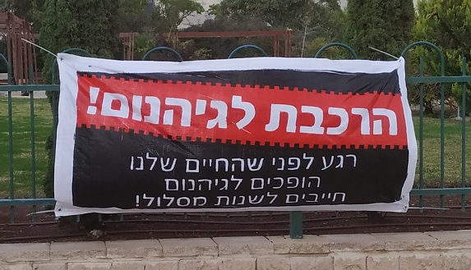
Against the red background it reads: The train to Hell!
While below, it declares: A moment before our lives become hell, we must change the route!

24-12-19
As I have written previously, I am the first person to ever stay in my AirBnB, and almost everything in it has been brand new. But there have been one or two teething problems, as one might expect with a brand-new apartment. Also, it is a basement flat, meaning that there is no telephone reception, and I only get a clue as to the weather once I get myself out and up to ground level. It's funny how something can seem perfect to start with, and then, slowly, slowly, awareness grows of the imperfections of reality. (Yes, you may make your comparisons with falling in love. As Francis Urquhart would say, I could not possibly comment).
Interesting things have been happening in the last week or two regarding trying to improve my Hebrew. First of all, Gideon, who was my landlord last year, wanted me to teach him English so I agreed so long as it was a relationship in which we each taught each other our own native language; and that has been going well. Also, my daughter told me of a website and an app called Tandem, which links up people who wish to learn each other's language. That is also showing a lot of promise.
The grandchildren are delightful. Tzviya is kind and protective and big-sisterly towards Amit, although of course they both do have their moments. I spend quite a lot of time with them. And in four months’ time Jessica is expecting baby number three!
My laptop has died and I'm surviving (and writing this) using my trusty old Windows tablet, which was on 8.0 when I bought it but is now up to the latest release of Windows 10. I will hold off from replacing things until I am in my own flat, which will possibly be within the next two months. The flat is halfway (that is, on the tenth floor) up the left hand building of the two that can be seen in the background of the photos below.
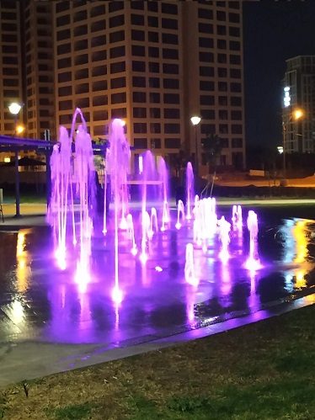 | 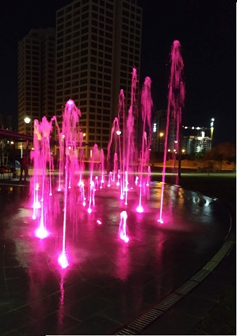 | 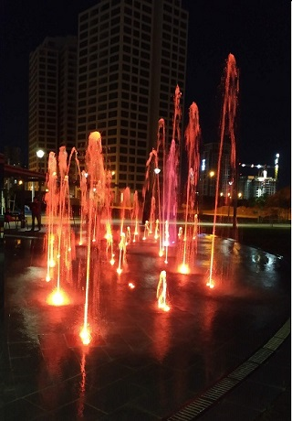

The United Colours of Givat Shmuel – Part 1

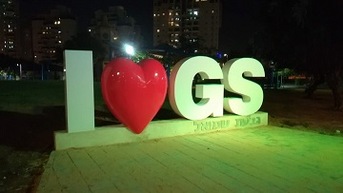 | 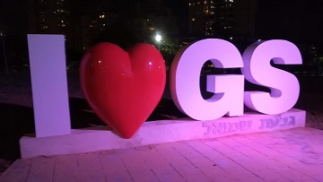
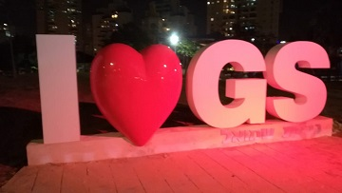 | 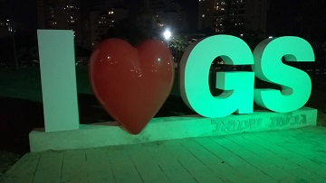

The United Colours of Givat Shmuel – Part 2
(whose residents have disunited views on the new attraction, other than agreeing that the S is upside down)

15-01-20
I am sitting out on a balcony in Eilat, bathed in hot sunshine. It is quite a contrast from a few days ago, when a record-breaking week of rain throughout Northern and Central Israel began with a record-breaking day of the same:
04-01-20
I took myself out for a five mile walk at 1:30 a.m. for two reasons:
- The first, my nocturnal nature: I am most active after dark - though some people reduce that to an acronym.
- The second: two straight days of Noachian deluge were forecast. Anticipating being holed up in my basement flat for those two days, I thought I ought to get my exercise in while I could.

Throughout those five miles on the streets, I saw just one other pedestrian. I returned to my flat at around 2:45 a.m.

So a late night was followed by a late morning, and I awoke to find my basement flat underwater. Luckily I sustained very little property damage, but it took my AirBnB hosts the best part of two hours to squeegee away the flood. Meanwhile, videos were circulating online of cars being washed away on the streets of Tel Aviv, and two people tragically drowned in a lift.

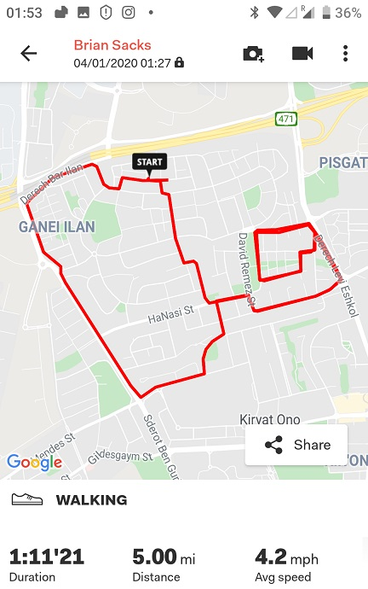 | 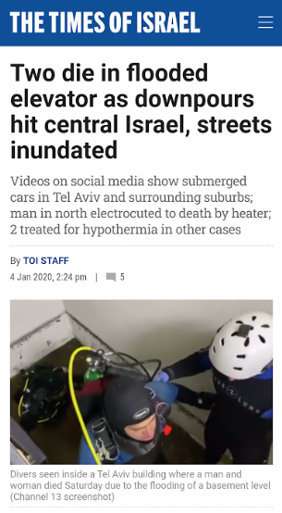

25-01-20
What is a fellow to do when he is only able to think, and work, standing up, but the only surface in his holiday apartment is a low coffee table?
He struts the coffee table across the armchair and stands his tablet computer atop an upturned cooking bowl.
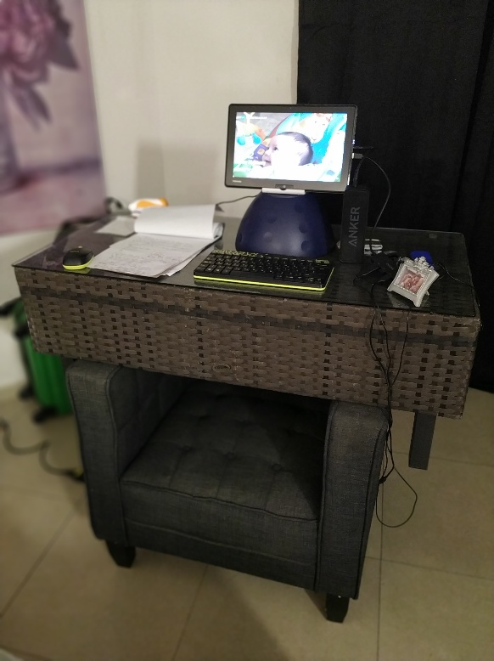
At the Royal Suites Eilat, my home for eighteen days on another temporary move from my Airbnb. Somewhat basic inside, but it does have an excellent balcony for enjoying the afternoon sunshine!

07-02-20
On Thursday, January 23, I was listening to a talk online in which the name "Hugh of Lincoln" was mentioned. I knew of Hugh of Lincoln from of old, not least because of the "Little Sir Hugh" song by Steeleye Span. But the mention in the talk led me to look into the story further. One thing that I found disturbed me immensely, namely the logo and school uniform badge of St Hugh's School, Lincoln. I discussed it with my younger brothers Alan and Eliot. I wanted to write a Comment piece about it for the Jewish Chronicle, but Eliot suggested that I should write to the Headmaster of the school. I felt that was a good idea, except that I was concerned to get the story out promptly, to coincide with the 75th anniversary of the Liberation of Auschwitz on January 27. I started writing the piece, and quickly decided that the subject was anyway well suited to being constructed as an open letter to the Headmaster. I sent it to the newspaper in the early hours of Friday morning.
I did not hear back from the Jewish Chronicle until Monday, the actual 75th anniversary. They wanted to treat it as a news item rather than a comment piece, to which I was agreeable. But I also sent the letter to the Headmaster as I wanted him to see it on that day in particular. I reproduce it here:
Dear Mr Wyld
As the world remembers the Liberation of Auschwitz this day 75 years ago, many people will reflect on the thousand year history of European anti-Semitism that culminated in the Holocaust. One of the most pernicious manifestations of this unique hatred was the blood libel, the canard that Jews murder Christian children to use their blood in religious rituals or in making the Passover unleavened bread. Perhaps the most famous blood libel myth is that of Hugh of Lincoln - the "Little Sir Hugh" of the Steeleye Span song and the “Sir Hugh” as sung by A L Lloyd. Both of these are based on the Old English Ballad “The Jew's Garden / (Little) Sir Hugh”.

Wikipedia contains an impressive article on your school, founded in 1925 by Mr and Mrs Forbes. I reproduce a section here:

The school is named after Saint Hugh, Bishop of Lincoln but also Little Saint Hugh of Lincoln. Little St Hugh was a child whose alleged murder by Jews in 1255 formed one of the most well-known and persistent anti-semitic blood libels. The Church of England formally apologised for the Little St Hugh allegations in 1955. In some ballads retelling the story, Hugh was playing with a ball, which he lost over the wall of a neighbouring Jewish family, and was murdered after being invited into their garden to retrieve it. Mrs Forbes was familiar with the myth while Mr Forbes asserted that this story should remind his boys to maintain control, both of the ball and where they were allowed to play with it. The story and its moral are represented in the school badge, which shows a ball flying over a wall.

Your website is also impressive. The school badge crowns its home page, above a photograph of young pupils proudly posing in school uniform.

But, in my opinion, the badge is no more and no less than a symbol of the blood libel, memorializing Little St Hugh. In the year 2020, the suggestion that the badge represents a reminder of where children should play football is, I would suggest, laughable.

Again from Wikipedia:

In 1955, the Church of England placed a plaque at the site of Little Hugh's former shrine at Lincoln Cathedral, bearing these words:

By the remains of the shrine of "Little St Hugh".
Trumped up stories of "ritual murders" of Christian boys by Jewish communities were common throughout Europe during the Middle Ages and even much later. These fictions cost many innocent Jews their lives. Lincoln had its own legend and the alleged victim was buried in the Cathedral in the year 1255.

Such stories do not redound to the credit of Christendom, and so we pray:

Lord, forgive what we have been,
amend what we are,
and direct what we shall be.

We live in an age where we aspire to harmony, respect and sensitivity across boundaries of race, religion and sex. We educate our children in those values, in the hope that they do not maintain the hatreds of the last millennium. They should not be wearing a symbol that memorializes the blood libel.

With great respect, may I ask you to strongly consider replacing the school badge.

Brian Sacks
Givat Shmuel, Israel
Formerly of Finchley, London

Some references
St Hugh’s School wikipedia article:
https://en.wikipedia.org/w…/St_Hugh%27s_School,_Woodhall_Spa
The Jew's Garden / (Little) Sir Hugh
https://www.sacred-texts.com/neu/eng/child/ch155.htm

Steeleye Span version
https://www.youtube.com/watch?v=FhW1iZQvqlA

A L Lloyd version
https://www.youtube.com/watch?v=-PPU5R8sN2g

Little “Saint” Hugh
https://en.m.wikipedia.org/wiki/Little_Saint_Hugh_of_Lincoln

The Headmaster replied to me, with courtesy and solicitude, within half an hour of my sending him the letter. The following day, the Jewish Chronicle informed me that the Headmaster and School Governors had agreed to change the badge.
This is the article as published in the print edition of the Jewish Chronicle that week: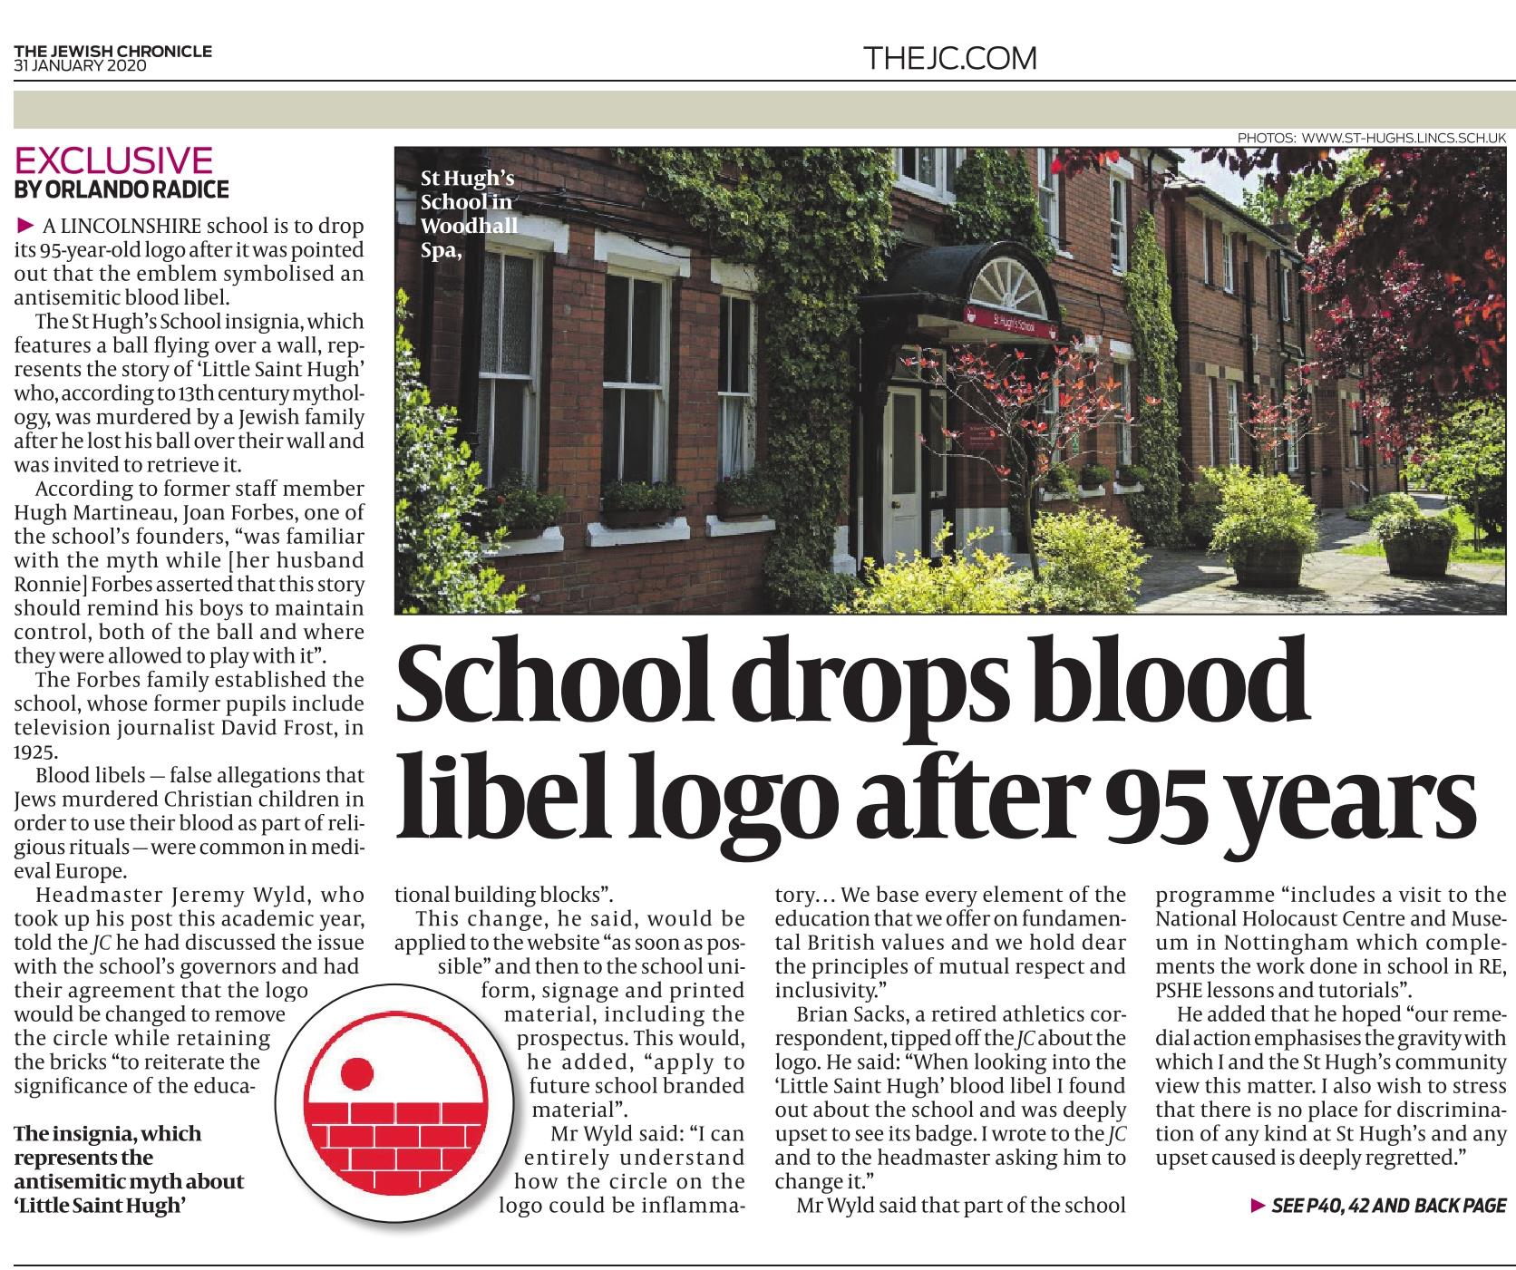
The story was also picked up by Lincolnshire Live,
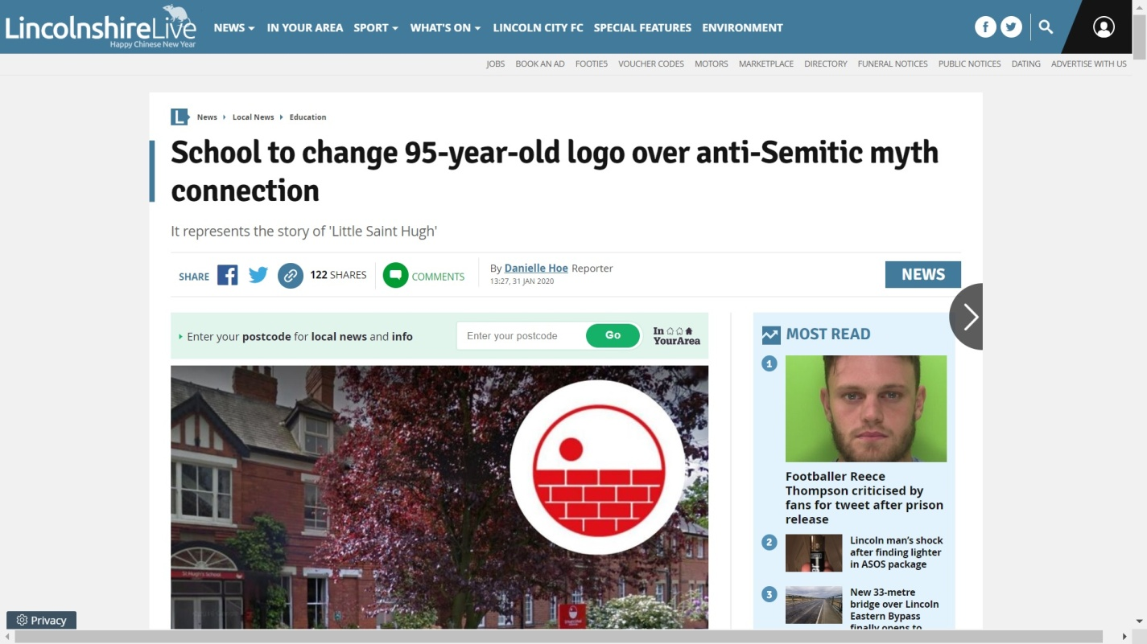

and by the Times of Israel.
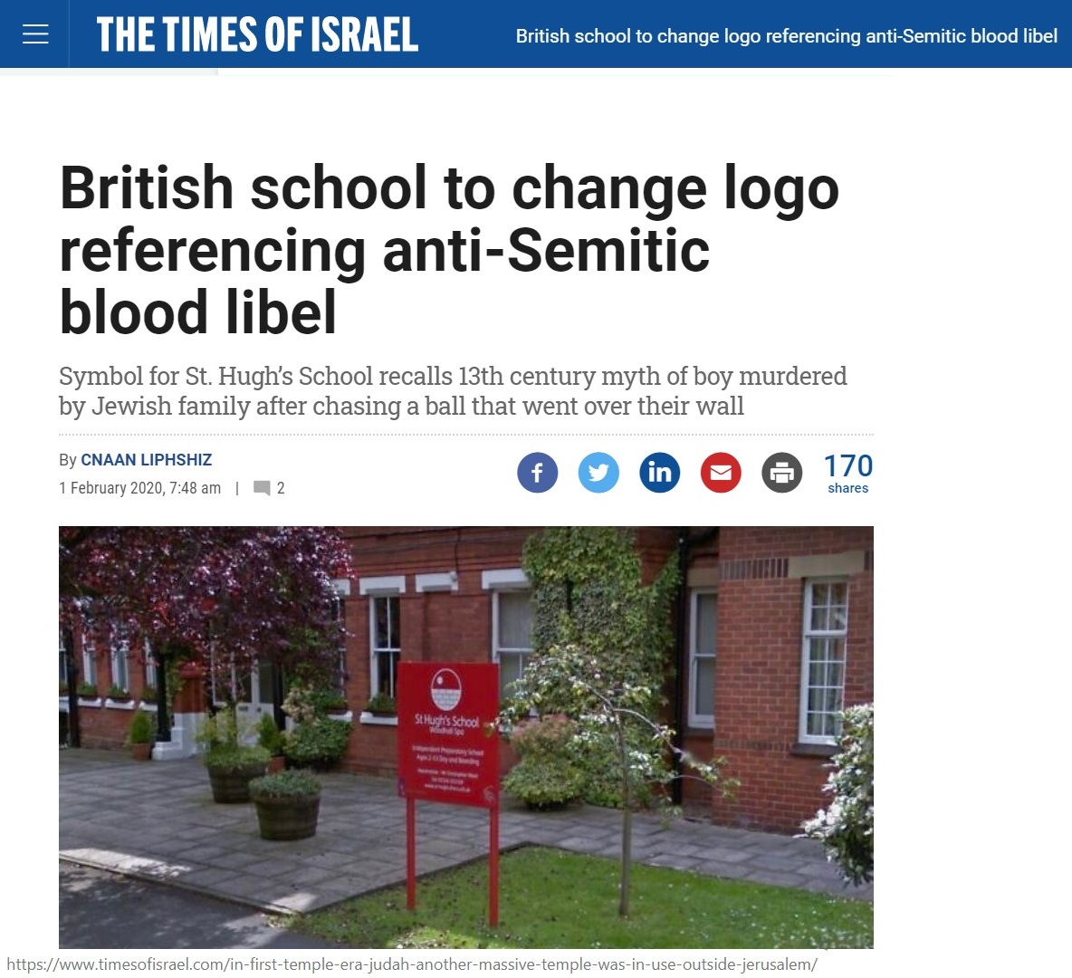
In the Comment section below the Times of Israel online article, someone had written a post along the lines of "Too little, too late". That, to me, was very unfair, so I added this comment:
The headmaster was new to the school having only joined in September. Yet within a day of my letter he had obtained agreement from the School governors and confirmed the decision to change the badge. One has to give considerable credit for that. Although one might have wished for a complete redesign that left no trace of the original, at least the removal of the ball breaks the connection to the "Little St Hugh" myth, allowing the school name to now be only associated with the other – legitimate – St Hugh (a completely different, adult, historical figure).

I have looked at the School website today, and this is its Home Page now:
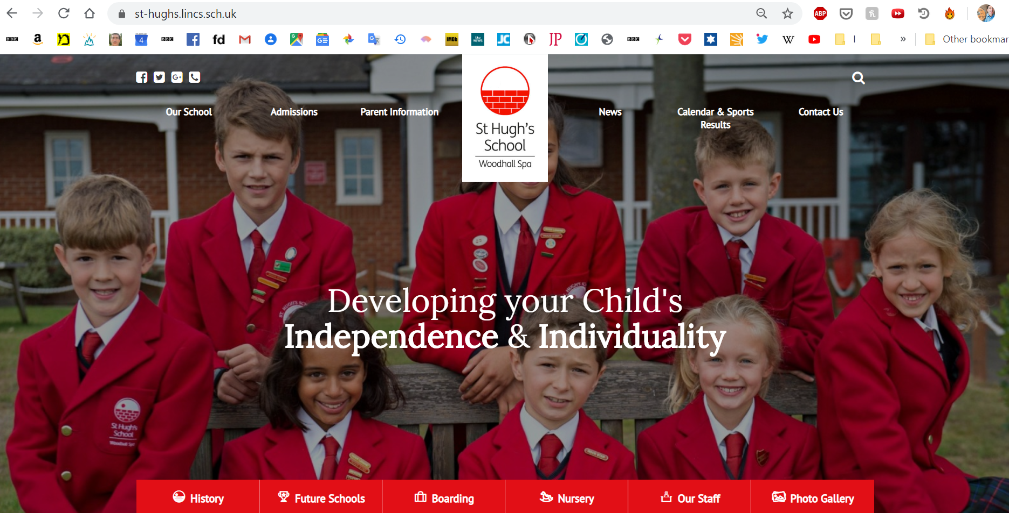
I have written to the Headmaster, again expressing my thanks to him and to the School Governors.
07-02-20
On a lighter note:
A friend asked me which eight songs I would take to a desert island. A list of the music and artists that I enjoy would be very long and probably similar to the corresponding list for most of my contemporaries. So I thought it would be more interesting to provide a list of my musical "crushes" over the last decade.
There have been several minor crushes in the last couple of years: Duffy (2018), Circ (2018), Avicii (2018), Queen (2018/19), Mark Knopfler and Dire Straits (2018/19), Anastasia (2019).
My big 'flings' in recent years have been Eva Cassidy (2011), Passenger (2017) and Adrian Von Ziegler (2019). A common factor amongst my major flings is that they are all such nice people. I do find that enhances my appreciation of their work.
I discovered Adrian Von Ziegler in my search for pleasant and relaxing music to play while I performed tedious physiotherapy exercises for my broken arm. And if I still needed to do those exercises on my desert island, Adrian von Ziegler would be my number one choice.
07-02-20
On a lighter note still:
The joys of Hebrew (continued)
I found out a few days ago that the word for "pesticides" is the same word as the word for "commandments" (as in the Ten Commandments): הדברות. Rhetorical and satirical question: Is there a connection between a commandment and a pesticide?
Another friend commented: "Different vocalization. t’s nt sy t rd wht’s wrttn f thr r n vwls".

12-02-20
Today is exactly six months since I sprinted for a bus, fell splat on the pavement, and split my humerus into two pieces. So here is the six-monthly report:
The best news is that pain is no longer significantly impinging on my quality of life. But I can still only sleep on the "good side" and my left arm cannot comfortably support a heavy duvet, so it must lay above the bulk of my copious winter night-time covering.
My range of left arm movement plateaued after about eight weeks, without much subsequent improvement. In most directions it is at about eighty percent of the range of my right arm, and adequate for everyday purposes. But it is extremely limited behind my back.
I do my exercises every day, mixing and matching the different ones I have been shown by the four physiotherapists I have seen in England and Israel. With the lights off and Adrian Von Ziegler music playing, it doubles as a relaxation session.
My DEXA bone density scan showed that I have osteoporosis, to add to the anaemia that I learned of soon after moving to Israel. But, at my age, I guess news like that comes with the territory.
But yesterday marked a different and happier milestone: I learned that on February 25 I should receive the keys to my new flat!

16-03-20
Today was definitely an Israeli day. I had two appointments in the diary: the first, at 9 a.m., for a fitter to come from Ikea to assemble the cabinets that I bought last week; the second a "shoulder club" physiotherapy appointment at 5 p.m.
At 10:50 a.m., when Mr Ikea had not arrived, I rang customer services, who put me through to the fitter himself. This triggered a repeating loop that seemingly lacked a limiting condition:
/start loop
Fitter: "I rang you twelve times yesterday. Why you no answer?"
Brian: "I had no reception on my phone all day. I did not receive any calls. But I had an appointment. I had paid in advance. I had not cancelled. An appointment is an appointment."
/body of loop
Fitter: <raise decibel level> "But I rang you twelve times yesterday. Why you no answer?"
Brian: <likewise raise decibel level> "I have already told you. I had no reception on my phone all day. I did not receive any calls. But I had an appointment. I had paid in advance. I had not cancelled. An appointment is an appointment."
< Return to /body of loop >.
After about ten iterations, Fitter broke out of the loop and said "You want I come in one hour? You be there in one hour?" And so he came, actually within twenty minutes.
Which led to the next problem: the neighbours. Straight away a neighbour on the same floor came round, raising Cain. Thankfully I was largely able to leave her to have a true Israeli yelling match with the fitter. But here is a choice specimen taken from the several posts on the subject on the Whatsapp group for the new buildings:
Post | Translation
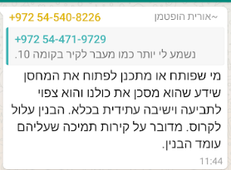 | Anyone who opens or plans to open the store room (adjacent to the apartment) knows he is endangering us all and is likely to be prosecuted and face future jail time. The building may collapse. These are the support walls on which the building stands.
to which my response was
The noise is mine. It is the man from Ikea who is putting together some cupboards. I am sorry that this disturbs you, but it won't be for much longer.
To those of you who are concerned that the building will collapse and you will be required to visit your neighbour in jail, the drilling is on cupboards and not a finger will touch the walls.
In later posts I was forced to say that the drilling in the building was no longer mine and, as with Richard Nixon in 1972, "you won't have me to kick around any more". I was also induced to point out that several of the entries in recent days and weeks on the group have been requests for recommendations for builders and handymen, so any expectations of monastic silence are probably going to be dashed. I did refer to my sin in calling in Ikea, but stopped short of saying, "Let he who is without sin cast the first stone".
In some ways it was a welcome relief to get out for the half-hour walk to the shoulder group, but on arrival I was told that the group had been cancelled. "We rang up everybody yesterday!". It was a mistake, I was told, that the only SMS I received from the health provider, actually this morning, was to remind me of my appointment on Thursday. All the more of a mistake given that the clinic is closed for at least a month.
Finally, on arriving back at my AirBnB - thankfully I am now in the last three days here - I was terrorised by the hosts’ new dog, and couldn't enter the property for five or ten minutes until the owner came out to subdue it.
All in all, an Israeli day.
21-03-20
The age of Corona virus begins.
It is now mandatory to stay indoors, other than for a few specified reasons including buying groceries, visits to the pharmacy or for medical treatment. Short local walks only are allowed. We all feel pretty much under house arrest.
Three evenings ago I moved into my new apartment. The previous day my shipment from England had arrived, and the following day my son-in-law David brought around much of the stuff I had accumulated last year in Israel, which had been sitting in his storeroom. So since then I've been frantically trying to create order out of chaos, which certainly takes the mind off of Corona virus temporarily.
24-03-20
I am taking things one day at a time; each day is different. Last week I had various early starts for deliveries (washing machine, tumble dryer, dishwasher). Yesterday, apart from a brief sleep in the early morning, I stayed up all night to go for the "60+ only" session at the supermarket, from 7 – 9 AM. It was a mistake that I will not make again. It was extremely crowded, no-one was keeping their distance, and I was in the distinct minority of people not wearing masks. I felt vulnerable. If I do physically go to the supermarket again during this crisis, it will be just before the 10 PM close, or I will venture further afield for an all-night branch.
But the spinoff was that I was up to see dawn breaking and I was able to take a reasonably brisk (though too short) walk in very pleasant sunshine at 6 AM. Another spinoff was that today I slept for 9-plus hours straight.
A significant chunk of my day, on most days, is spent working through the “Whatsapp” group for my new building and its identical twin next door. Each building has 106 flats, although a fair proportion are as yet unsold. There are hundreds of Whatsapp messages each day, all in Hebrew, and I find it very important to work through them to keep up with what is going on. It also gives me very useful Hebrew practice.
I'm somewhat limited in furniture at the moment, but am making prolific use of the packing boxes from my shipment from the UK. I have one table formed from three of them, a workstation from four of them, and several others being utilised as ottomans or stands. But in some ways I have been extremely lucky with my timing - up to 7 days ago I was living below ground, whereas now I have a spacious balcony with a panoramic view to the south.
31-03-20
All shops are now closed by government regulation, other than food suppliers and pharmacies. We are restricted to a 100 metre radius of our home, unless we are venturing for food shopping or to collect prescriptions. When I ventured out this afternoon, it felt as if I had stepped into a ghost town. With the building sites around me uncannily quiet, but the warm breeze stirring up the sand, one almost expected the "Fistfull of Dollars" theme to start up and Clint Eastwood to emerge into the foreground.
I have now been living in my new flat for almost a fortnight. A lot of my shipment from England, and the stuff accumulated last year in Israel, remains in boxes and bags, because I do not have the shelves and cupboards to accommodate them, and will not until this lockdown is over. There are many other challenges to do with lack of usable hot water (the tank being in the boiler room some distance away from the flat), and needing to buy most white goods and bathroom fittings.
What with all of this, up until a couple of days ago, rather than feeling bored, I was feeling swamped by so much needing to be done. But in the last couple of days, a feeling of tiredness, especially muscular, has overtaken me. A good part of this must be the effect of the confinement at home.
Meanwhile Jessica is coping very well, with both children at home all the time, and now into her final month of pregnancy. I speak to them through WhatsApp, and Tzviya remains happy that she is not going to her kindergarten. Lyn, in London, is of course not enjoying things. She tries to be a support to all the local sufferers of Parkinson's, and the news she hears isn't good.

05-04-20
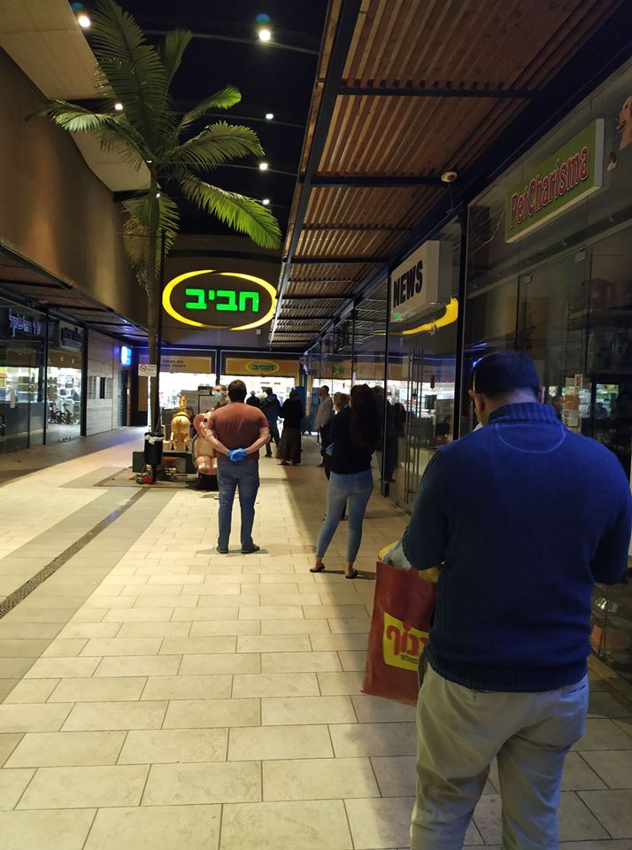
Queue to enter the supermarket
I arrived half an hour before closing to avoid the crowds. Strange times we are living through.
25-04-20
The leash has now been loosened to the extent that one can move up to 500 metres away from home so long as it is by means of a sporting activity. But David tells me that, as a senior citizen, I remain under house arrest. Although I Whatsapp Jessica, David, Tzviya and Amit almost every day, I haven't seen them in the flesh for virtually two months.
23-05-20
One month on from my last update, and several happy events and milestones have occurred. First and foremost, Jessica has given birth to Ya’ara Adina, a baby sister for Tzviya and Amit. Jessica wrote and spoke very movingly about the choice of names: Ya’ara meaning ‘honeysuckle’ or ‘honeycomb’, and Adina meaning ‘gentle’ or ‘refined’. Adina was chosen to remember Ada, who lived with my parents from 1954 until the end of 2010 and epitomised the attributes captured in the name. The start of Jessica’s labour was the event that plucked me out of lockdown isolation and into two and a half days of heavy-duty babysitting - thankfully everything went well.
During the fortnight previous to the birth, I wrote a full-page article for the JC on the Jewish History of the London Marathon. It was published for the weekend during which this year's event SHOULD have taken place. It was an enjoyable exercise, although it will probably be unrewarded financially, given that the Jewish Chronicle is currently in receivership.
Coinciding with the nine months' anniversary of my broken arm, I had my first physiotherapy appointment since lockdown, and was discharged; I am now officially healed!
Israel has now come out of lockdown to a very considerable extent, though the wearing of masks out of doors is mandatory. I travelled on a bus for the first time two days ago, and was very pleased that the journeys were uncrowded. I have now resumed Friday night meals with the family, and likewise they pop round to me.
01-08-20
Today is the second anniversary of my "Aliyah" – my becoming an Israeli citizen.
At the time of my first anniversary, I was heavily engaged in preparing for my move back to London, where my task was to sell/donate/transport my possessions and to sell my flat. So it was not a time to sit back and take stock.
I am in a very different situation now, one year further on. My new flat is still a work in progress, but bit by bit it is becoming very comfortable and satisfying. Every week my previous landlord, Gideon, visits for one and a half hours so that I can teach him English and he can teach me Hebrew. Every Friday evening I eat with David, Jessica and their three children (Ya'ara is now three months old), each Shabbat afternoon they come round to visit me, and once a week I look after the two older children for a few hours. All this is thanks to us living within a ten minutes’ walk from each other. On the other hand, due to the corona crisis (as it is known here – "corona" trips off the Hebrew tongue much better than "Covid-19”) I have not been able to visit my brothers in Jerusalem for six months.
This second year has also been a year of recovery from my upper arm fracture. I have made an almost-full recovery; certainly the arm does not trouble me in normal daily living. I am forever grateful for the care (mainly physio) received in London and Israel; and for the music of Adrian von Ziegler in making my daily exercise sessions relaxing and enjoyable.
One of the motivating factors of moving to Israel was to put myself in a position where I would learn Modern Hebrew. I wistfully wondered whether I would learn it effortlessly like a child acquires language. There is no point in putting myself down, but let's just say that I am not a natural linguist. My brain is certainly not as retentive as it was fifty years ago. I am grateful for all the classical Hebrew that I learned in my teens because that knowledge is definitely the main hook I utilise in trying to catch and keep hold of new words.
Life in Israel continues to confound from time to time. The postal service is highly unreliable, especially internationally. Exercise bands that I ordered from abroad had not arrived by the time the three months' delivery window had expired, and the price I paid was refunded, only for the bands to arrive the following day. The banking system is almost ante-deluvian. This is well illustrated by my recent desire to have a cheque book for my new bank account, which was occasioned by my changing bank branch on moving to my new apartment. To request the cheque book entailed booking an appointment with a bank clerk and paying for that appointment. Unsurprisingly (other than to people who have experienced banking in other countries) one has to pay for the cheque book; and one has to pay for the bank appointment to pick the cheque book up. If one wishes to actually write cheques, again unsurprisingly (caveat as previously) one pays an item charge for each cheque. In other words, to actually use cheques, one pays four times over. Ah well, in Israel, one takes the rough with the smooth.
Do I feel Israeli? No. Language difficulties are a significant barrier to feeling comfortable and integrated in the public space. So much of the time I have to respond to questions with "I don't know, sorry". I feel a little bit like an interplanetary explorer, stepping his way through an alien environment, protected not by a space suit but by my own sense of separateness, and my life supported not by an oxygen tank but by Google Translate on my phone. My response to this feeling of disconnectedness is to simply take things day by day – as I suppose people are doing around the world at this time. And I have felt different all my life anyway, and needed to be different to survive.
Another small element of my motivation was to "do something out-of-the-ordinary". I had always looked on with some awe at people who did things like "renting out their house for a few years to go and live abroad". When people expressed it in just a few words like that, it gave the impression that, to them, it was relatively straightforward and natural. And yet to me it sounded way beyond my comfort zone. Well, now I can tick those things off on my bucket list. My life has not been boring.
In summary, I passed my first anniversary during a period of movement, uncertainty and change. Today, on my second anniversary, I feel I have arrived. It is indeed the end of a chapter.

